mslogo

Microsoft Project Server 2013 Administrator's Guide

Copyright

This document is provided “as-is”. Information and views expressed in this document, including URL and other Internet Web site references, may change without notice.

This document does not provide you with any legal rights to any intellectual property in any Microsoft product. You may copy and use this document for your internal, reference purposes.

© 2013 Microsoft Corporation. All rights reserved.

Microsoft, Active Directory, Excel, Internet Explorer, Outlook, SharePoint, SQL Server, and Windows are trademarks of the Microsoft group of companies. All other trademarks are property of their respective owners.

# Table of Contents

Table of Contents 3

Introduction 1

What Will You Learn from this Book? 1

Who Should Read this Book? 1

Changes in Project Server 2013 that affect administration 2

How is this Book Structured? 3

Part I 5

**Project Web App Settings in Project Server 2013** 5

1 7

**Personal Settings** 7

My Queued Jobs 8

Manage Delegates 8

Act as a Delegate 10

2 12

**Enterprise Data: Project Web App Settings** 12

Enterprise Custom Fields and Lookup Tables 13

Enterprise Custom Fields 13

Creating Enterprise Custom Fields 14

Creating Enterprise Custom Lookup Tables 26

Departments 31

Configuring departments 35

Resource Breakdown Structure (RBS) 37

Enterprise Calendars 39

Create a new calendar 40

Copy an existing calendar 41

Edit an existing calendar 42

Delete a calendar 43

Modify Working and Nonworking Times 43

Resource Center 54

Create a new resource 54

Edit an existing resource 60

3 63

**Queue and Database Administration: Project Web App Settings** 63

Manage Queue Jobs 64

Use the Manage Queue Jobs settings 64

Jobs Grid 71

Understanding Jobs 73

Delete Enterprise Objects 77

Delete projects 77

Delete resources and users 79

Delete status report responses 80

Delete timesheets 81

Delete user delegates 81

Force Check-in Enterprise Objects 82

Check-in Enterprise Projects 83

Check-in Enterprise Resources 84

Check-in Enterprise Custom Fields 84

Check-in Enterprise Calendars 85

Check-in Lookup Tables for Enterprise Custom Fields 86

Check-in Resource Plans 87

4 88

**Look and Feel: Project Web App Settings** 88

Manage Views 89

Create a New View 93

Modify a View 97

Copy a View 98

Delete a View 99

Grouping Formats 99

Gantt Chart Formats 101

Quick Launch 102

Change Quick Launch Behavior 103

Add a New Link 104

Modify an Existing Link 106

Reorder Quick Launch Items 107

Delete a Link 108

5 109

**Time and Task Management: Project Web App Settings** 109

Fiscal Periods 110

Define Fiscal Periods 110

Delete Fiscal Periods 113

Time Reporting Periods 114

Create Bulk Time Reporting Periods 114

Insert or Delete Time Reporting Periods 116

Line Classifications 117

Timesheet Settings and Defaults 119

Administrative Time 122

Task Settings and Display 123

Manage Timesheets 124

Timesheet Managers 125

6 127

Operational Policies: Project Web App Settings 127

Additional Server Settings 128

Enterprise Settings 128

Currency Settings 129

Resource Capacity Settings 132

Resource Plan Work Day 133

Task Mode Settings 134

Active Directory Resource Pool Synchronization 135

Changes in Active Directory Resource Pool synchronization for Project Server 2013 136

User Synchronization scenarios 136

Requirements for Enterprise Resource Pool synchronization 138

Configure Enterprise Resource Pool Synchronization 138

Schedule Enterprise Resource Pool Synchronization 139

Supported Active Directory topologies for Project Server 2013 Enterprise Resource Pool synchronization 142

Single Domain topology 142

Single Forest Parent-Child Trust topology 143

Single Forest Tree-Root Trust topology 144

Forest Trust topology 145

External Trust topology 146

Unsupported Topologies 147

Best practices to configure Active Directory groups for Enterprise Resource Pool synchronization in Project Server 2013 147

Active Directory group configuration for ERP and security group synchronization 148

Manage connected SharePoint sites in Project Server 2013 149

Create Site settings 150

Edit Site Address settings 151

Synchronize settings 152

Delete site settings 155

Go to Project Site Settings 155

7 157

**Workflow and Project Detail Pages: Project Web App Settings** 157

Enterprise Project Types 158

Workflow Phases 161

Workflow Stages 162

Change or Restart Workflows 164

Project Detail Pages 166

8 169

**Security: PWA Settings** 169

Permission modes 170

SharePoint permission mode 171

Adding users 172

Project Server permission mode 172

Permissions 173

Manage Users 174

Add or Edit a User 175

Deactivate a user account 185

Reactivate a user account 186

Manage security groups 187

Create or modify a security group 188

Delete a security group 193

Security group synchronization with Active Directory 193

Manage categories 199

Create or modify a category 201

Delete a category 207

Manage security templates 208

Create or modify a security template 209

Delete a security template 212

Manage Project Web App permissions 213

Manage Delegates 214

Enable the Delegation feature 214

Set up which users and groups can act as delegates 215

Set up which users and groups can have delegates 216

To create a delegation 217

Part II 219

**SharePoint Central Administration Project Web App Settings** 219

9 221

**Queue and Database Administration OLAP Database Management: SharePoint Central Administration PWA Settings** 221

Manage Queue Jobs 222

Use the Manage Queue Jobs settings 222

Jobs Grid 229

Understanding Jobs 231

OLAP Database Management 235

Create an OLAP cube 236

Configure an OLAP cube 240

Copy an OLAP cube 244

Delete an OLAP cube 245

Build an OLAP cube 246

10 247

Operational Policies: SharePoint Central Administration PWA Settings 247

Alerts and Reminders 248

Notification Email Settings 248

Additional Server Settings 250

Project Professional Versions 250

Enterprise Settings 252

Currency Settings 253

Resource Capacity Settings 255

Resource Plan Work Day 256

Exchange Server Details 257

Task Mode Settings 258

Server Side Event Handlers 259

Project Site Provisioning Settings 261

Site URL 262

Default Site Properties 262

Site Creation Settings 263

Bulk Update Project Sites 264

Update Site Paths 264

Update Content Types 265

11 267

Workflow and Project Detail Pages: SharePoint Central Administration PWA Settings 267

12 269

Manage Queue Settings 269

Requirements 270

Configure Queue Settings 270

Maximum Degree of Concurrency 271

Retry Interval 272

Retry Limit 272

SQL Timeout 273

Cleanup Age Limit for Successful Jobs 273

Cleanup Age Limit for Non-Successful Jobs 274

Bookkeeping Interval 275

Queue Timeout 276

Appendices 277

A 278

Project Server 2013 Category Permissions 278

B 288

Project Server 2013 Global Permissions 288

C 304

Project Server 2010 Default Security Groups 304

Default global permissions 305

D 311

Project Server 2013 Default Categories 311

Categories associated to default security groups 311

Category permissions 312

E 316

SharePoint Permissions Mode default permissions for Project Server 2013 SharePoint groups 316

Permissions for SharePoint groups in Project Server 2013 317

Global permissions for SharePoint groups in SharePoint Permission Mode 317

Category permissions for SharePoint groups in SharePoint Permission Mode 323

F 326

Description of Project Server 2013 Windows PowerShell Cmdlets 326

# Introduction

The *Microsoft Project Server 2013 Administrator’s Guide* helps your organization understand the tasks involved with administering Microsoft Project Server 2013.

**Send us your feedback (projdocs@microsoft.com).** Please let us know what you think about the quality of this content. If this text does not meet your needs, let us know how we can improve it. If this text was helpful to you, let us know how it helped.

## What Will You Learn from this Book?

There are several important tasks that an administrator must manage in Microsoft Project Server 2013 for Project Web App users to access and interact effectively with project data, including:

* Managing users, groups, and categories.
* Customizing Project Web App to fit the specific needs of your organization.
* Managing workflows.
* Managing enterprise data (custom fields, calendars, views, etc.).
* Managing queue settings for your specific environment.
* Managing time and task tracking.
* Configuring Active Directory synchronization to security groups and resources.

## Who Should Read this Book?

This book is designed to produce maximum benefits for the following professionals:

Project Server administrators

Those individuals who will have administrative privileges for Project Server and will perform the duties required to configure and maintain Project Server.

SharePoint Server farm administrators

Those individuals responsible for administering the SharePoint Server Central Administration web site and ensuring that Project Server and Microsoft SharePoint Server are always properly synchronized and that SharePoint Server features and functionality are available.

Project Management Office (PMO)

Those individuals who help to define and maintain project management standards and practices throughout the organization.

Project site administrators

Those individuals who will have administrative privileges for Project Server and will perform the duties required to configure Project Server to meet organizational portfolio and project management needs.

Active Directory administrators

Those individuals responsible for setting up individual e-mail accounts and security groups in the Active Directory directory service that will be mapped to the Project Server Enterprise Resource Pool and Project Server security groups.

Any member of your organization’s Project Server deployment planning team

Those individuals within your organization who will plan the deployment of Project Server 2013 and who may need a better understanding of the day-to-day Project Server administrative tasks that are available in Project Web App.

## Changes in Project Server 2013 that affect administration

There are several key changes in Project Server 2013 that differ from the way administration was done in previous versions. This includes:

* **Some server settings moved to SharePoint Central Administration**: A few Project Web App Server Settings that have previously been located in Project Web App in Project Server 2010 have been moved to SharePoint Central Administration in Project Server 2013. The reason for this change was that these settings were tasks that were more typically done by a farm administrator, instead of a PMO manager or Project Server administrator.
* **SharePoint Permissions Mode**: By default, Project Server 2013 security will be in SharePoint Permissions Mode. This mode uses “Project Server 2013” SharePoint Security groups as containers in which Project Server 2013 users can be added as members. Project Server 2013 permissions are assigned to these group, and they are not editable. If you require more control, you can change to the traditional Project Server Permissions Mode. It is important to understand security modes when you are viewing the “Security” chapter.
* **Project Online**: Project Online is a hosted version of Project Server 2013 in which the service is hosted in the cloud. Administration will differ between Project Online and Project Server 2013, since many administrative tasks are done for you and are not accessible to users. The tasks documented in this guide are intended for Project Server 2013 users, and not for Project Online users.

## How is this Book Structured?

This book is divided into two sections (plus several appendices), since Project Server administrative settings are now located in Project Web App and in SharePoint Central Administration. The Project Web App section contains eight chapters and is targeted to the Project Server Administrator or PMO. The SharePoint Central Administration section contains four chapters and contains information that is of more interest to your farm administrator. Both sections are organized in the same manner in this book as they are organized in Project Web App and in SharePoint Central Administration. Appendix data is primarily reference data and lists:

* Introduction

Project Web App Settings in Project Server 2013

* + Chapter 1, “Personal Settings”
  + Chapter 2,  “Enterprise Data”
  + Chapter 3,  “Queue and Database Administration”
  + Chapter 4,  “Look and Feel”
  + Chapter 5,  “Time and Task Management”
  + Chapter 6,  “Operational Policies”
  + Chapter 7,  “Workflow and Project Detail Pages”
  + Chapter 8, “Security”

Project Web App Settings in SharePoint Central Administration

* + Chapter 9,  “Queue and Database Administration”
  + Chapter 10,  “Operational Policies”
  + Chapter 11,  “Workflow and Project Detail Pages”
  + Chapter 12,  “Manage Queue Settings”

Appendices

* + Appendix A, “Project Server 2013 Category Permissions”
  + Appendix B, “Project Server 2013 Global Permissions”
  + Appendix C, “Project Server 2013 Default Security Groups”
  + Appendix D, “Project Server 2013 Default Categories”
  + Appendix E, “SharePoint Permission Mode default permissions for Project Server 2013 SharePoint groups”
  + Appendix F, “Project Server 2013 Windows PowerShell cmdlets”

Part I

# **Project Web App Settings in Project Server 2013**

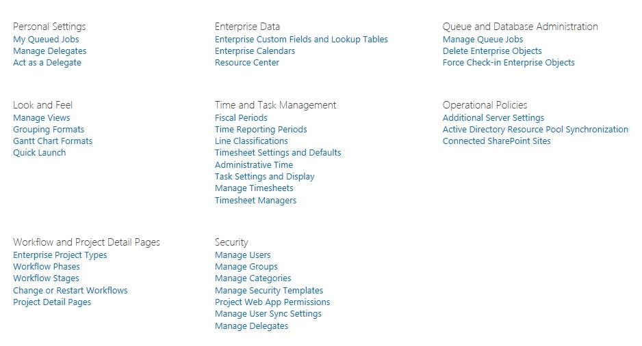

Part I of this book includes all Project Web App settings that are available in Project Server 2013. These are different from the Project Web App settings that are available in SharePoint Central Administration since these settings are more for Project Server Administrators and PMO managers (versus farm administrators). The Project Web App settings available in Project Server 2013 are described in the following chapters:

* Chapter 1, “Personal Settings”
* Chapter 2,  “Enterprise Data”
* Chapter 3,  “Queue and Database Administration”
* Chapter 4,  “Look and Feel”
* Chapter 5,  “Time and Task Management”
* Chapter 6,  “Operational Policies”
* Chapter 7,  “Workflow and Project Detail Pages”
* Chapter 8, “Security”

Use the following procedure access the Project Web App Settings in Project Server 2013:

* To access the PWA Settings in Project Server 2013

1. In Project Web App, click the Settings icon to display the menu, and then click PWA Settings.

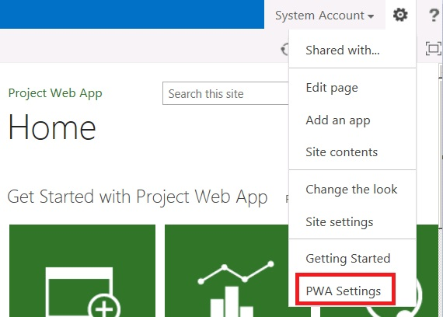

1

# **Personal Settings**

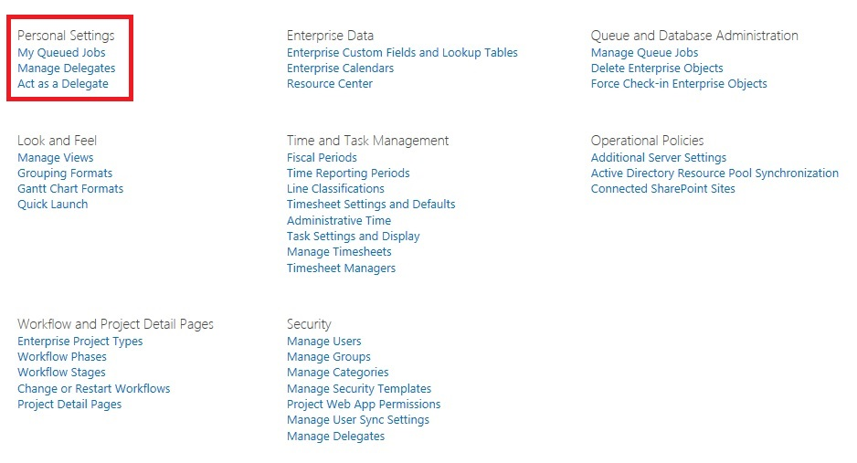

Personal Settings in the Project Web App settings page

The Personal Settings are located in the Project Web App Server Settings page and allow you to manage the following server settings:

* My Queued Jobs
* Manage Delegates
* Act as a Delegate

## My Queued Jobs

The My Queued Jobs section of the Personal Settings page allows you to view the status of jobs that you have submitted to the queue.



Job displayed in My Queued Jobs

Through the View menu, you are able to view all of your jobs by job state.

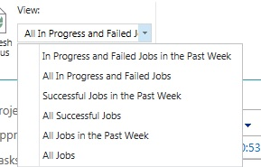

View menu

For example, you can filter by “In Progress and Failed Jobs in the Past Week” to see all of your jobs that had not completed successfully in the last week.

The My Queued Jobs page differs from the Manage Queue Jobs page because the Manage Queue Jobs page will provide data about all jobs that are submitted to the queue. The My Queued Jobs page will only display data about your own jobs.

## Manage Delegates

You can use the Manage Delegates page in the Personal Settings section to create a new delegation. This enables on user to work on behalf of another user, such as submitting a second user’s timesheet.

In order to create a new delegation, the user delegation feature must be enabled in Project Server 2013 and you must have the required permissions. For more information about user delegation, see the Manage Delegates section of Chapter 8: Security.

* To create a delegation

1. In Project Web App, click the Settings icon, and then click PWA Settings.
2. In the Security section, click Manage Delegates.
3. On the Manage Delegates page, click New.

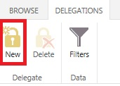

New button

1. In the Set Delegation Period section, select the date range for the period in which the delegate will be able to manage work.

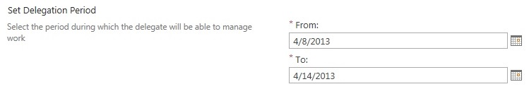

Set Delegate Period

1. In the Set Delegation section, select the delegate that you want to manage work during the specific period.

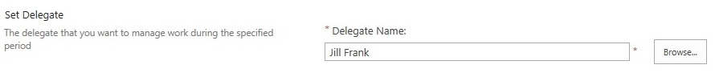

New Custom Field page

1. In the Working on Behalf of section, select the user who requires a substitute.

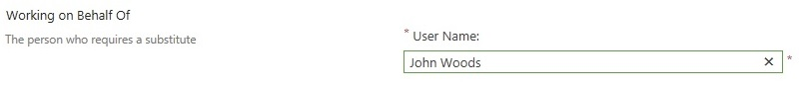

Working on Behalf of

1. Click Save to save the permissions on the server.

## Act as a Delegate

The Act as a Delegate page allows you to start or stop working on behalf of a user for which you are acting as a delegate.

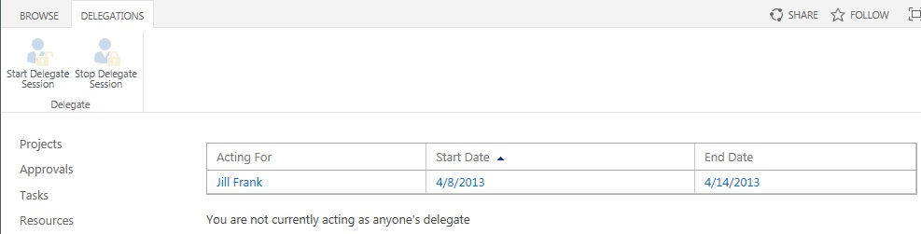

Act as a Delegate page

* To start a delegation session

1. In Project Web App, click the Settings icon, and then click PWA Settings.
2. In the Personal Settings section, click Act as a Delegate.
3. On the Act as a Delegate page, in the Acting For column, select the user for which you want to start the delegation session. Note that only users for which you are assigned as a delegate will be listed.
4. In the ribbon, click Start Delegation Session. A message box will display stating that you are currently acting as a delegate for the specific user.

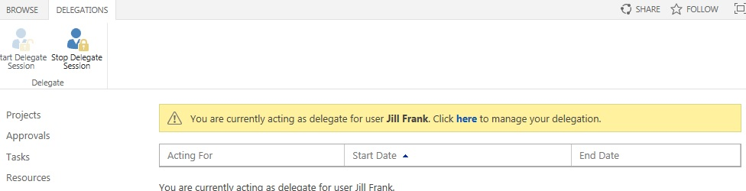

Currently Acting as a Delegate message

* To stop a delegation session

1. In Project Web App, click the Settings icon, and then click PWA Settings.
2. In the Personal Settings section, click Act as a Delegate.
3. On the Act as a Delegate page, in the ribbon, click Stop Delegate Session. The message box that states that you are acting as a delegate will no longer display. A message will appear under the Acting For list stating that you are not currently acting as a delegate.

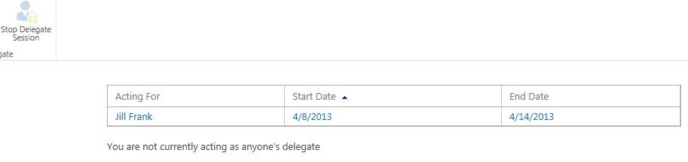

Stop a Delegate Session button

2

# **Enterprise Data: Project Web App Settings**

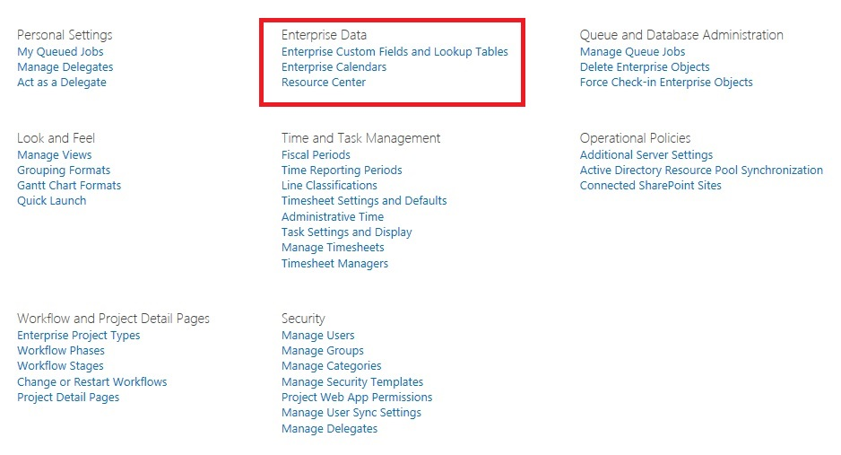

The Enterprise Data settings in the Project Web App settings page

The Enterprise Data section of the Project Web App settings page allows you to manage the way enterprise data (custom fields, lookup tables, and calendars) are used in your environment. The topics described in this chapter include:

* Enterprise Custom Fields and Lookup Tables
* Calendars
* Departments
* The Resource Breakdown Structure (RBS)

.

## Enterprise Custom Fields and Lookup Tables

In Project Web App, you can use Enterprise Custom Fields to help establish consistency across all the organization’s projects. That way that you can ensure that fields and associated lookup tables are used in the same manner for all projects, tasks, resources, and assignments in a given instance of Project Web App.

Enterprise Custom Fields can include custom formulas and can use lookup tables and graphical indicators. By using Enterprise Custom Fields effectively, you can help customize Project Web App to fit the unique needs of your organization. When you use Enterprise Custom Fields, all users in your organization have access to a standard set of fields, which enables operations to be applied in the same manner across whole sets of projects. For example:

* You can customize project management to reflect your organization's structure and processes. All users in your organization can have access to a standard set of fields, which enables the same operations to be completed across whole sets of projects.
* You can set Enterprise Custom Fields as required fields so that users are prompted to enter information in that field before they save.
* You can use Enterprise Custom Fields on a per-department basis.

Because creating Enterprise Custom Fields can range from being easy to being very complex and labor-intensive, it is important to correctly design your Enterprise Custom Fields. To determine the scope of Enterprise Custom Fields that your organization requires, consider the following questions:

* What words or phrases are used by stakeholders in your organization, such as return on investment (ROI), Key Performance Indicator (KPI), and so on? You might want to quantify and codify these concepts by using Enterprise Custom Fields. Also consider the concepts behind the common words and phrases used by stakeholders in your organization.
* What are the user requirements in your organization? User requirements are frequently based on reporting requirements.
* How will you sort and select data? How will you use graphical indicators?

### Enterprise Custom Fields

You can create Enterprise Custom Fields at the task, project, and resource level. It is important to determine which specific Enterprise Custom Fields your organization needs when you review your business requirements while planning your Project Server 2013 deployment. It is best to do this after you have performed a gap analysis by comparing the capabilities of Project Server 2013 against the business needs of your organization.

For example, a group of executives in an organization wants to be able to view project data by department. In order to achieve this business requirement, they have to define a consistent method for identifying departments within the organization. In addition, if each department has a different accounting method or funding process, the executives might have to determine a method for defining this, also. You can use the Project Departments or Resource Departments custom fields together with the Department custom lookup table, or any enterprise custom field that has the Department property set to do this.

The most important use for Enterprise Custom Fields is to enable organizations to enforce consistency across all projects. For example, if two project managers use different fields to specify a resource’s location, then users are unable to determine when the same resource is assigned to projects managed by each project manager.

Note that using a lot of custom fields with formulas can have a performance impact on your system.

### Creating Enterprise Custom Fields

Project Server Enterprise Custom Fields are created and maintained through the PWA Settings page in Project Web App.

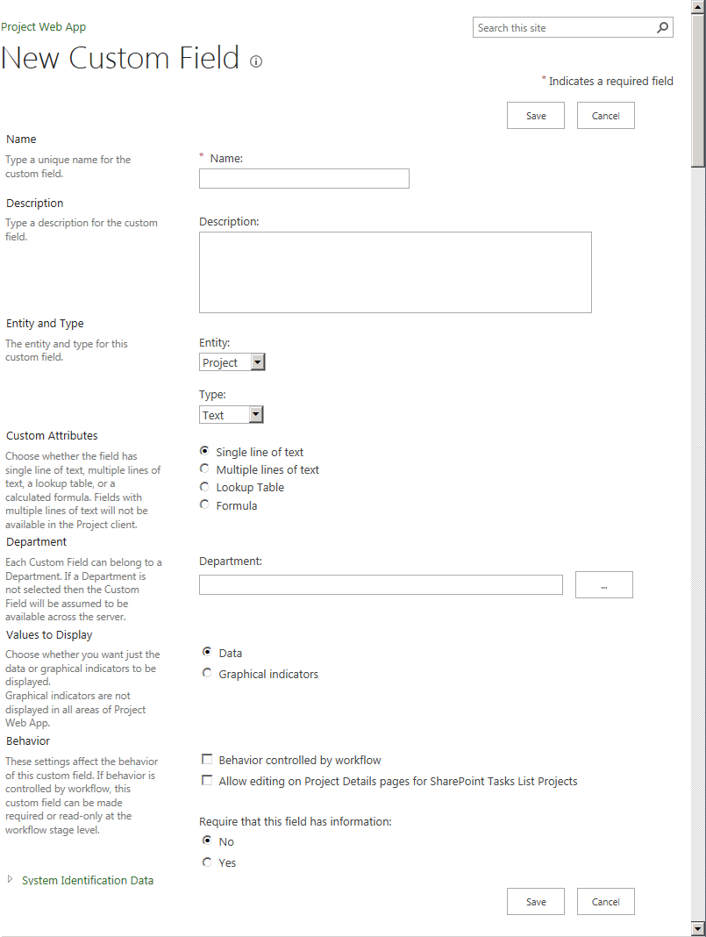

New Custom Field page

The New Custom Field page allows you to specify the options for a custom field. Use the following procedure to create a new enterprise custom field.

* To create Enterprise Custom Fields

1. On the Project Web App home page, click Settings, and then click PWA Settings.
2. On the PWA Settings page, click Enterprise Custom fields and Lookup Tables.
3. Under Enterprise Custom Fields, click New Field.
4. Fill out the New Custom Field page with the custom field options that you want to use. See the descriptions for each field in the following sections.
5. Click Save.

#### Name and Description

Use the Name and Description areas to specify a name and description for the custom field.

Note If you plan to use custom fields in your OLAP cubes, avoid using non-alphanumeric characters in the name.

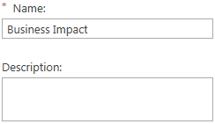

Custom Field Name and Description

The following table describes the name and description fields.

|  |  |
| --- | --- |
| Attribute | Description |
| Name | The name of the custom field. |
| Description | A description of the custom field. |

#### Entity and Type

Use the Entity and Type areas to specify whether you want a Project, Resource, or Task custom field, and what data type the field should be. Note that Entity and Type cannot be edited after the custom field has been saved.

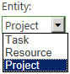

Custom Field Entities

The following table describes each of the available entities.

|  |  |
| --- | --- |
| Attribute | Description |
| Project | Select to create Enterprise Custom Fields that are applied at the project level. |
| Resource | Select to create Enterprise Custom Fields that are applied at the resource level. |
| Task | Select to create Enterprise Custom Fields that are applied at the task level. |

The Type selection defines the data type of the custom field. The value you choose here will affect which options are available in the Custom Attributes, Calculation for Summary Rows, and Behavior section.

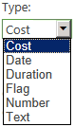

Custom Field Types

The following table describes the available custom field types.

| Attribute | Description |
| --- | --- |
| Cost | Use custom cost fields to define currency data. For example, you can use a custom cost field to define a project’s Approved Budget. |
| Date | Use custom date fields to specify date-driven data. For example, you can create an Enterprise Custom Field called Project Approval Date, and use it to record the date on which a project is approved. |
| Duration | Use custom duration fields to define a duration. These are frequently defined as calculations that use custom formulas. For example, a custom duration field can enable your organization to define a way for a project manager to show and store the difference between a project’s original schedule and the actual schedule. |
| Flag | Use custom flag fields to define anything that can have only two choices for defining the data. For example, you might use a flag field to determine whether to display a field or to enable a macro that controls whether a particular set of data is available in the project. |
| Number | Use custom number fields to define any numeric set of data or to perform a custom calculation by using a custom formula. For example, you might use a task-level field to record the estimated lines of code in a software development project or to compare a project’s actual cost to its proposed cost. |
| Text | Use custom text fields to define simple, non-hierarchical, alphanumeric data. For example, you can create a custom text field that is named Project Status that includes options such as Initiated, Approved, In-Progress, Suspended, Cancelled, and Closed. |

#### Custom Attributes

When you select a Project Text custom field, you have the option of specifying one or multiple lines of text for the custom field.



Custom Attributes - text

The following table describes the custom text options.

| Attribute | Description |
| --- | --- |
| Single line of text | Select if you want the custom field to be a single line of text. This option is available only for Project Text fields. |
| Multiple lines of text | Select if you want the custom field to be multiple lines of text. This option is available only for Project Text fields. The project field created by using this option is not visible in the project information tab in Project Professional. However, this field can be exposed by using a Web-based Project Detail Page (PDP). |

You can choose to have a custom lookup table supply the values for a custom field. This lets you to control the values selected for the custom field. You can do the following:

* Choose whether to have a default value if no other value is selected
* Choose whether to allow multiple values to be selected from the lookup table
* Choose to restrict available values to those values in the table that have no subordinates

The lookup table option is available when you have selected Text as the field type.

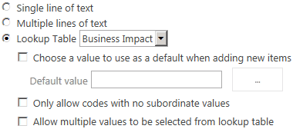

Custom Attributes – lookup table

The following table describes the lookup table options for custom fields.

| Attribute | Description |
| --- | --- |
| Lookup Table | The name of the Enterprise Custom Lookup Table that you want to associate with this custom field. Once you have associated a lookup table with a field and have saved it, you cannot remove the lookup table relationship. Therefore, make sure that you need the lookup table before you make this association. |
| Choose a value to use as a default when adding new items | If you want to have a default value included in this custom field in cases where the user does not specify one, select this check box, and then select the default value. |
| Default value | The default value to be used in this field when users do not specify a value. To set the value, click the browse button and select the desired value. |
| Only allow codes with no subordinate values | Select this option if you want to allow only values in the lookup table that have no subordinate values (that is, values at the lowest level of each branch). |
| Allow multiple values to be selected from lookup table | Select this option if you want to allow users to select more than one value from the lookup table. Once this selection has been made and saved, it cannot be removed. This option is not compatible with OLAP cubes. |

Note If you plan to create a custom field that refers to a lookup table, create the lookup table before creating the custom field.

You can use formulas to define your own parameters for how your Enterprise Custom Fields measure data or present information when they are used in a project. Formulas cannot be used with all types of Enterprise Custom Fields.

The formula option is available with all field types.

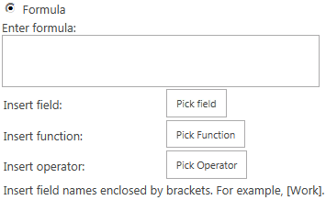

Custom Attributes - formula

Note Once a formula is associated with a custom field, it can be edited but it cannot be removed.

* To use a known formula, type the formula in the Edit formula box.
* To add a field to the formula, click Pick field, point to a field type, and then click the name of the field that you want to reference. To reference an existing Enterprise Custom Field, point to a field type, point again to a custom field type (such as Custom Date or Custom Finish), and then click the Enterprise Custom Field that you want.

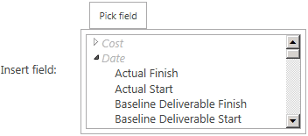

* To use a function in the formula, click Pick function, click a function type, and then click the function that you want. Each function includes placeholder arguments that you can replace with the fields and values that you want to use.

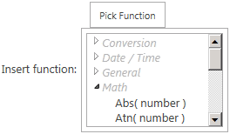

* To build a formula by using a standard set of operators, click Pick operator and choose the operator that you need. The formula can operate by using referenced fields, functions, or literal data.

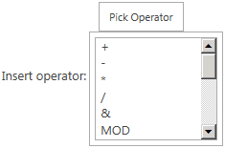

The following table describes the formula options.

| Attribute | Description |
| --- | --- |
| Enter formula | The formula you want to use. |
| Insert field | Inserts a field (cost, date, duration, flag, number, or text) into the formula. |
| Insert function | Inserts a function (conversion, date/time, general, math, Microsoft Project, or text) into the formula. |
| Insert operator | Inserts an operator (mathematical or Boolean) into the formula. |

#### Department

You can select a department to be associated with a custom field. Selecting a department allows you to limit a user’s ability to see the custom field if they are not a member of that department. If you do not specify a department, then all users will be able to see the custom field.

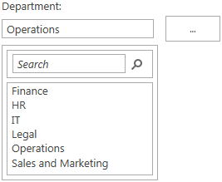

Custom fields department selector

The values available for Department are specified in the Department custom lookup table.

#### Calculation for Summary Rows

For entity types of Resource and Task, you can select options for the calculation of summary rows.



Summary row calculation options

Note that summary row calculation is not available with a field type of Text.

The following table describes the options for summary task calculation.

|  |  |
| --- | --- |
| Attribute | Description |
| None | Choose None if you do not want the custom field to be applied to summary and group summary rows. |
| Rollup | Choose Rollup to roll up the individual rows for the summary row. |
| Use formula | Choose Use formula to use a specific formula to calculate the summary row. You must specify the formula to use under Custom Attributes. |

#### Calculation for Assignment Rows

For resource types of Resource and Task, you choose to use a roll down calculation for assignment rows.



The following table describes the options for calculating assignment rows.

|  |  |
| --- | --- |
| Attribute | Description |
| None | Choose None if you do not want to roll down assignment rows. |
| Roll down, unless manually specified | Choose Roll down if you want data that is entered at the task or resource level to be rolled down and copied to each assignment with the same value. |

#### Values to Display

You can choose to display raw data or to have the data represented graphically.



Values to display - data

If you select Graphical indicators, you can select different criteria for Non-summary rows, Summary rows, and, if you are using an entity type of Project, Project summary.

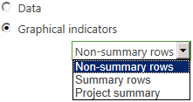

Graphical indicators options

When you select an option, further configurable parameters specific to that option are displayed.

The following table describes the options for graphical indicators.

|  |  |
| --- | --- |
| Attribute | Description |
| Non-summary rows | Choose Non-summary rows to specify criteria for graphical representation of data rows that are not summary rows. |
| Summary rows | Choose Summary rows to specify criteria for graphical representation of summary rows. |
| Project summary | Choose Project summary to specify criteria for graphical representation of the project summary. |

When you configure graphical indicators, you can specify the exact value and comparison parameters that determine when a particular graphic is used. The available comparison (test) parameters are as follows:

* Equals
* Does not equal
* Is greater than
* Is greater than or equal to
* Is less than
* Is less than or equal to
* Is within
* Is not within
* Contains
* Does not contain
* Contains exactly
* Is any value

These are used to compare the data value with a threshold value that you specify to determine which graphic to display. For example, you can configure values greater than or equal to 50 to display a green indicator and values less than 50 to display a red indicator.

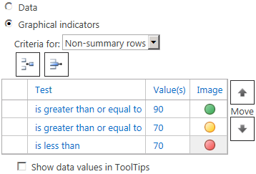

Graphical indicators

You can specify as many images for different values as required. Add a new row to the table for each test/value comparison. Rows in the table are evaluated from top to bottom and the image associated with the first row where the test/value combination is true is displayed.

The following table describes the graphical indicator options for non-summary rows.

|  |  |
| --- | --- |
| Attribute | Description |
| Test | Choose the operator (equals, less than, and so on.) to apply to the field value to determine the image to use. |
| Values | Type the field value or a field reference (for example, [cost]) that, combined with the operator in the test column, determines when to use the image in the Image column. |
| Image | Choose the image to display when the test/value combination is true. |
| Move | Use the move buttons to move a row up or down in the table. |
| Show data values in ToolTips | Select this attribute to show the field value in the tool tip associated with the image. |

When using graphical indicators for summary rows, you can choose to inherit the graphical indicator settings that you have defined for non-summary rows.

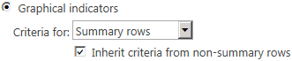

Graphical indicators – summary rows

If you select the Inherit criteria from non-summary rows check box when you configure graphical indicators for summary rows, the graphical indicator parameters that you configured for the non-summary rows are used.

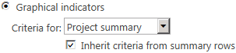

Graphical indicators – project summary

If you select the Inherit criteria from summary rows check box when configuring graphical indicators for project summary, the graphical indicator parameters you configured for the summary rows will be used.

#### Behavior

You can configure a custom field to be controlled by workflow or to require a value.

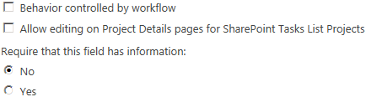

Behavior options

If you choose to have the custom field controlled by a workflow, the required field option is not be available because that behavior is controlled by workflow.

The following table describes the options for configuring custom field behavior.

| Attribute | Description |
| --- | --- |
| Behavior controlled by workflow | Select this check box if you want the custom field behavior to be controlled by workflow. |
| Allow editing on Project Detail pages for SharePoint Task List Projects | Select this option if you want this custom field to be available to users editing SharePoint task list projects. |
| Require that this field has information | Choose whether you want this to be a required field (that is, the field cannot be left blank). This option is not available if the Behavior controlled by workflow option is selected. |

### Creating Enterprise Custom Lookup Tables

Consider using custom lookup tables for any Enterprise Custom Field for which standardization of data is the most important factor. One project manager might enter Started, and another might enter In-Progress, both indicating that the project has begun and is underway. Without using lookup tables, it is difficult to standardize terminology in your organization.

For example, you might create a custom text field that is associated with Resources. To do this, you click the Resource option, select Text from the list, and rename it Manager. If you do not specify a lookup table for this custom text field, a user can enter any text value in the Manager field.

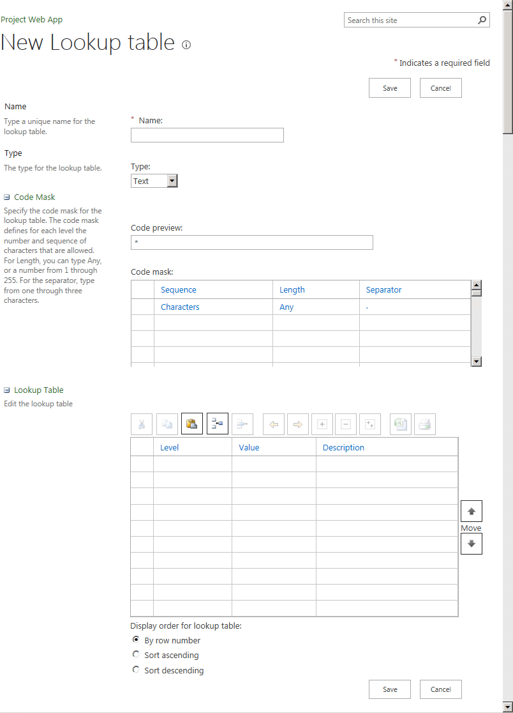

New custom lookup table page

The New Lookup table page allows you to specify the options for a custom lookup table. Use the following procedure to create a new enterprise custom lookup table.

* To create Enterprise Custom Lookup Tables

1. On the Project Web App home page, click Settings, and then click PWA Settings.
2. On the PWA Settings page, click Enterprise Custom fields and Lookup Tables.
3. In the Lookup Tables for Custom Fields section, click New Lookup Table.
4. Type a name for the lookup table in the Name box.
5. Fill out the New Custom Lookup Table page by specifying the options that you want to use. See the descriptions for each field in the following sections.
6. Click Save.

#### Type

You must specify a data type for each lookup table. It is not possible to mix field types in a table.

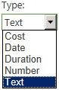

Lookup table types

The following table describes the options for data types in a custom lookup table.

|  |  |
| --- | --- |
| Attribute | Description |
| Cost | Each field in the table is a cost value. |
| Date | Each field in the table is a date value. |
| Duration | Each value in the table is treated as a duration. |
| Number | Each value in the table is a number. |
| Text | Each value in the table is text. Choosing Text also allows a hierarchy of values to be specified if you want. |

#### Code mask

The code mask option only appears when a field type of Text has been selected.

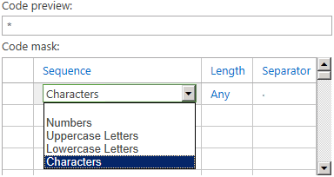

Code mask options

The code mask lets you specify what types of text characters appear in the lookup table, the length of the string, and what characters to use to separate levels in a hierarchy. If you are creating a hierarchical lookup table, you must specify a code mask for each level of the hierarchy.

The following table describes the options available for configuring code masks.

|  |  |
| --- | --- |
| Attribute | Description |
| Code preview | Displays a preview of the code mask for the table. |
| Sequence | Specify the type of text characters to allow. Choose Numbers, Uppercase characters, Lowercase characters, or Characters. |
| Length | Specify the maximum length of the string. Choose a number from 1 to 255 or Any. |
| Separator | Specify from one to three characters to use as a separator between levels of the table hierarchy. |

#### Lookup Table

Use the Lookup Table section of the New Lookup table page to specify the values in the lookup table.

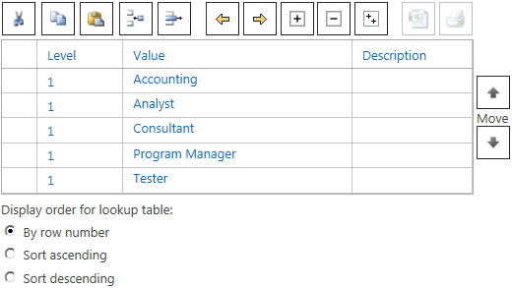

Lookup table options

Type each value that you want in the lookup table in the Value column. Create as many rows as needed to accommodate the values that you want to include. Optionally, include a description for the value in the Description column.

The following table describes the options for creating lookup table values.

|  |  |
| --- | --- |
| Attribute | Description |
| Level | Denotes the level in the hierarchy. This is a read-only field. Select the row and use the Indent and Outdent buttons to change levels. |
| Value | Specify the value of the field. |
| Description | Describes what the field represents. |
| Move | Use the Move buttons to change the position of rows in the table. Select a row and then click the Up or Down Move button to move a row. |
| Display order for lookup table | Species how to sort the lookup table. If you select By row number, the table will remain sorted as you specify it. If you choose to sort ascending or descending, the table is sorted based on the values in the Value column. |

## Departments

Both projects and resources can have departments. The main purpose of departments is to act as a filter for what custom fields are displayed to users within given areas of Microsoft Project Professional 2013 and Project Web App. Departments allow for different business units to define and make visible their own set of custom fields. Departments are also used to filter OLAP databases so that only the data for that department is loaded.

When you configure a cube, you can specify both the project and resource departments so that the database data is filtered based on these criteria. These values are specified in the OLAP Database Build Settings page.

Also, within the OLAP database configuration, you can add the Project department field as a dimension to the Project and Tasks cubes. And you can add the Resource department field as a dimension to the Resource cube as long as the department field has not been converted to a multi-value field.

With Project Web App, departmental custom fields help relieve the problem of too much information and too many choices. Departments help you manage the custom field list, and help you define, at a resource, task, or project level, which fields are required or not required.

In Project Web App, fields can be globally scoped or they can be scoped to a specific department.

Departmental fields enable two primary functions:

* Filtering custom fields so that a user sees, by default, only those fields that are either global to the system or in the department that the user belongs to.
* Controlling which fields require input.

Example of departments in use

| Field | Scope | Department | Required? |
| --- | --- | --- | --- |
| ProjectCustomText1 | Global | - | No |
| ProjectCustomText2 | Global | - | Yes |
| ProjectCustomText3 | Department | Marketing | No |
| ProjectCustomText4 | Department | Marketing | Yes |
| ProjectCustomText5 | Department | Development | Yes |
| ProjectCustomText6 | Department | Development | No |

If John Woods belongs to the Development department, then when he views areas of the product that have departmental custom fields enabled, he sees the following:

* ProjectCustomText1
* ProjectCustomText2
* ProjectCustomText5
* ProjectCustomText6

John will be required to enter data into ProjectCustomText2 and ProjectCustomText5.

Cindy White belongs to the Marketing department. When she views areas of the product that have departmental custom fields enabled, she sees the following:

* ProjectCustomText1
* ProjectCustomText2
* ProjectCustomText3
* ProjectCustomText4

Cindy will be required to enter data into ProjectCustomText2 and ProjectCustomText4.

By default, departments filter the list of custom fields that John Woods and Cindy White see. But the filter does not prevent them from viewing custom fields assigned to the other departments.

Important Departmental fields are not tied into security. You cannot use them with security categories and groups to enable or disable fields and their functions. Instead, their main purpose is to filter out fields which are not useful for the target user.

Department considerations for cubes

| Which cubes are filtered by which value | No project department specified | Project department specified |
| --- | --- | --- |
| No resource department specified | All data is loaded for all cubes | Project non-timephased cube  Task non-timephased cube  Issues cube  Risks cube  Deliverables cube  MSP_Project_WSS virtual cube  MSP_Project_Timesheet virtual cube  MSP_Portfolio_Analyzer virtual cube  Assignment non-timephased cube  Assignment timephased cube  EPM timesheet cube |
| Resource department specified | Assignment non-timephased cube  Assignment timephased cube  Resource non-timephased cube  Resource timephased cube  Timesheet cube  MSP_Project_Timesheet virtual cube  MSP_Portfolio_Analyzer virtual cube | Filtered by Project Department:   * Project non-timephased cube * Task non-timephased cube * Issues cube * Risks cube * Deliverables cube * MSP_Project_WSS virtual cube   Filtered by Resource & Project Department:   * Assignment non-timephased cube * Assignment timephased cube * EPM timesheet cube * MSP_Project_Timesheet virtual cube * MSP_Portfolio_Analyzer virtual cube   Filtered by Resource Department:   * Resource no- timephased cube * Resource timephased cube * Timesheet cube |

Cubes include assignments for resources in projects that belong to other departments or to no department. This ensures that all data is present when examining data such as a department's resources full calendar capacity.

The subset of projects and resources will be used to filter at the project and timesheet level as follows:

Project non-timephased:

* The data in this cube will be filtered by the departmental project list.
* Projects with assignments to the department’s resources will be included.

Task non-timephased:

* Non-departmental tasks with assignments to the department's resources will be included. The full non-departmental project will not be included.
* All tasks for departmental projects will be included.

Assignment non-timephased:

* Non-departmental project assignments for the department’s resources will be included.
* All assignments for departmental projects will be included.

Assignment timephased:

* Non-departmental project assignments for the department's resources will be included.
* All assignments for departmental projects will be included.

Deliverables:

* All deliverables owned by the filtered list of projects will be included.
* All deliverables to which the filtered list subscribes and the projects/tasks that subscribe to the filtered list's deliverables will be included.
* All deliverables offered by non-departmental projects that are subscribed to by departmental projects will be included.

Issues:

* Issues connected to the filtered list of projects and tasks will be included.

Risks:

* Risks connected to the filtered list of projects and tasks will be included.

Resource non-timephased:

* Resources in the departmental list will be included.

Resource timephased:

* Resources in the departmental list will be included.

Timesheet:

* Timesheets for departmental list resources will be included.

EPM Timesheet:

* Timesheets for departmental list resources will be included.
* Task assignments from projects outside the department will be included.

Resources are described in three ways in the OLAP databases:

* Fact focus (timesheets, capacity)
* Associated with Facts (project task assignments)
* Owning Facts (project owner, issue owner, assignment owner)

The departmental resource list is used to filter facts with focus (Timesheets). Consequently, a non-departmental resource will never have any timesheets or capacity in the OLAP database if the database has a resource filter. However the non-departmental resource will be in the Resource List dimension if it has association with a departmental project, and will only have the relevant assignment facts.

Resources who own things that have separate dimensions (that is, Assignment Owner) do not have to be in the resource list. The Resource List dimension for a specific OLAP database contains:

* The departmental resources
* All resources with assignments to departmental projects

### Configuring departments

Departments are configured using a built in Enterprise Custom Lookup Table called Departments. By configuring values in this table, you can define a hierarchy of departments for your organization.

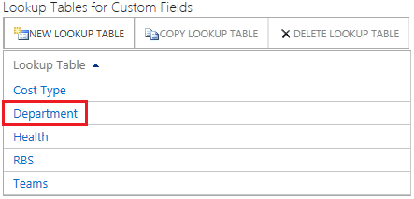

Department custom lookup table

Use the following procedure to add initial values to the Department custom lookup table or to modify it.

* To modify the Department lookup table

1. On the Project Web App home page, click Settings, and then click PWA Settings.
2. On the PWA Settings page, click Enterprise Custom Fields and Lookup Tables.
3. On the Enterprise Custom Fields and Lookup Tables page, under Lookup Tables for Custom Fields, click Department.
4. In the Code Mask section, create a code mask for each level of the hierarchy that you plan to have for the Department lookup table:
5. In the Sequence column, choose Characters from the dropdown list.

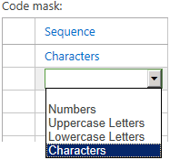

1. Keep the defaults for the Length and Separator columns.

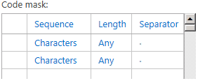

1. In the Lookup Table section, type a Value and optionally a Description for each Department.

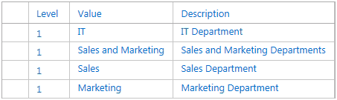

1. If you are creating a hierarchy with more than one level, use the Indent and Outdent buttons to change the level values for each department as required for you hierarchy.

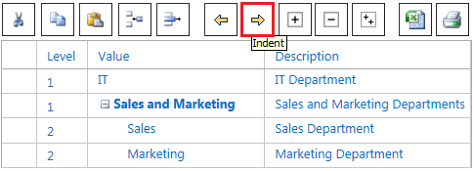

1. Click Save.

## Resource Breakdown Structure (RBS)

The Resource Breakdown Structure (RBS) is a hierarchical structure typically based on the management reporting structure of your organization, although it can also be structured in other ways. The RBS can be an important element in your Project Web App security model when it is used to define the reporting relationships among users and projects in your organization. When you specify an RBS value for each Project Web App user, you can take advantage of the dynamic security options that can be defined for each security category.

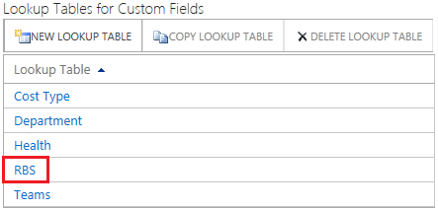

RBS custom lookup table

The RBS structure is defined by adding values to the RBS custom lookup table that is built in to Project Web App. Once you define the structure, you can assign RBS values to individual users by setting the RBS property in the user's account settings page.

Once the RBS is configured, Categories can use RBS codes to dynamically determine which projects and resources particular users can view or access.

Dynamic filtering based on RBS code can be applied to projects in the following ways:

* Users can see projects owned by their descendants in the RBS
* Users can see projects on which their descendants in the RBS are a resource
* Users can see projects owned by other users with the same RBS value

Dynamic filtering based on RBS can applied to resources in the following ways:

* Users can see their descendants in the RBS
* Users can see their direct descendants in the RBS
* Users can see other users with the same RBS value

Use the following procedure to create a new Resource Breakdown Structure or to modify an existing one.

* To modify the Resource Breakdown Structure

1. On the Project Web App home page, click Settings, and then click PWA Settings.
2. On the PWA Settings page, click Enterprise Custom Fields and Lookup Tables.
3. On the Enterprise Custom Fields and Lookup Tables page, under Lookup Tables for Custom Fields, click RBS.
4. In the Code Mask section, create a code mask for each level of the hierarchy that you plan to have for the Department lookup table:
5. In the Sequence column, choose Characters from the dropdown list.



1. Keep the defaults for the Length and Separator columns.



1. In the Lookup Table section, type a Value and optionally a Description for each Department.

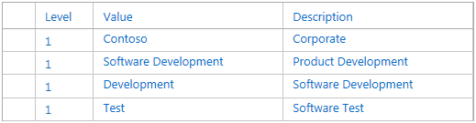

1. If you are creating a hierarchy with more than one level, use the Indent and Outdent buttons to change the level values for each department as required for you hierarchy.

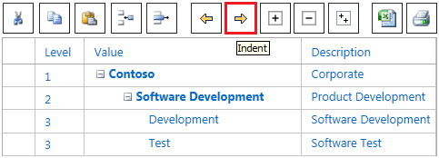

1. Click Save.

## Enterprise Calendars

Enterprise calendars capture the predefined working hours, holidays, and other schedule details within an organization. They are used to standardize the working time for all of an organization’s projects. In Project Web App, you can view a list of existing calendars, select a calendar to edit, or begin the process of creating a new calendar. However, to create or modify a calendar, you must have Project Professional 2013 installed on the computer that you are using to access Project Web App.

**A best practice is to modify the Standard calendar** as the main calendar for your organization. The **Standard** calendar is the default base calendar in Project Server. By modifying the **Standard** calendar to include your organizations holidays and hours, you save having to select a different calendar each time you create a project or resource.

### Create a new calendar

Project Server uses a standard enterprise calendar for scheduling, by default. Some organizations may use multiple calendars. For example, if some of your organization’s employees work in another country, those workers will likely observe different holidays, and so will need a different enterprise calendar for scheduling project work. You can create a new, blank enterprise calendar using Project Web App and Project Professional 2013.

To create a new, blank enterprise calendar

1. Click Settings  > **PWA Settings**.
2. Under Enterprise Data, click Enterprise Calendars.
3. Click **New Calendar**.

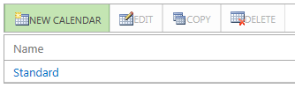

Project Professional 2013 opens and displays the **Change Working Time** dialog box.

1. Type a name for the new calendar in the **For calendar** box.



1. Use the calendar with the **Exceptions** and **Work Weeks** tabs to modify the working and nonworking times for your organization. For more information, see the “Modify Working and Nonworking Times” section of this guide.
2. Click **OK** on the **Change Working Time** dialog box to save the new calendar to Project Server.
3. Close Project Professional 2013.

### Copy an existing calendar

If an existing calendar has many of the same holidays and other calendar items that you want to use in a new calendar, you can base a new calendar on an existing calendar. Copy the existing calendar in Project Web App, and then modify the copy in Project Professional 2013. For example, if the standard calendar in your organization captures all of your organization’s unique holidays and events, but you need a separate calendar to reflect a 24/7 working schedule, you can copy the standard calendar and then modify it for the 24/7 schedule.

To create a new calendar as a copy of an existing calendar

1. Click Settings  > **PWA Settings**.
2. Under Enterprise Data, click Enterprise Calendars.
3. Click the row containing the calendar you want to copy, and then click **Copy**.

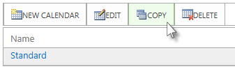

1. On the **Copy Calendar** dialog box, type a name for the new calendar in the box, and then click **OK**. The calendar is added to the list on the **Enterprise Calendars** page.

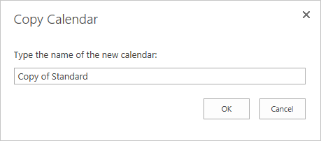

1. Click the row containing the new, copied calendar, and then click **Edit Calendar**.

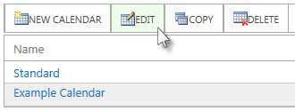

Project Professional 2013 opens and displays the **Change Working Time** dialog box.

1. Use the calendar with the **Exceptions** and **Work Weeks** tabs to modify the working and nonworking times for your organization. For more information, see the “Modify Working and Nonworking Times” section of this guide.
2. Click **OK** on the **Change Working Time** dialog box to save the new calendar to Project Server.
3. Close Project Professional 2013.

### Edit an existing calendar

As you are initially configuring Project Server, you can modify the default standard enterprise calendar to account for the working and nonworking times observed by your organization. You can modify any enterprise calendar at any time by selecting the calendar in Project Web App, and making changes in Project Professional 2013.

To modify an existing enterprise calendar

1. Click Settings  > **PWA Settings**.
2. Under Enterprise Data, click Enterprise Calendars.
3. Click the row containing the new, copied calendar, and then click **Edit Calendar**.



Project Professional 2013 opens and displays the **Change Working Time** dialog box.

1. Use the calendar with the **Exceptions** and **Work Weeks** tabs to modify the working and nonworking times for your organization. For more information, see the “Modify Working and Nonworking Times” section of this guide.
2. Click **OK** on the **Change Working Time** dialog box to save the new calendar to Project Server.
3. Close Project Professional 2013.

### Delete a calendar

If you find your organization is not using a specific enterprise calendar, you can easily delete it in Project Web App.

To delete an enterprise calendar

1. Click Settings  > **PWA Settings**.
2. Under Enterprise Data, click Enterprise Calendars.
3. Click the row containing the calendar you want to delete, and then click **Delete Calendar**.

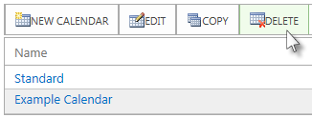

1. When prompted, click **OK** to delete the selected calendar.

**Note** If the calendar is currently in use, a notification will appear.

### Modify Working and Nonworking Times

When working with calendars in Project Professional 2013, there are a few different things you can do to accurately account for working and nonworking time in your organization. The following sections provide examples for each type of change, and walk you through the steps involved with making each change.

#### Change a working day into a nonworking day

Occasionally, you may need to turn a working day into a nonworking day. For example, if your organization observes specific days as holidays, you can turn those holidays into nonworking days. Project Server will not schedule work on nonworking days.

To change a working day into a nonworking day

1. Click the date on the calendar that you want to turn into a nonworking day.

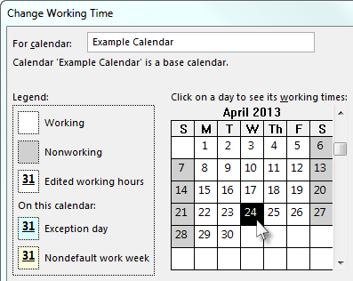

1. On the **Exceptions** tab, type a name for the nonworking day in the **Name** column. The **Start** and **Finish** columns are automatically populated with the date you clicked in Step 1.

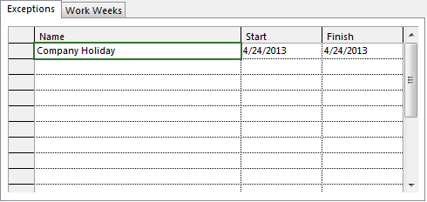

**Note** While you can create multiple exceptions that contain a specific day, only the lowest-level exception will apply on that day. For example, you might have one exception that changes the standard working times for a month, and another exception that calls out a specific day within that month as a nonworking day. Because the single-day exception is at a lower level than the month-long exception, the single nonworking day exception will be applied on that day. You cannot create multiple single-day exceptions on the same day.

#### Change a nonworking day into a working day

There may be times when your organization has to work on what would otherwise be a nonworking day. For example, say your organization participates in a convention each year that takes place over a weekend. You can turn the weekend days of the convention into working days, so that Project Server knows to schedule work on those days.

To change a nonworking day into a working day

1. Click the date on the calendar that you want to turn into a nonworking day.

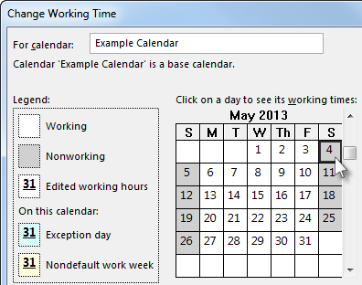

1. On the **Exceptions** tab, type a name for the working day in the **Name** column, and then press **Enter**.

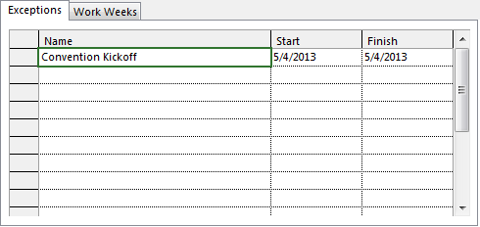

**Note** While you can create multiple exceptions that contain a specific day, only the lowest-level exception will apply on that day. For example, you might have one exception that changes the standard working times for a month, and another exception that calls out a specific day within that month as a nonworking day. Because the single-day exception is at a lower level than the month-long exception, the single nonworking day exception will be applied on that day. You cannot create multiple single-day exceptions on the same day.

1. Click the row you added for the working day, and then click **Details**.

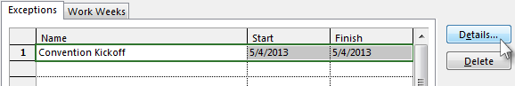

1. Under **Set working times for these exceptions**, click **Working times**, and then set the working times for that day by adjusting the times in the **From** and **To** columns.

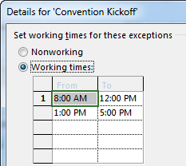

1. If your organization observes these working times on a regular basis (for example, once a month or once a year), under **Recurrence pattern**, choose whether these times should recur **Daily**, **Weekly**, **Monthly**, or **Yearly**, and then set the following options:

* **Daily** Set the frequency for these working times. For example, every 10 days.

**Tip** If you find that the working day exception is happening very frequently, you may find it easier to change the default calendar options under **Schedule** on the **Project** **Options** dialog box in Project Professional 2010. All calendars begin with these default days and times. It may be easier to change the default calendar options than to set up exceptions that recur frequently.

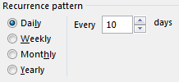

* **Weekly** Specify how often you want the working times to recur, and on what day of the week you want them to recur. For example, every two weeks on Saturday.

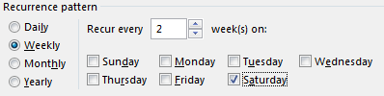

* **Monthly** Choose what day of the month and at what monthly frequency you want the working times to recur. For example, day 15 of every 3 months, or the third Saturday of every 6 months.

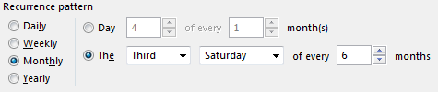

* **Yearly** Choose what day of the year you want the working times to recur. For example, May 4, or the third Saturday of July.

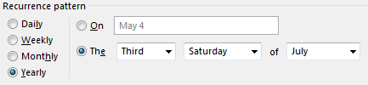

1. Under **Range of recurrence**, choose the period when you want the recurrence to take place, if appropriate.

* **Start** Choose the date when you want the recurrence pattern to begin.
* **End after** If you want the recurrence to happen only a set number of times, choose **End after**, and then type the number of instances when the working times should occur.
* **End by** If you want the recurrence to happen only during a certain time period, choose **End by**, and then choose when the recurrence should stop.

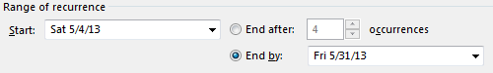

1. Click **OK**.

#### Change the working times for a working day

While the specific days on the calendar may be accurately accounted for as working and nonworking, there may be working days that use a different time schedule than the typical 8-hour work day. You can adjust the working times for a specific working day so that work is accurately scheduled on that day.

To change the working times for a working day

1. Click the date on the calendar for the working day that you want to adjust.



1. On the **Exceptions** tab, type a name for the changed working day in the **Name** column, and then press **Enter**.

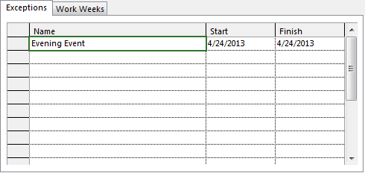

**Note** While you can create multiple exceptions that contain a specific day, only the lowest-level exception will apply on that day. For example, you might have one exception that changes the standard working times for a month, and another exception that calls out a specific day within that month as a nonworking day. Because the single-day exception is at a lower level than the month-long exception, the single nonworking day exception will be applied on that day. You cannot create multiple single-day exceptions on the same day.

1. Click the row you added for the changed working day, and then click **Details**.

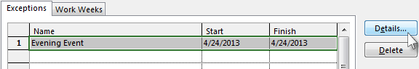

1. Under **Set working times for these exceptions**, click **Working times**, and then set the working times for that day by adjusting the times in the **From** and **To** columns.

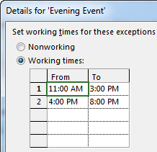

1. If your organization observes these working times on a regular basis (for example, once a month or once a year), under **Recurrence pattern**, choose whether these times should recur **Daily**, **Weekly**, **Monthly**, or **Yearly**, and then set the following options:

* **Daily** Set the frequency for these working times. For example, every 10 days.

**Tip** If you find that the working day exception is happening very frequently, you may find it easier to change the default calendar options under **Schedule** on the **Project** **Options** dialog box in Project Professional 2010. All calendars begin with these default days and times. It may be easier to change the default calendar options than to set up exceptions that recur frequently.



* **Weekly** Specify how often you want the working times to recur, and on what day of the week you want them to recur. For example, every two weeks on Saturday.



* **Monthly** Choose what day of the month and at what monthly frequency you want the working times to recur. For example, day 15 of every 3 months, or the third Saturday of every 6 months.



* **Yearly** Choose what day of the year you want the working times to recur. For example, May 4, or the third Saturday of July.



1. Under **Range of recurrence**, choose the period when you want the recurrence to take place, if appropriate.

* **Start** Choose the date when you want the recurrence pattern to begin.
* **End after** If you want the recurrence to happen only a set number of times, choose **End after**, and then type the number of instances when the working times should occur.
* **End by** If you want the recurrence to happen only during a certain time period, choose **End by**, and then choose when the recurrence should stop.



1. Click **OK**.

#### Change the working times for each day of a work week

If your organization has a specific work week (or set of work weeks) when the working times are different from the default, you can make those changes to the working times for each day in a work week, during a set period of time. For example, if your organization does not use the default Monday through Friday, 8am to 5pm schedule, you can change the working times for each day in the work week to reflect your organization’s accurate schedule.

To change the working times for each day of a work week

1. Click the date on the calendar when you want the changed working times to begin.

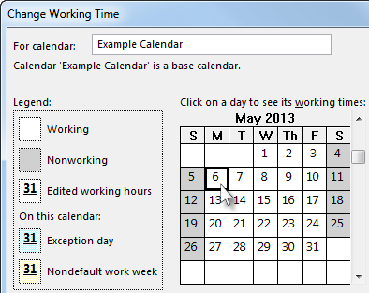

1. On the **Work Weeks** tab, type a name for the changed work week(s) in the **Name** column, and then press **Enter**.

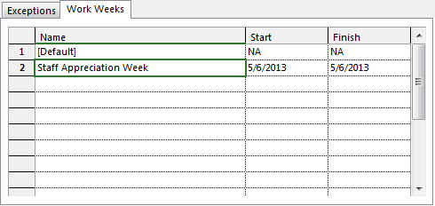

1. Change the date in the **Finish** column for the row you just added, to reflect the last day that you want to include in the changed work week(s).

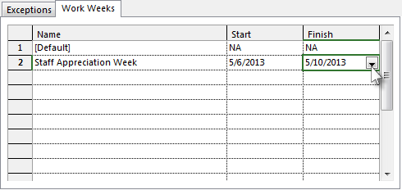

1. Click **Details**.

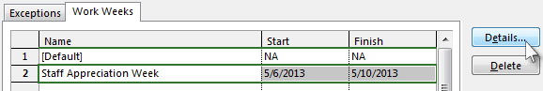

1. Under **Select day(s)**, click the day of the week that you want to use adjusted working times. Press **Ctrl** and click, or press **Shift** and click to select multiple days.

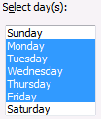

1. If you want to turn the selected day(s) into nonworking time, click **Set days to nonworking time**.



1. If you want to change the working times for the selected day(s), click **Set day(s) to these specific working times**, and then set the working times by typing in the **From** and **To** columns.

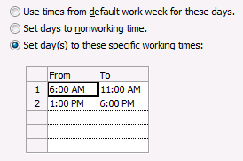

1. Click **OK**.

## Resource Center

The **Resource Center** is a view in Project Web App that can be used to create new resources and modify existing ones. It can be accessed from the **PWA Settings** page.

**Tip** Depending on how your organization has Project Web App configured, you may also be able to access the Resource Center from the Quick Launch.

### Create a new resource

When you create a new Project Web App user, you can choose to also make that user a resource. However, sometimes you may want to create a resource that cannot log on to Project Web App. For example, you may want to add a material resource, such as a conference room, that has no need to be able to log on to Project Web App. Project managers can still assign the resource to work, but if there is not any work to track, and the project manager can account for when the resource is actually used, there is not a need for that resource to also be a user.

To create a new resource

1. Click Settings  > **PWA Settings**.
2. Under Enterprise Data, click Resource Center.
3. Click **Resources** > **New**.

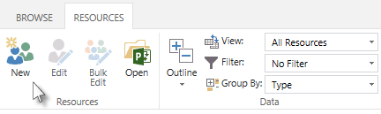

1. In the **Type** section, complete the following:

* **Type** Choose whether you are creating a **Work**, **Material**, or **Cost** resource.
* **Budget** If the resource is a budget resource, select the **Budget** check box.
* **Generic** If the resource is generic, meaning that you will use it for planning purposes and replace it with at least one named resource further in the planning process, select the **Generic** check box.

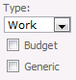

1. In the **Identification Information** section, complete the following:

* **Associate resource with a user account** Select this check box if you want the resource to also be a Project Web App user.
* **Display Name** Type the resource’s name in this box. This field is required.
* **Email address** If this resource has an email address that he or she wants associated with project work, type the address in this box.
* **RBS** If your organization uses a resource breakdown structure (RBS), click the button next to this field and choose the appropriate RBS code for this resource from the list.
* **Initials** This field is automatically populated with the resource’s initials, based on the name typed in the **Display Name** box. If you want to use different initials to refer to this resource, type them in the **Initials** box.
* **Hyperlink Name** If this resource has an associated Web site, type the name of that site in this box.
* **Account Status** If you want the new resource to be available to assign to projects and tasks right away, leave this set to **Active**. You can change this to **Inactive** if you don’t want the resource to be available right away.

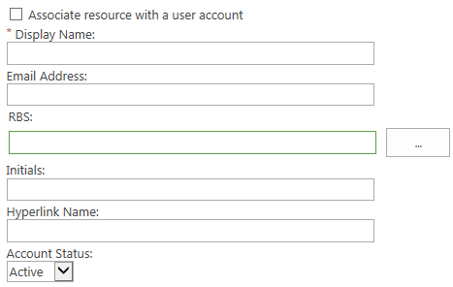

1. In the **Assignment Attributes** section, complete the following:

* **Resource can be leveled** If you want to enable project managers to balance this resource’s workload based on his or her availability and assignments (leveling), select this check box.
* **Base Calendar** Choose the calendar that most closely represents this resource’s overall availability. For example, if your organization has a base calendar that accounts for specific holidays or events, you can set that as this resource’s calendar, and work assigned to this resource will be scheduled around the calendar’s nonworking days.
* **Default Booking Type** Choose whether you want this resource to be **Committed** or **Proposed** when assigning work.
* **Timesheet manager** Type the name of the person who approves or rejects this resource’s timesheets, or click **Browse** to choose the timesheet manager from a list. Resources may not have separate timesheet managers.
* **Default Assignment Owner** Type the name of the person who approves or rejects this resource’s task progress, or click **Browse** to choose the assignment owner from a list. Resources may not have separate assignment owners. For example, if the resource is a conference room, and the project manager tracks the amount of time that the conference room is used, the assignment owner may be the project manager.

**Tip** You can set the assignment owner within the project on an assignment-by-assignment basis.

* **Earliest Available** Choose the date when the resource becomes available to assign to tasks, if appropriate. If the resource does not have a set period of availability (that is, if he or she is always available), leave this blank.

**Note** The earliest and latest available dates correspond to the resource availability dates for a resource, as seen in Project Professional.

* **Latest Available** Choose the last date that the resource is available to work on tasks, if appropriate. If the resource does not have a set period of availability (that is, if he or she is always available), leave this blank.
* **Standard Rate** Type the resource’s standard pay rate in this box.
* **Overtime Rate** Type the resource’s overtime pay rate in this box.
* **Current Max. Units (%)** Specify the maximum amount of time that a resource is available for work, as a percentage. For example, if the resource is available full-time, type 100%. If the resource is available half-time, type 50%.
* **Cost/Use** If the resource has a flat fee associated with each use, type that cost in this box. For example, a van rental may require a flat fee upfront, with an added standard cost per mile. The flat fee is its cost per use.

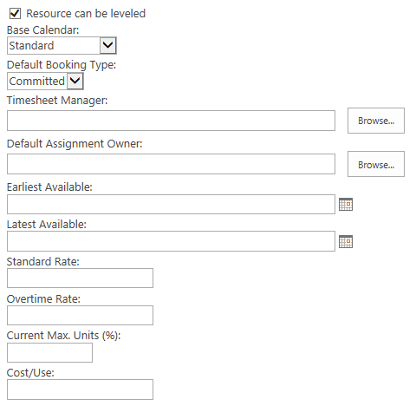

1. In the **Departments** section, click the button next to the **Resource Departments** box, and choose which department(s) the resource is associated with. If the resource is not associated with a particular department, leave this blank.

**Tip** Associating a resource with a department narrows down what the resource sees when using Project Web App. It can help the resource find what he or she is looking for more quickly, by removing things from other departments that do not apply to his or her work.



1. If your organization created codes for grouping and costing purposes, in the **Group Fields** section, complete the following:

* **Group** Type the name of the group in this box.
* **Code** Type the code for the group in this box.
* **Cost Center** Type the cost center code for the group in this box.
* **Cost Type** Click the button next to the **Cost Type** field, and then choose the type of cost associated with this group.

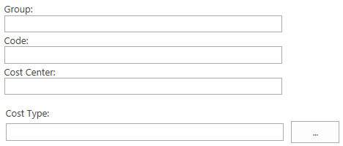

1. In the **Team Details** section, click the button next to the **Team Name** box, and choose which team the resource belongs to, if appropriate. If the resource will be managing and delegating tasks that are assigned to the team, select the **Team Assignment Pool** check box.

**Tip** Some organizations create a generic resource for each team, so that tasks assigned to the team first go to the generic resource. This way, no single resource takes on the task assignment before it is appropriately delegated. If you choose to use a generic resource in this way, set the assignment owner for the resource as the team manager, select the **Team Assignment Pool** check box, and choose the team from the **Team Name** list.

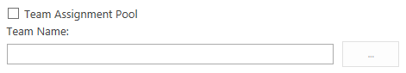

1. In the **System Identification Data** section, type additional identifying information for the user in the **External ID** box, if appropriate.

For example, your organization’s HR department may use employee ID numbers to track data in their HR systems. By providing that ID number in the **External ID** box, you identify an association between the resource that you are creating and the HR department’s employee data. The **External ID** box can also be used to facilitate the consolidation of reporting of resource use beyond what Project Server provides.

**Tip** If you are not sure whether you should be capturing any data in the **External ID** box, check with other departments in your organization to find out if it would be useful to connect resource data with other systems, or simply leave this box blank.

1. Click **Save** to create the new resource.

### Edit an existing resource

Once a resource is added, you may find that you need to make changes to the resource’s information. Perhaps the resource had a rate change, or needs to use a different base calendar.

To edit a resource

1. Click Settings  > **PWA Settings**.
2. Under Enterprise Data, click Resource Center.
3. Select the check box in the left column for the row containing the resource you are editing. Be sure to clear any resources you may have already had selected, so that you don’t edit those, as well.

**Tip** If your organization has a lot of resources and you cannot easily find the one you want to edit, you can filter the **Resource Center**. On the **Resources** tab, in the **Data** group, click **Custom Filter** in the **Filter** list. Identify the parameters for the resource you are editing, and then click **OK**.

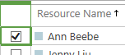

1. Click **Resources** > **Edit**.

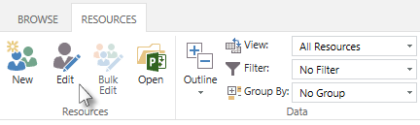

1. Make changes to the resource data, as needed, and then click **Save**.

In some cases, several resources may require the same change. For example, if several resources use the same timesheet manager, and that person takes a job elsewhere, you will need to replace the timesheet manager for those resources with whoever steps in as a replacement. Project Web App supports bulk editing of several resources at once. You can bulk edit the **Timesheet manager**, **Default Assignment Owner**, **RBS**, **Team Name**, **Cost Type**, and **Resource Departments** fields.

**Tip** Another good way to edit many resources simultaneously is by using Project Professional 2013. By making changes through the Project Professional 2013, you can add fields that you will not see if you make bulk changes through Project Web App, and you can also copy and paste from Microsoft Excel or another list.

To make the same change to several resources simultaneously

1. Click Settings  > **PWA Settings**.
2. Under Enterprise Data, click Resource Center.
3. Select the check box in the left column for each row containing a resource you are editing.
4. Click **Resources** > **Bulk Edit**.

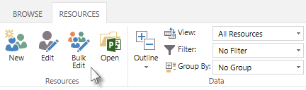

1. For each field that you want to edit, select the **Apply Changes** check box, to the left of the field, and then make your changes.

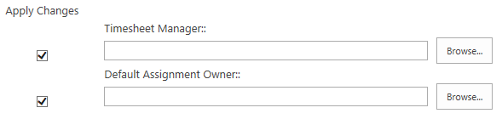

**Tip** If you are having trouble remembering which resources you are editing, expand the **Resources Selected** section. This section displays a list of all resources that will be changed when you click **Save**.

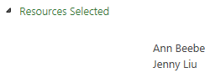

1. Click **Save** to save your changes to all selected resources.

3

# **Queue and Database Administration: Project Web App Settings**

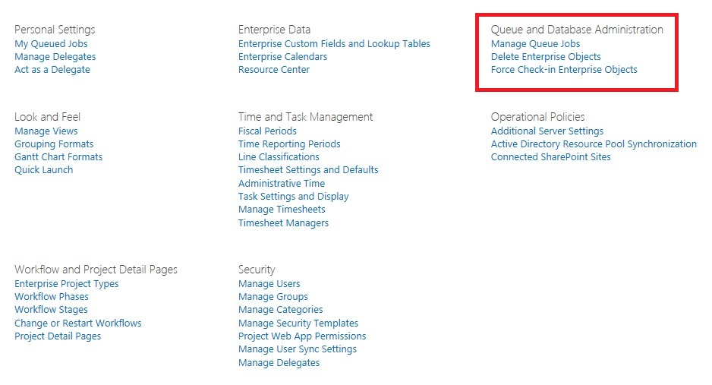

The Queue and Database Administration settings in the Project Web App settings page

The Queue and Database Administration settings are located in the Project Web App Server Settings page and allow you to manage the following server settings:

* Manage Queue Jobs
* Delete Enterprise Objects
* Force Check-in Enterprise Objects

## Manage Queue Jobs

The Manage Queue Jobs page lets you view Project Server 2013 operations ("jobs") that have been processed by the queue system. You can use the configuration options to filter jobs and only see the jobs that you are interested in viewing. You can also retry or cancel jobs through this page.

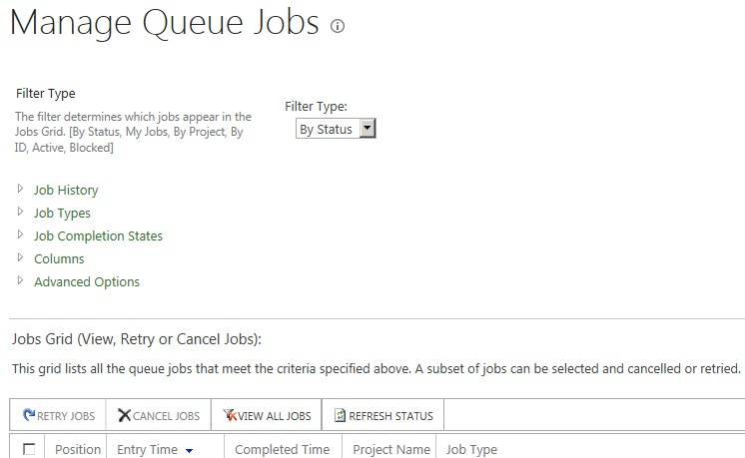

The Manage Queue Jobs page

The Project Server 2013 Manage Queue Jobs settings are available through both the Project Server 2013 Project Web App settings and in the SharePoint Central Administration page in the General Application Settings. They were previously located in the Project Web App (PWA) Server Settings page in Project Server 2010.

### Use the Manage Queue Jobs settings

The Manage Queue Jobs page lets you view, retry, or cancel jobs in the queue through the Jobs Grid. Viewable jobs are displayed according to the settings you select in the Manage Queue Jobs page. The configuration settings on the Manage Queue Job page include the following:

* Filter Type
* Job Types
* Job History
* Job Completion States
* Columns
* Advanced Options

#### Filter Type

The Filter Type configuration option lets you select filters to query for specific types of jobs that will appear in the Jobs Grid. The filters available in the Filter Type drop-down list are as follows:

* **By Status** Displays jobs in the queue in order by status. This is the default setting.
* **My Jobs** Displays only the jobs initiated by you.
* **By Project** Displays jobs in the queue in order by project.
* **By ID** Displays jobs in the queue in order by Job ID.
* **Active** Displays all jobs that have a status of **Active**.
* **Blocked** Displays all jobs that have a status of **Blocked**.

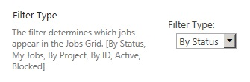

Filter Type

Use the following procedure to select a filter type.

* To select a filter

1. On the Manage Queue Jobs page, in the **Filter Type** section, click the **Filter Type** drop-down list and select the type of filter you want to use to determine which jobs display in the Jobs Grid.
2. In the Jobs Grid, select **Refresh Status**.

Jobs in the Jobs Grid appear according to the filter type that you select. For example, if you select the By Status filter, jobs are listed alphabetically by status.

#### Job History

This configuration option enables you to select the date range of jobs that appear in the Jobs Grid. Use the From and To fields to select a beginning and end data. The default selection is to select the one-day date range for the present date.

You can use the Maximum Number of Jobs field to limit the number of jobs that appear for a given date range. If the selected date range contains a very large number of jobs that have to appear in the Jobs Grid, the load time for the Manage Queue Jobs page can be very long. The Maximum Number of Jobs field lets you limit the jobs that appear. The default setting is 500.

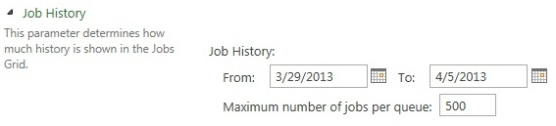

Job History

Use the following procedure to configure the Job History settings.

* To configure the Job History setting

1. On the Manage Queue Jobs page, in the **Job History** section, specify the following values:

* In the **From** field, specify the start date for which you want jobs to appear in the Jobs Grid. You can also click the calendar icon to select a start date.
* In the **To** field, specify the end date for which you want jobs to appear in the Jobs Grid. You can also click the calendar icon to select an end date.

1. In the Maximum number of jobs per queue box, you can specify the maximum number of jobs that you want to display. The default value is 500.
2. In the Jobs Grid, click **Refresh Status**.

#### Job Types

The Job Types configuration option lets you select the type of job (for example, Project Create, Timesheet Submit, Notifications, and so on) that you want to appear in the Jobs Grid. By default, all job types are listed in the Selected Jobs list.

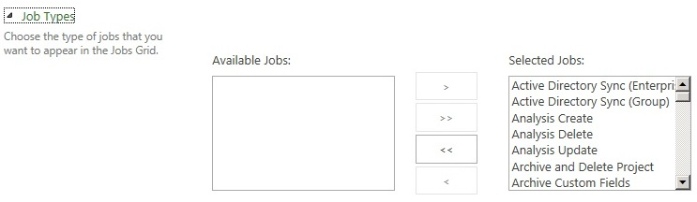

Job Types

Use the following procedure to configure the Job Types setting.

* To configure the Job Types setting

1. On the Manage Queue Jobs page, in the **Job Types** section:

* If you want to keep certain job types from appearing in the Jobs Grid, from the **Selected Jobs** list, select the job types that you do not want to appear in the Jobs Grid, and then click **Remove**. (This action moves the selected job types to the **Available Jobs** list.) Click **Remove All** if you want to remove all job types from the **Selected Jobs** list.
* If you want to add jobs types to the Jobs Grid, from the **Available Jobs** list, select the job types that you want to appear in the Jobs Grid, and then click **Add**. This action moves the selected job types to the **Selected Jobs** list. Click **Add All** if you want to add all job types to the **Selected Jobs** list.

1. In the Jobs Grid, click **Refresh Status**.

#### Job Completion States

The Job Completion States configuration option lets you select the job states (for example, Success, Blocked Due to a Failed Job, Processing, and so on) of the jobs that you want to appear in the Jobs Grid. By default, all job types except Success are listed in the Selected Jobs list, since Project administrators would be more interested in job types that signify a failure or blocking issue.

You can add or remove different job states to and from the Selected Job States list and the Available Job States list. The Jobs Grid will query for jobs in the job stats listed in the Selected Job States list.

This setting can be helpful for troubleshooting jobs that are not completing successfully in the queue. For example, some users might have experienced problems over the past several days. You can see specifically which jobs are not completing successfully by going to the Job Completion States setting and adding all job states except Success. You can also select a Job History date range that begins shortly before the problems occurred (for example, seven days). In this scenario, the Jobs Grid should display information about all jobs that are in a non-successful job status that have occurred over the past week.

The Job Completion states that you can select for this setting are as follows:

* Blocked Due to a Failed Job
* Cancelled
* Failed and Blocking Correlation
* Failed but not Blocking Correlation
* Getting Queued
* Processing
* Skipped for Optimization
* Success
* Waiting to be Processed
* Waiting to be Processed (On Hold)
* Waiting to be Processed (Ready for Launch)
* Waiting to be Processed (Sleeping)

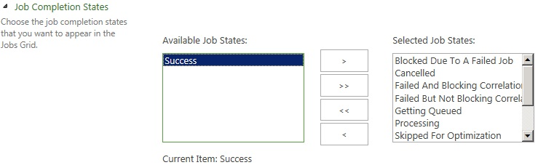

Job Completion States

Use the following procedure to configure the Job Completion States setting.

* To configure the Job Completion States setting

1. On the Manage Queue Jobs page, in the **Job Completion States** section, add all job states that you want to display in the Jobs Grid to the **Selected Job States** list. Job states that are shown in the **Available Job States** list will not appear in the Job Grid.

* To move an available job state in the **Available Job States** list to the **Selected Job States** list, select the job and then click **Add**.
* To remove a job state from the **Selected Job States** list, select the job and then click **Remove**. To select multiple job states press the Ctrl key while making your selections.

1. In the Jobs Grid, click **Refresh Status**.

#### Columns

The Columns configuration option lets you select the columns that appear in the Jobs Grid. It also lets you configure the order of the columns in the Jobs Grid.

The column options available to you are as follows:

* % Complete
* Completed Time
* Correlation ID
* Correlation Priority
* Entry Time
* Error
* Job ID
* JobGroup ID
* JobInfo ID
* Job State
* Job Type
* Last Admin Action
* Owner
* Position
* Priority
* Project Name
* Queue Type
* Wait Time (secs)
* Wakeup Time

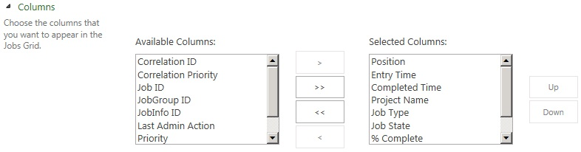

Job Grid Columns

Use the following procedure to configure the columns setting for the Job Grid.

* To configure the Columns setting

1. On the Manage Queue Jobs page, in the **Columns** section, add all columns that you want to display in the Jobs Grid to the **Selected Columns** list. Columns that are shown in the **Available Columns** list will not appear in the Job Grid.

* To move a column in the Available Columns list to the Selected Columns list, select the column name and then click the **Add** button (“**>**”).
* To remove a column from the Selected Columns list, select the column and then click the **Remove** button (“**<**”). To select multiple columns, press the Ctrl key while making your selections. You can also move all columns from one list to another by using the **Add All** (“**>>**”) or the **Remove All** (“**<<**”) buttons.

1. In the Jobs Grid, click **Refresh Status**.

Note that you can change the order of the columns as they display in the Job Grid by selecting a column name in the Selected Columns list and using the **Up** or **Down** button to move the column to a different position.

#### Advanced Options

The Advanced Options queue setting applies to the way that jobs in the queue are canceled.

The Cancel jobs getting enqueued option allows you to cancel all jobs that remain in a “getting enqueued” state for a prolonged time. When a job is in this state, it means that the queue has been told to start to receive a job that will be processed later. But it has not received a tag telling it that all the data for the job has been received. Until the full job has been received, the job will remain in the getting enqueued state. If a job remains in the getting enqueued state for a prolonged time, it is likely that something is preventing the job from finishing. If the job continues to remain in this state after you re-run it, review your ULS logs to troubleshoot why they problem is occurring.

Saving a project from Project Professional to Project Server is a job that typically enqueues. When you save a project from Project Professional to the Project Server, the job synchronizes with the server. If the synchronization is not completed, then the job remains in the enqueued state.

By default, this setting is enabled.

Make sure to click Refresh Status in the Jobs Grid after you make any changes.

Note In Project Server 2010, the Advanced Options page also included an option to **Cancel Subsequent Jobs in Correlation**. This option in not available in Project Server 2013.

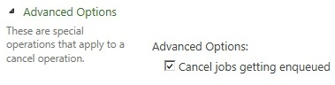

Manage Queue Jobs Advanced Options

### Jobs Grid

The Jobs Grid provides a view of the jobs that meet the criteria listed in the Manage Queue Jobs page. Options within this section let you select a job or group of jobs and to apply the following options to them, if applicable:

* **Retry Job** Allows you to rerun selected jobs in the queue that were not completed successfully.
* **Cancel Job** Allows you to cancel selected jobs in the queue that were not completed successfully.
* **View Related Jobs** Allows you to view jobs that have a dependency relationship (for example, jobs in the same correlation) with a selected job in the queue.
* **Refresh Status** Allows you to update the jobs in your job grid with the latest status.

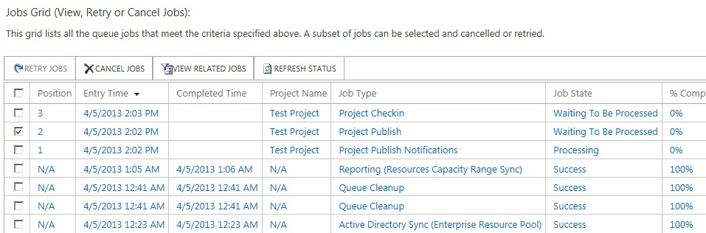

Queue Jobs Grid

Use the following procedure to retry a job in the Jobs Grid.

* To retry a job

1. In the Jobs Grid, find the job you want to retry, and then select the check box to the far left column of this job.
2. Click **Retry Job**. Recheck the status of the job in the Jobs Grid to verify the results of retrying the job.

Use the following procedure to cancel a job in the Jobs Grid.

* To cancel a job

1. In the Jobs Grid, find the job you want to cancel, and then select the check box to the far left column of this job. Note that a job that has already completed successfully cannot be cancelled.
2. Click **Cancel Job**.

Use the following procedure view other jobs that are related to a specific job in the Jobs Grid.

* To view related jobs

1. In the Jobs Grid, find the job for which you want to find related jobs, and then select the check box to the far left column of this job.
2. Click **View All Jobs**. All jobs that have a dependency relationship with this job will appear in the Jobs Grid.

### Understanding Jobs

This section describes how the queue processes jobs in Project Server 2013. The following will provide you a better understanding of how to use the job grid.

* Queue groupings
* Parent/Child relationship between submitted jobs
* Queue States

#### Queue groupings

There are three distinct levels of grouping for queued data:

1. **Jobs**A job is a trackable packet of work that gets executed by Project Server (for example, project save, project publish, timesheet submit). Some jobs are not explicitly initiated by the user (for example, email notifications, reporting data synch-up). Jobs are the level at which queuing is tracked (using a Job ID).
2. **Correlated Job Group**A correlated job group is a categorization of jobs imposed by internal rules of Project Server. Jobs within a correlated job group are always processed together and in order (with some exceptions). In the example below, Project 1 is edited and saved from Project Professional and then checked in. Project 1 is then checked out by another user, who then publishes it. Publishing Project 1 triggers Reporting and a Reporting job is added to the queue as well. Project Server assembles a correlation group comprised of the four jobs related to Project 1. It then will attempt to process the jobs in sequence since the Project Server internal rules dictates that there is a dependency between the jobs. The dependency that exists is that the Project 1 publish and the Reporting database update cannot occur until Project 1 is saved. Also, if any of the jobs in the correlation fail, the other jobs after it in the correlation group will be blocked. For example, if the Save Project 1 job (job ID 12) fails, the Checkin Project 1 job (job ID 13) should get blocked. If the Checkin Project 1 job were executed, this would lead to problems because someone else may then checkout Project 1 and then attempt to modify it which may be in an inconsistent state due to the failed save.
3. **Sub-jobs**Each job can be broken down further into smaller segments called sub-jobs. If a job is very large (such as saving a 10 MB project) it will be broken into multiple sub-jobs. Sub-jobs are not exposed to the PSI or the Project Web App user. However, sub-jobs may be noted in ULS logs (depending on the verbosity option that is selected).

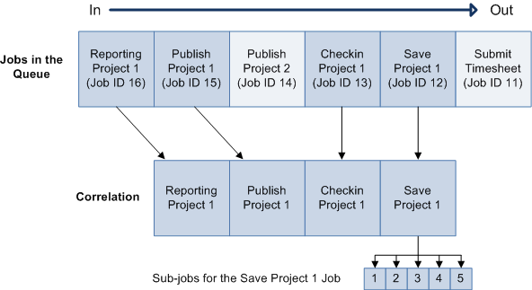

#### Parent/Child Relationships between submitted Jobs

It is important to realize that parent/child relationships can exist for submitted jobs which require that further processing be done. For example, if a user publishes Project 1, a reporting request for Project 1 will be generated, as well as notification requests regarding Project 1. Note that Notifications for Project 1 will always be generated, but since Reporting Project 1 is generated only if the Publish of Project 1 is successful, should the publish job fail, the Reporting Project 1 job will not be generated.

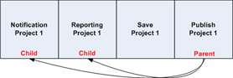

Similarly, a child job may fail without any effect to the parent job. For example, if Notification Project 1 should fail, there will be no effect on Publish Project 1 since it will have already occurred. It is important to note that although the user may be aware that the publish of Project 1 was processed through the queue, he/she may not be aware that a child job may have failed. If you would like to verify what child jobs were spawned from a parent job that they had entered into the queue as well as their status, you can do this through the My Queued Jobs page in Project Web App. Administrators can use the Queue Management UI and see all jobs in the queue.

#### Queuing states

When a job is submitted to the queue it can transition through various states. The table below describes each of these states:

| **State** | **Description** |
| --- | --- |
| Getting queued | Job is put into the queue. A job ID is issued. |
| Waiting to be Processed | Job is in the queue and is waiting to be processed. |
| Processing | Job is being processed. |
| Success | Job has been successfully processed. This is a terminating state in which the job can go no further. |
| Blocked | Job has been blocked by failure of another job before it in the same correlation group. The user will need to retry or cancel. |
| Failed and Not Blocking Correlation | Job has failed, but is not blocking any other jobs in its group. This is a terminating state in which the job can go no further. |
| Failed and Blocking Correlation | Job has failed and may be blocking one or more dependent jobs. |
| Skipped for optimization | Job has been skipped because a duplicate job has been found after it within the group. For example, a project manager may attempt the following in sequence when working with a project:   1. Saves Project 1 2. Publishes Project 1 3. Changes a task in Project 1 4. Save Project 1 5. Publishes Project 1 6. Changes the start date of Project 1 7. Save Project 1 8. Publishes Project 1   All three incremental saves to Project 1 will be processed. However, all three publish attempts do not need to be processed. If the last publish job is processed, it would produce the same results as if all three publish jobs were processed. For optimization, the first two publish attempts are skipped. |
| Cancelled | Job has been cancelled. A job can be cancelled from any state except the two terminating states (Success, Failed and Not Blocking Correlation). |
| Sleeping | Job could not process immediately because of another conflicting job and is temporarily in an inactive mode. The job will be retried. |

#### Changes in queue state

As jobs are entered into the queue and processed, it is important to understand the possible changes in queue state that can occur. The following flowchart describes the possible paths through each state.

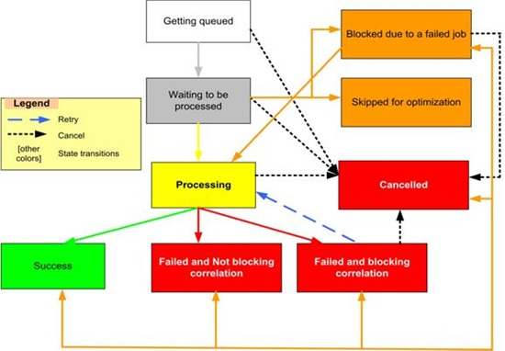

| **State** | **Next Possible State** |
| --- | --- |
| Getting Queued | * Waiting to be Processed * Cancelled |
| Waiting to be Processed | * Processing * Cancelled * Blocked * Skipped for optimization |
| Processing | * Success * Failed and Not Blocking Correlation * Failed and Blocking Correlation * Cancelled |
| Success | * End |
| Blocked | * Processing * Cancelled |
| Failed and Not Blocking Correlation | * End |
| Failed and Blocking Correlation | * Cancelled * Processing |
| Skipped for Optimization | * Blocked (due to a failed job) * Cancelled * Success * Failed and Not Blocking Correlation * Failed and Blocking Correlation * Processing |
| Cancelled | * End |

## Delete Enterprise Objects

You can delete enterprise objects from Project Web App when they are no longer needed. You can delete the following types of objects from Project Web App:

* Projects
* Resources and users
* Status report responses
* Timesheets
* User delegates

### Delete projects

When a project is no longer needed, you can delete it from Project Web App. Note that this process deletes the project entirely from Project Web App and it cannot be retrieved.

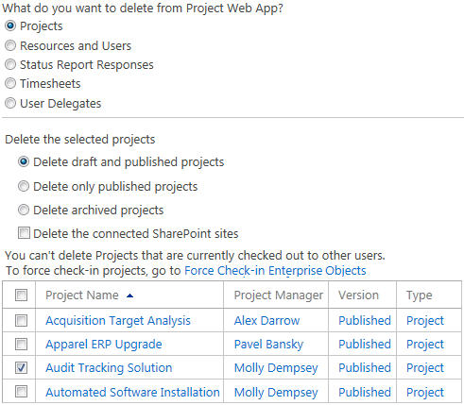

Delete project

Use the following procedure to delete a project from Project Web App.

Important The project will be permanently deleted from Project Web App.

* To delete a project

1. On the Project Web App home page, on the Settings menu, click PWA Settings.
2. On the Server Settings page, under Queue and Database Administration, click Delete Enterprise Objects.
3. On the Delete Enterprise Objects page, select the Projects option.
4. Select one of the following options:

* Delete draft and published projects to display a list of both draft and published projects.
* Delete only published projects to display a list of published projects.
* Delete archived projects to display a list of archived projects.

1. To delete the associated SharePoint site, select the Delete the connected SharePoint sites check box.

Note If you do not delete the associated SharePoint site and you save and publish a new project with the same name as the deleted project, the SharePoint site publishing process will fail.

1. Select the project that you want to delete.
2. Click Delete.

### Delete resources and users

When a resource or user is no longer needed, you can delete it from Project Web App.

Important We recommend not deleting resources from Project Web App as this can affect the reporting of actuals. Instead, deactivate resources that are no longer needed.

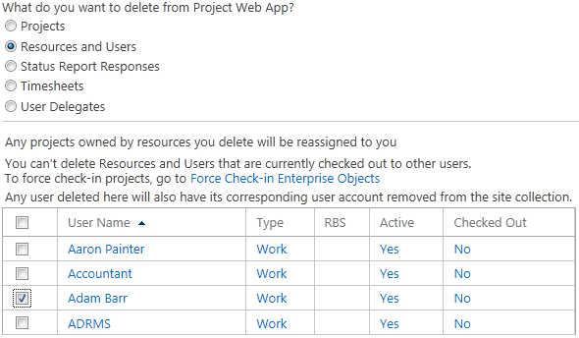

Delete resources and users

Use the following procedure to delete resources and users from Project Web App.

Important The resources and users will be permanently deleted from Project Web App.

* To delete resources and users

1. On the Project Web App home page, on the Settings menu, click PWA Settings.
2. On the Server Settings page, under Queue and Database Administration, click Delete Enterprise Objects.
3. On the Delete Enterprise Objects page, select the Resources and Users option.
4. Select the user or resource that you want to delete.
5. Click Delete.
6. On the confirmation dialog box, click OK.

### Delete status report responses

When a status report response is no longer needed, you can delete it from Project Web App. Note that this process deletes the status report response entirely from Project Web App and it cannot be retrieved.

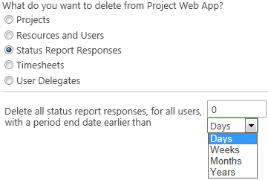

Delete status report responses

Use the following procedure to delete status report responses from Project Web App.

* To delete status report responses

1. On the Project Web App home page, on the Settings menu, click PWA Settings.
2. On the Server Settings page, under Queue and Database Administration, click Delete Enterprise Objects.
3. On the Delete Enterprise Objects page, select the Status Report Responses option.
4. Specify a period end date parameter (number of days, weeks, months, or years ago prior to which you want to delete all status report responses).
5. Click Delete.

### Delete timesheets

When a timesheet is no longer needed, you can delete it from Project Web App. Note that this process deletes the timesheet entirely from Project Web App and it cannot be retrieved.

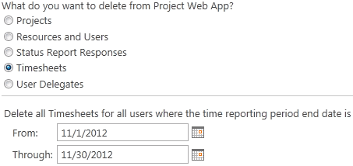

Delete timesheets

Use the following procedure to delete timesheets from Project Web App.

* To delete timesheets

1. On the Project Web App home page, on the Settings menu, click PWA Settings.
2. On the Server Settings page, under Queue and Database Administration, click Delete Enterprise Objects.
3. On the Delete Enterprise Objects page, select the Timesheets option.
4. Select the range of timesheet end dates that you want to delete.
5. Click Delete.

### Delete user delegates

When a user delegate is no longer needed, you can delete it from Project Web App. Note that this process deletes the user delegate entirely from Project Web App and it cannot be retrieved.

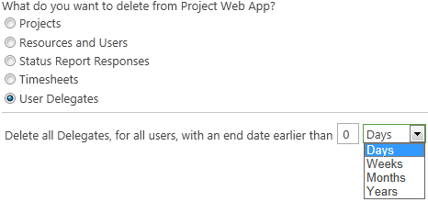

Delete delegates

Use the following procedure to delete user delegates from Project Web App.

* To delete

1. On the Project Web App home page, on the Settings menu, click PWA Settings.
2. On the Server Settings page, under Queue and Database Administration, click Delete Enterprise Objects.
3. On the Delete Enterprise Objects page, select the User Delegates option.
4. Specify a period end date parameter (number of days, weeks, months, or years prior to which you want to delete all user delegates).
5. Click Delete.

## Force Check-in Enterprise Objects

If an enterprise object has been checked out and the user who checked it out is unavailable or unable to check it back in, you can force a check-in.

Important If you force check-in an enterprise object that a user is modifying, the modifications may be lost.

You can force check-in the following types of enterprise objects:

* Enterprise projects
* Enterprise resources
* Enterprise custom fields
* Enterprise calendars
* Lookup tables for enterprise custom fields
* Resource plans

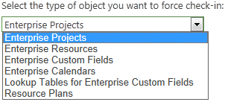

Enterprise object check-in options

On the Force Check-in Enterprise Objects page in Project Web App Server Settings, choose the type of enterprise object that you want to check in to see a list of objects of that type that are checked out.

### Check-in Enterprise Projects

You can force the check-in of an enterprise project that is checked out. Note that forcing a check-in of a project that is being modified by a user may result in the loss of those changes. We highly recommend that users check in projects normally and that you use force check-in only when absolutely necessary.

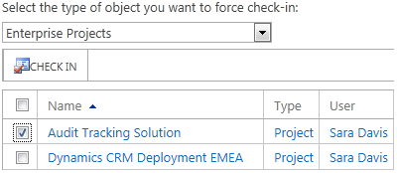

Check in Enterprise Projects

Use the following procedure to check in enterprise projects.

* To force check-in Enterprise Projects

1. On the Project Web App home page, on the Settings menu, click PWA Settings.
2. On the Server Settings page, under Queue and Database Administration, click Force Check-in Enterprise Objects.
3. From the Select the type of object you want to force check-in dropdown list, choose Enterprise Projects.
4. Select the projects that you want to check in.
5. Click Check In.

### Check-in Enterprise Resources

You can force the check-in of an enterprise resource that is checked out. Note that forcing a check-in of a resource that is being modified by a user may result in the loss of those changes.

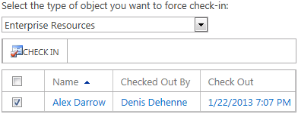

Check in Enterprise Resources

Use the following procedure to check in enterprise resources.

* To force check-in Enterprise Resources

1. On the Project Web App home page, on the Settings menu, click PWA Settings.
2. On the Server Settings page, under Queue and Database Administration, click Force Check-in Enterprise Objects.
3. From the Select the type of object you want to force check-in dropdown list, choose Enterprise Resources.
4. Select the resources that you want to check in.
5. Click Check In.

### Check-in Enterprise Custom Fields

You can force the check-in of an enterprise custom field that is checked out. Note that forcing a check-in of a custom field that is being modified by a user may result in the loss of those changes.

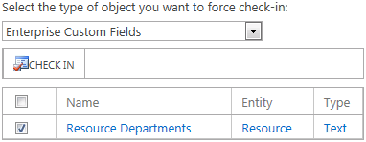

Check in Enterprise Custom Field

Use the following procedure to check in enterprise custom fields.

* To force check-in Enterprise Custom Fields

1. On the Project Web App home page, on the Settings menu, click PWA Settings.
2. On the Server Settings page, under Queue and Database Administration, click Force Check-in Enterprise Objects.
3. From the Select the type of object you want to force check-in dropdown list, choose Enterprise Custom Fields.
4. Select the custom fields that you want to check in.
5. Click Check In.

### Check-in Enterprise Calendars

You can force the check-in of an enterprise calendar that is checked out. Note that forcing a check-in of an enterprise calendar that is being modified by a user may result in the loss of those changes.

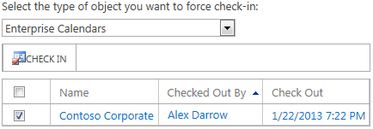

Check in Enterprise Calendars

Use the following procedure to check in enterprise calendars.

* To force check-in Enterprise Calendars

1. On the Project Web App home page, on the Settings menu, click PWA Settings.
2. On the Server Settings page, under Queue and Database Administration, click Force Check-in Enterprise Objects.
3. From the Select the type of object you want to force check-in dropdown list, choose Enterprise Calendars.
4. Select the calendars that you want to check in.
5. Click Check In.

### Check-in Lookup Tables for Enterprise Custom Fields

You can force the check-in of an enterprise lookup table that is checked out. Note that forcing a check-in of a lookup table that is being modified by a user may result in the loss of those changes.

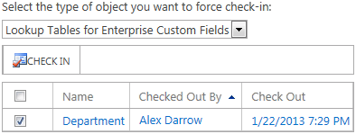

Check in Lookup Tables for Enterprise Custom Fields

Use the following procedure to check in lookup tables.

* To force check-in Lookup Tables for Enterprise Custom Fields

1. On the Project Web App home page, on the Settings menu, click PWA Settings.
2. On the Server Settings page, under Queue and Database Administration, click Force Check-in Enterprise Objects.
3. From the Select the type of object you want to force check-in dropdown list, choose Lookup Tables for Enterprise Custom Fields.
4. Select the lookup tables that you want to check in.
5. Click Check In.

### Check-in Resource Plans

You can force the check-in of an enterprise resource plan that is checked out. Note that forcing a check-in of a resource plan that is being modified by a user may result in the loss of those changes.

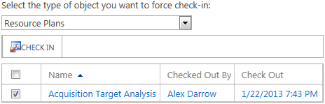

Check in Resource Plans

Use the following procedure to check in resource plans.

* To force check-in Resource Plans

1. On the Project Web App home page, on the Settings menu, click PWA Settings.
2. On the Server Settings page, under Queue and Database Administration, click Force Check-in Enterprise Objects.
3. From the Select the type of object you want to force check-in dropdown list, choose Resource Plans.
4. Select the resource plans that you want to check in.
5. Click Check In.

4

# **Look and Feel: Project Web App Settings**

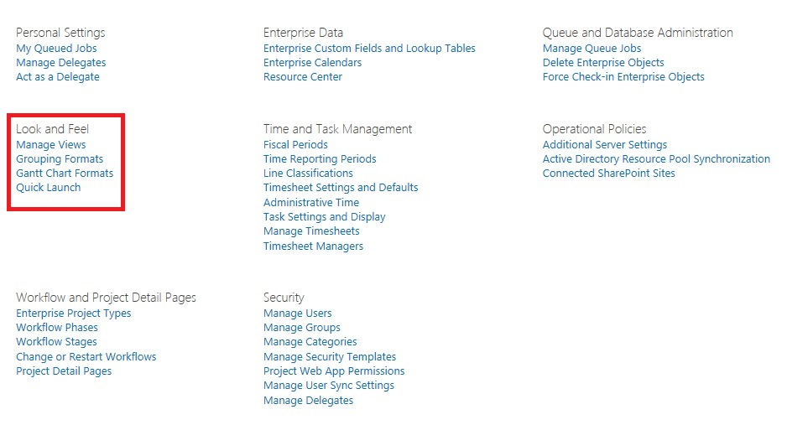

The Look and Feel settings in the Project Web App settings page

Project Server 2013 supports customization of various user interface elements, including:

* Views
* Color and text formats of grouping levels within views
* Color and shape options for Gantt bars
* Links, or groups of links, included on the Quick Launch in Project Web App

The options that are described in this chapter are available under **Look and Feel** on the **PWA Settings** page.

## Manage Views

Team members can view project information by selecting different views from the **View** list at the top of most pages within Project Web App. As an administrator, you can better meet the information needs of your organization by adding new views and changing the existing views.

There are several different kinds of views in Project Web App, as listed in the following table.

| **View Type** | **Example** |
| --- | --- |
| **Project**  Use this type of view to review the task, assignment, and resource details of a specific project when a team member clicks a project in the Project Center. |  |
| **Project Center**  Use this type of view to review information about all projects in the Project Center. |  |
| **Resource Assignments**  Use this type of view to review details about specific resource assignments. |  |
| **Resource Center**  Use this type of view to review and compare all resources in the Resource Center. |  |
| **My Work**  Team members use this type of view to review their task assignments. |  |
| **Resource Plans**  Managers use this type of view to create resource plans for their projects. |  |
| **Team Builder**  Managers use this type of view to create a team for their project (not a resource plan). |  |
| **Timesheet**  Team members use this type of view to report time against the projects to which they are assigned. |  |
| **Portfolio Analyses**  Portfolio managers use this type of view to compare project proposals and determine which meet organizational goals. |  |
| **Portfolio Analysis Project Selection**  Portfolio managers use this type of view to choose which proposals to approve as projects. |  |

### Create a New View

Options for creating a new view vary depending on the type of view you are creating.

* To create a new view

1. Click Settings  > **PWA Settings**.
2. Under Look and Feel, click Manage Views.
3. Click **New View**.

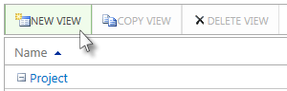

1. Under **Name and Type**, select the **View Type**.

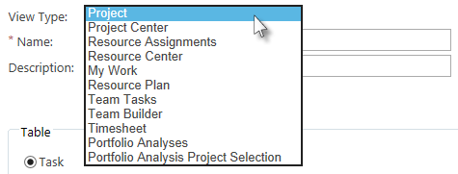

1. In the **Name** box, type the name of the new view.
2. In the **Description** box, type a description of the new view.
3. Complete the remaining fields on the **New View** page. Not all options listed below are available for every view type.

* **Task, Resource, or Assignment** Choose the type of information to display in the view.

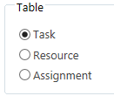

**Note** These choices are only available when **Project** is selected as the **View Type**.

* **Available fields and Displayed fields** In the **Available fields** list, select the fields that you want to include in the view and then click **Add**. To reorder the fields, click a field name in the **Displayed fields** box, and then click **Up** or **Down** to move it within the list.

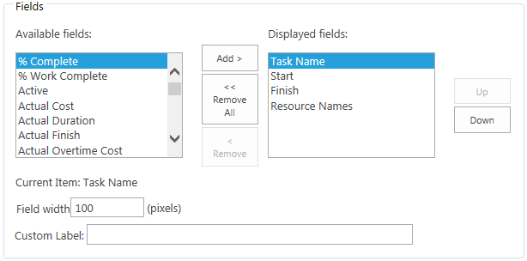

* **Field width** Click the name of a field in the **Displayed fields** box, and then type a number of pixels in the **Field width** box. You can repeat this for each field listed in the **Displayed fields** box. Setting this value is optional.
* **Custom Label** Click the name of a field in the **Displayed fields** box, and then type a display name in the **Custom Label** box. You can repeat this for each field listed in the **Displayed fields** box. Setting this value is optional.

**Note** Custom labels are not available for the Resource Plan, Team Tasks, Team Builder, or Portfolio view.

* **Make column read only** Click the name of a field in the **Displayed fields** box, then select this check box to make that field read-only. Not all fields can be made read-only.

**Note** Only the **Timesheet** and **My Work** views have this option.

* **Gantt Chart format** Select the type of Gantt chart that you want to use to display information.

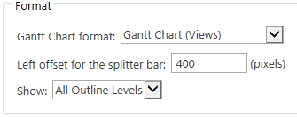

**Note** This option is only available for views that can show a Gantt chart.

* **Left offset for the splitter bar** Type an offset measurement in pixels to define the placement of the splitter bar in the view.

**Note** This option is only available for views that can show a Gantt chart.

* **Show** Select the number of outline levels that you want to display, by default, in this view. People using the view will be able to expand additional outline levels.
* **Grouping format** Select the grouping style that you want to use, and then define the order of grouping by using the **Group by** and **Then by** lists. For more information on setting up grouping formats, see “Grouping Formats,” later in this chapter.

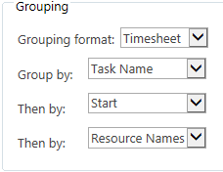

* **Sort by** Select the fields by which you want to sort the view. In the **Order** list, select **Ascending** or **Descending** to define the order in which you want to sort the view.

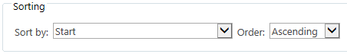

* **Filter** Click this button to create or edit filters that you can apply to this view.
* **Filter Resources to user’s RBS branch** Select this check box to display only those resources that fall under the resource breakdown structure branch of the resource looking at the view.

**Note** This option is only available in Resource Center views.

1. After you have set all appropriate options for the new view, click **Save**.

You can apply a filter to a view, so that data in the view is automatically narrowed down based on a set of criteria.

* To set up a filter for a view

1. On the **New View** page, under **Filter**, click **Filter**. The **Custom Filter** dialog box is displayed.
2. Select a field in the **Field Name** list and a test in the **Test** list, and then type a value to test for in the **Value** box. You can set a range of values by typing two values separated by a comma (,) in the **Value** box.

**Tip** As you create the filter rules, a green check mark or a red X is displayed to the left of the rule, under the **Valid?** heading. If you see a red X next to a rule, hover over the X for more information on why the rule is not considered.

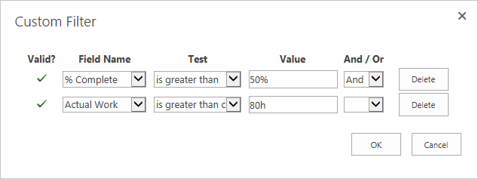

1. If the filter contains more than one row, select an operator in the **And/Or** column to start a new row.
2. Click **OK** when you have finished setting up filters.

### Modify a View

After you have been using a view in Project Web App, you may find that it needs some fine-tuning. It may need a field added, or some adjustments to the security settings. You can easily modify existing views.

* To modify an existing view

1. Click Settings  > **PWA Settings**.
2. Under Look and Feel, click Manage Views.
3. Click the name of the view you want to modify, in the **Name** column.

**Tip** If you know the view type for the view you want to modify, you can collapse the other view types to reduce the number of views to scroll through.

1. Modify the fields and options for the view, and then click **Save**.

### Copy a View

Sometimes it may be easier to create a new view by basing it on an existing view. You can select a view and copy it to create a new view.

* To create a new view as a copy of an existing view

1. Click Settings  > **PWA Settings**.
2. Under Look and Feel, click Manage Views.
3. Click a cell in the row for the view you are copying, and then click **Copy View**.

**Note** Be careful NOT to click the name of the view, in the **Name** column. This will open that view for editing, instead of selecting it.

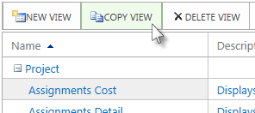

1. On the **Copy View** dialog box, type a name for the new view, and then click **OK**. The copied view is added to the table on the **Manage Views** page.

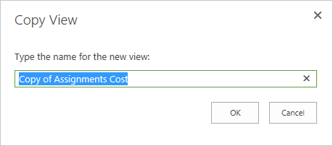

1. Scroll through the list of views to find the view you just created, and then click the name of the new view in the **Name** column.
2. Modify the fields and options for the new view, and then click **Save**.

### Delete a View

If a view is not meeting your organization’s needs, or is just not being used, you can delete it from Project Web App.

* To delete a view

1. Click Settings  > **PWA Settings**.
2. Under Look and Feel, click Manage Views.
3. Click a cell in the row for the view you are deleting, and then click **Delete View**.

**Note** Be careful NOT to click the name of the view, in the **Name** column. This will open that view for editing, instead of selecting it.

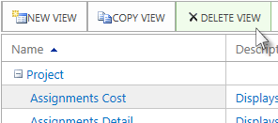

1. When prompted, click **OK** to delete the view.

## Grouping Formats

You can change how rows (or levels) of information appear when task and resource information is grouped in the **Project Center**, **Resource Center**, **Project**, **Task**, **Timesheet**, and **Assignment** views. By changing the appearance of these grouping levels, you can highlight specific information for your team members.

The following figure shows an example of grouping level formatting. The first-level groups are shaded in yellow with bold text, and the second-level groups are shaded in blue with bold text.

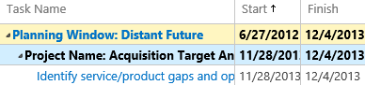

* To change the appearance of grouping levels

1. Click Settings  > **PWA Settings**.
2. Under Look and Feel, click Grouping Formats.
3. In the **Grouping format** list, above the table, select the grouping level that you want to format. This will refresh the table and narrow down which levels are displayed.

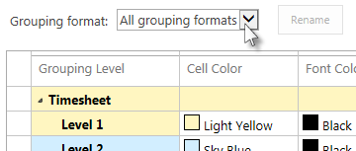

1. To rename the selected grouping level, click **Rename**.



Type the new name in the **New name for the grouping format** box, and then click **OK**.

If you do not want to rename the selected grouping level, skip this step.

1. Use the lists in the **Cell Color**, **Font Color**, and **Font Style** columns to define the appearance of each grouping level.

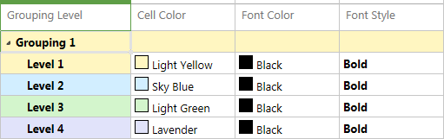

1. Click **Save**, at the bottom of the page.

After you have created a format for grouped task or resource information, you apply the formatting when a new view is created or modified. See “Manage Views,” earlier in this chapter, for more information.

## Gantt Chart Formats

You can format the color, shape, and pattern of the Gantt bars in Gantt Charts views, Project Center views, and other views.

* To format a Gantt chart

1. Click Settings  > **PWA Settings**.
2. Under Look and Feel, click Gantt Chart Formats.
3. In the **Gantt Chart** list, above the table, select the name of the Gantt chart view that you want to format.

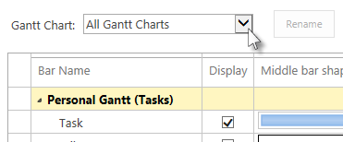

1. To rename the selected Gantt chart view, click **Rename**. Type the new name in the **New name for Gantt Chart** box, and then click **OK**. If you do not want to rename the selected Gantt chart view, skip this step.



**Note** You cannot change the names of the individual Gantt bars.

1. For each bar type within the selected Gantt chart view (represented as a row in the table), choose the following:

* **Display** Select this check box to display this bar type on the selected Gantt chart view.
* **Middle bar shape** Select the shape you want to use for the bar type.

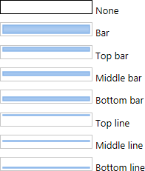

* **Bar Color** Choose a color to fill in the selected bar shape.
* **Bar Pattern** Choose a pattern to fill in the selected bar shape.
* **Start shape** Choose a graphic to display at the start of a Gantt bar of this type.
* **Start color** Choose a color to fill in the start shape.
* **End shape** Choose a graphic to display at the end of a Gantt bar of this type.
* **End color** Choose a color to fill in the end shape.

A preview of the resulting Gantt bar is displayed on the right side of the table.

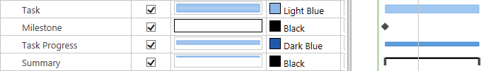

1. Click **Save**, at the bottom of the page, below the table.

## Quick Launch

The Quick Launch is the left navigation list in Project Web App.

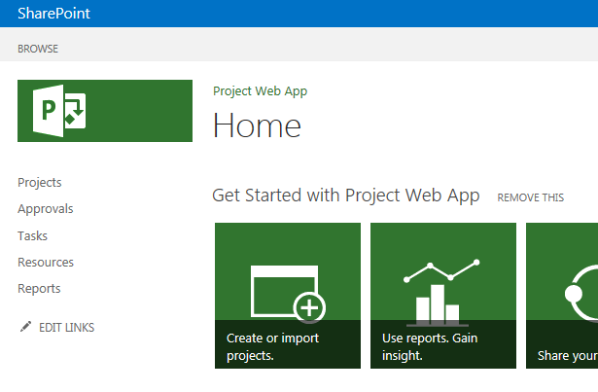

You can change how links behave on the Quick Launch, add new links or groups of links, reorder the links, or delete links or groups of links.

### Change Quick Launch Behavior

Links on the Quick Launch can be displayed at all times, or you can choose to collapse links based on the context of what a user is currently viewing. You can also choose whether to include links from Microsoft SharePoint Foundation.

* To change how the Quick Launch displays links

1. Click Settings  > **PWA Settings**.
2. Under Look and Feel, click Quick Launch.

**Tip** You can also click **Edit Links** on the Quick Launch to change its behavior.

1. Under **Expand Quick Launch Items for**, choose from the following options:

* **All sections by default** If you want to display all Quick Launch items at all times, regardless of what view is currently displayed, click **All sections**.
* **Current section only** If you want to collapse the Quick Launch items to just the top-level headings for sections that do not apply to the current view, click **Current section only**. For example, if you have selected **Current section only**, when you are looking at the Project Center, you will only see the Quick Launch items under the **Projects** heading.

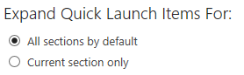

1. Click **Save**.

### Add a New Link

You can also add new links to the Quick Launch, to meet your organization’s needs. Links can be to views within Project Web App, intranet sites, or even external Web sites.

* To add a link to the Quick Launch

1. Click Settings  > **PWA Settings**.
2. Under Look and Feel, click Quick Launch.
3. Click **New Link**.

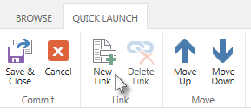

1. Type a name for the link in the **Custom link name** box. This is the text that will appear linked on the Quick Launch.

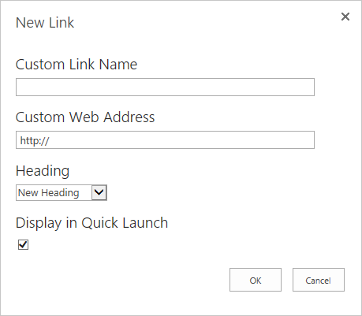

1. Type the URL for the link in the **Custom Web address** box.
2. In the **Heading** section, choose the placement for the new link:

* If you are creating a new heading link for the Quick Launch, similar to the **Projects** and **My Work** headings, select **New Heading**.
* If you are creating a link to be included below an existing heading, select the existing heading from the list. The link will be indented below the selected heading.

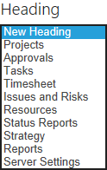

1. If you want to hide the new link from the Quick Launch, click **No** in the **Display link in Quick Launch** list.

**Tip** For example, if you are creating a new group of links below a new heading, you can choose to hide the new heading, then create all of the new links below the heading and set those to display. When you have the group of links ready to go, you can change the **Display link in Quick Launch** setting for the new heading to **Yes**, and the group of links is added to the Quick Launch.

1. Click **OK**.
2. Click **Save & Close**.

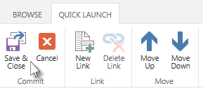

### Modify an Existing Link

If a link on the Quick Launch is not pointing to the right place, should have a different name, or needs to be temporarily hidden, you can easily make those changes.

* To modify an existing Quick Launch item

1. Click Settings  > **PWA Settings**.
2. Under Look and Feel, click Quick Launch.
3. Modify the name, URL, and/or display option for the link in the table.

**Tip** If you have a long list of Quick Launch items to scroll through, you can collapse the headers to hide the links you do not want to modify.

1. Click **Save & Close**.



### Reorder Quick Launch Items

As you use Project Web App, you may find that the links on the Quick Launch would be more helpful if they appeared in a different order. You can reorder the links to meet your organization’s needs.

* To reorder the links on the Quick Launch

1. Click Settings  > **PWA Settings**.
2. Under Look and Feel, click Quick Launch.
3. Click a cell in the row for the Quick Launch item you are moving, and then click **Move Up** or **Move Down**. If you select a heading, all items indented below the heading will move with it.

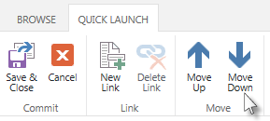

1. Click **Save & Close**.



### Delete a Link

If you find that your organization is not using a link that is currently included on the Quick Launch, you can easily remove it.

* To delete a link from the Quick Launch

1. Click Settings  > **PWA Settings**.
2. Under Look and Feel, click Quick Launch.
3. Click a cell in the row for the Quick Launch item you are deleting, and then click **Delete Link**. If you select a heading, all items indented below the heading will also be deleted.

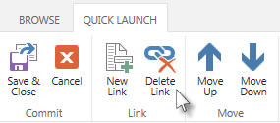

1. When prompted, click **OK** to delete the link, or group of links.
2. Click **Save & Close**.



5

# **Time and Task Management: Project Web App Settings**

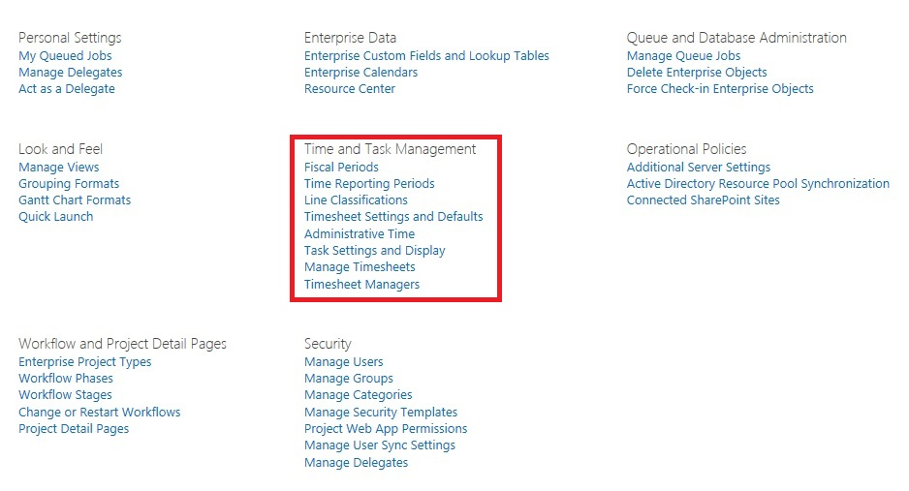

The Time and Task Management settings in the Project Web App settings page

Site administrators and others with appropriate permissions can configure how timesheets and task status are captured and handled in Project Server 2013. This includes:

* Setting up fiscal periods and time reporting periods
* Setting up timesheet line classifications
* Choosing the right timesheet settings
* Configuring administrative time categories
* Choosing task status settings
* Recalling and deleting timesheets
* Adding and removing timesheet managers

The options that are described in this chapter are available under **Time and Task Management** on the **PWA Settings** page in Project Web App.

## Fiscal Periods

Fiscal periods define the start and beginning dates of the business calendar. They are used to calculate financial statements on an annual basis. By setting up fiscal periods in Project Server 2010, you provide a way to map project work against your organization’s fiscal planning structure. Once set up, you can use fiscal periods as a dimension in your OLAP cubes.

### Define Fiscal Periods

Using Project Web App, you can easily define the fiscal periods for a specific year. By creating the fiscal periods in bulk, you can base them off of several different models, and Project Server will calculate the dates accordingly.

For example, if your organization divides each quarter into three periods—one that is four weeks long, followed by one that is five weeks long, and then another that is four weeks long—you can specify this model in Project Web App, and Project Server will create fiscal periods for the year according to that schedule. So, if the fiscal year begins on January 1, 2014, the first quarter will have three periods:

* Period 1: 1/1/2014 – 1/28/2014
* Period 2: 1/29/2014 – 3/4/2014
* Period 3: 3/5/2014 – 4/1/2014
* To set fiscal periods in Project Web App

1. Click Settings  > **PWA Settings**.
2. Under Time and Task Management, click Fiscal Periods.
3. Under **Manage Fiscal Period**, click the year that you want to define as the fiscal period, and then click **Define**.



1. Under **Define Fiscal Period Start Date**, type the date on which the fiscal year should begin, or select it using the date picker.



1. Under **Set Fiscal Year Creation Model**, select a formatting method for the fiscal period:

* **4,5,4 Method** This fiscal quarter method sets a four-week fiscal period, followed by a five-week fiscal period, and then another four-week fiscal period.
* **4,4,5 Method** This fiscal quarter method sets a four-week fiscal period, followed by another four-week fiscal period, and then a five-week fiscal period.
* **5,4,4 Method** This fiscal quarter method sets a five-week fiscal period, followed by a four-week fiscal period, and then another four-week fiscal period.
* **13 months** This method sets each fiscal period as four weeks.
* **Standard calendar year** This method sets each fiscal period according to the standard 12 month year, beginning on January 1.

**Note** If you want to use a different model for your organization’s fiscal year, use the steps in this procedure to choose a model that is closest to what you would like your fiscal year to look like. Once you have saved, you can go back and modify the calendar dates to refine the schedule to meet your organization’s needs.

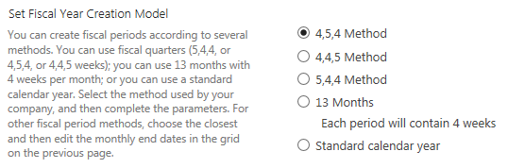

1. Under **Define Period Naming Convention**, create a unique name for the periods by entering:

* **Prefix** A prefix of up to 15 characters.
* **Next Sequence Number** A sequence number of up to six digits.
* **Suffix** A suffix of up to 15 characters.

**Tip** As you enter a naming convention in the **Prefix**, **Next Sequence Number**, and **Suffix** fields, an example of the final naming convention is displayed below the fields, next to **Sample**.

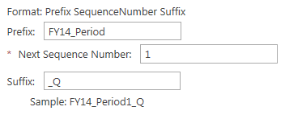

1. Click **Create and Save**.

On the **Fiscal Periods** page, the fiscal period will be displayed with the individual periods showing in the **Adjust Fiscal Months** grid.

After defining a fiscal period, you can edit it by using the **Adjust Fiscal Months** grid.

* To refine the fiscal period dates

1. Click Settings  > **PWA Settings**.
2. Under Time and Task Management, click Fiscal Periods.
3. Under **Manage Fiscal Period**, select the year that you want to adjust.
4. Under **Adjust Fiscal Months**, in the **End Date** column, click the end date that you want to modify, and then use the date picker to choose a new end date. Start and end dates for periods following the modified end date will be automatically adjusted so that all periods are contiguous.

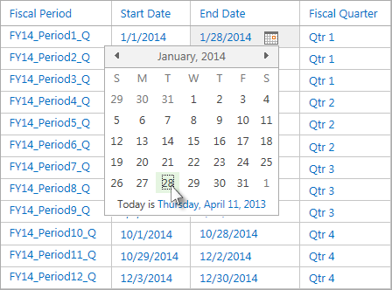

1. Click **Save**.

### Delete Fiscal Periods

After you have initially defined the fiscal periods for your organization, you may decide that a 13 month schedule would work better, or that you would prefer a 5,4,4 schedule over the 4,5,4 schedule that you initially selected. Instead of redefining each date, it may be easier to delete the fiscal periods altogether and start over from scratch.

* To delete the fiscal period for a specific year in Project Web App

1. Click Settings  > **PWA Settings**.
2. Under Time and Task Management, click Fiscal Periods.
3. Under **Manage Fiscal Period**, select the year that contains the fiscal periods you want to delete.
4. Under **Adjust Fiscal Months**, click **Delete**.

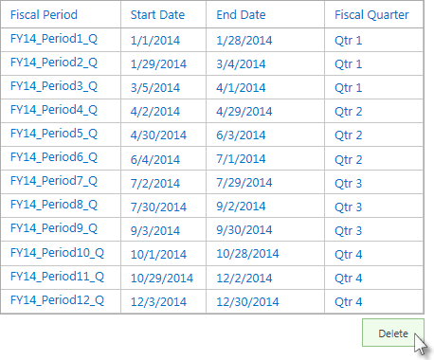

All periods are deleted, and the year returns to an **Undefined** status.

Once you have deleted the fiscal periods for a year, you can redefine them using the process outlined in the “Define Fiscal Periods” section.

## Time Reporting Periods

Time reporting periods define the start and end dates used for each timesheet and task status report. You can create several time reporting periods in bulk to set them up, and then insert or delete individual periods, as necessary. For example, you can create several time reporting periods for an entire fiscal year, and then modify those periods, as needed, to meet the individual needs of your organization.

### Create Bulk Time Reporting Periods

Rather than creating each time reporting period individually, you will save yourself quite a bit of time if you create them in bulk, using parameters for how many periods to create, when the first period should begin, and how long each period should last.

* To create several time reporting periods at once

1. Click Settings  > **PWA Settings**.
2. Under Time and Task Management, click Time Reporting Periods.
3. Under **Define Bulk Period Parameters**, enter the following:

* **Number of periods to be created** Type the number of time reporting periods you want to create at one time. If you want to create time reporting periods for each week in a year, leave this set to 52.
* **Date the first period starts** Type the date on which you want the first time reporting period to start, or use the date picker to choose a date. Project Server will calculate the dates for all subsequent periods, based on the date selected in this field.

**Note** Be sure to select the correct day of the week, as all time reporting periods will be based on this date.

* **Length of the standard period (days)** Type the number of days in each time reporting period. If you want to use one-week time reporting periods, leave this set to 7.

1. In the **Define Batch Naming Convention** section, create a unique name for each of the periods by entering:

* **Prefix** A prefix of up to 20 characters.
* **Next Sequence Number** A sequence number of up to six digits.
* **Suffix** A suffix of up to 20 characters.

**Tip** As you enter a naming convention in the **Prefix**, **Next Sequence Number**, and **Suffix** fields, an example of the final naming convention is displayed below the fields, next to **Sample**.

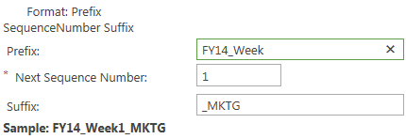

1. Click **Create Bulk** to create the time reporting periods you specified.

**Note** The **Status** column for all new time reporting periods is set to **Open**. Only a Project Server administrator can close a period. It is possible to restrict future timesheets from being submitted. See the “Timesheet Settings and Defaults” section for more information.

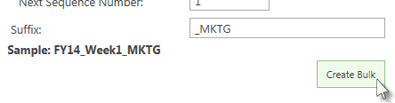

1. To make changes to a period label, date, or status, click in the grid in the **Create Periods** section, and then enter the modifications. See “Insert or Delete Time Reporting Periods” for more information.
2. Click **Save**.

### Insert or Delete Time Reporting Periods

Occasionally, you may need to insert an additional time reporting period. For example, if the current fiscal year uses Monday-Sunday time reporting periods, and you have decided that the next fiscal year will use Sunday-Saturday time reporting periods, you may need to insert a shortened period to transition between the two models.

* To insert a time reporting period

1. Click Settings  > **PWA Settings**.
2. Under Time and Task Management, click Time Reporting Periods.
3. Under **Create Periods**, scroll through the list to find where you want to insert a new time reporting period, and then click the nearest existing period.
4. Click **Insert Before** or **Insert After** to create a new row for the period you are inserting.

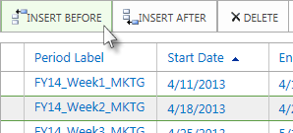

1. In the **Period Label** column, replace the **New Period** text with the name of the inserted period.
2. Replace the dates in the **Start Date** and **End Date** columns, if necessary.
3. If the inserted period is not currently open for resources to report data, select **Closed** in the **Status** column.
4. Click **Save**.

You may also find that you occasionally need to delete existing time periods. For example, if your organization has already set up one-week time reporting periods for the entire year, and partway through the year you decide to switch to two-week time reporting periods, you will need to delete the remaining one-week periods, and recreate the rest of the year as two-week periods.

* To delete a time reporting period

1. Click Settings  > **PWA Settings**.
2. Under Time and Task Management, click Time Reporting Periods.
3. Under **Create Periods**, click the row for the time period you want to delete, and then click **Delete**.

**Important** To protect project data provided by team members, time reporting periods that have associated timesheets cannot be deleted. Because it is common for time reporting periods to have associated timesheets, it is unlikely that you will be able to delete past time reporting periods.

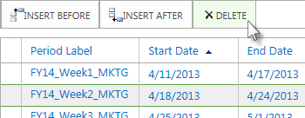

1. Click **Save**.

## Line Classifications

Timesheet line classifications are used to report different types of time against the same task assignment. For example, your organization may have different classifications for Travel, Training, and Standard (default) work. Using classifications enables the timesheet user to add the same task assignment once per classification type.

**Note** The Standard line classification is required, even if all work on the task assignment is being reported against timesheet lines with other classifications.

By default, all timesheet lines use the Standard (or default) line classification. Resources can manually change a timesheet line to use one of the additional line classifications you have configured.

* To create a new timesheet line classification

1. Click Settings  > **PWA Settings**.
2. Under Time and Task Management, click Line Classifications.
3. Click **New Classification**.

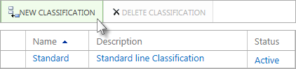

1. In the grid, type a new name and description that identifies the timesheet line classification for team members.
2. Click **Save**.

If you no longer want resources to be able to use a classification in timesheets, but that classification has been used in previous timesheets, you can make the classification inactive. This will maintain the classification in previous timesheets, for historical reporting purposes, but prevent it from being available in future timesheets.

* To inactivate an existing timesheet line classification

1. Click Settings  > **PWA Settings**.
2. Under Time and Task Management, click Line Classifications.
3. Choose **Inactive** in the **Status** column for the line classification you no longer want available to resources.

**Note** The Standard line classification cannot be inactivated.

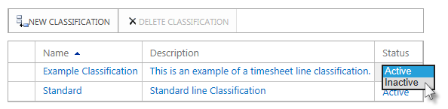

1. Click **Save**.

If a line classification has never been used on a timesheet, you can delete it from Project Web App altogether.

* To delete an existing timesheet line classification

1. Click Settings  > **PWA Settings**.
2. Under Time and Task Management, click Line Classifications.
3. Click the row for the line classification you are deleting, and then click **Delete Classification**.

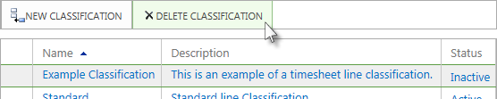

1. Click **Save**.

## Timesheet Settings and Defaults

Site administrators can choose several different options to control how resources enter time on their timesheets, and whose approval is required. The **Timesheet Settings and Defaults** page is also where you choose whether your organization will use Single Entry Mode, a feature that combines task status updates with timesheets in one view.

* To configure timesheet settings and defaults

1. Click Settings  > **PWA Settings**.
2. Under Time and Task Management, click Timesheet Settings and Defaults.
3. Under **Project Web App Display**, select the **The timesheet will use standard Overtime and Non-Billable time tracking** check box to enable team members to submit overtime and non-billable time. If you do not want team members to be able to submit overtime or non-billable time, clear this check box.
4. Under **Default Timesheet Creation Mode**, specify which data should be included in the default timesheet:

* Select **Current task assignments** to pre-populate timesheets with information about the team members' tasks assignments.
* Select **Current projects** to pre-populate timesheets with information about the team members' current projects.
* Select **No prepopulation** to create blank timesheets for team members.

1. Under **Timesheet Grid Column Units**, specify whether you want timesheet columns to represent **Days** or **Weeks**. If you choose **Weeks**, each column in a timesheet represents 7 days, and the date in the column represents the first day of the week.
2. Under **Default Reporting Units**, specify whether team members report time within each timesheet column in **Hours** or **Days**.
3. To specify how many hours constitute an entire day's worth of work, type the hours in the **The number of hours in a standard timesheet day is** box.
4. To specify how many hours constitute a standard work week, type the hours in the **The number of hours in a standard timesheet work week is** box.
5. Under **Hourly Reporting Limits**, specify the maximum and minimum hours allowed in a timesheet, as well as the maximum number of hours allowed to be reported in a day. If team members report time beyond these limits, errors will appear on their timesheets when they submit them.

**Note** You may need to put some restrictions on how time is entered based on accounting systems, customers, or internal business policies. Also, if your organization uses team resources, remember this when setting the maximum and minimum values in the **Hourly Reporting Limits** section.

If you don't want to set a maximum or a minimum hourly reporting limit, type **999** in the **Maximum Hours per Timesheet** box to represent unlimited hours, or type **0** in the **Minimum Hours per Timesheet** box to represent no minimum time. Typing either of these options effectively turns off reporting limits.

1. Under **Timesheet Policies**, specify the following:

* Select the **Allow future time reporting** check box to enable team members to record time for periods in the future.
* Select the **Allow new personal tasks** check box to enable team members to create as many personal tasks as needed. This time is not mapped to any Project Web App project or task. Personal tasks will not show up outside of a team member’s timesheet and/or task status.
* Select the **Allow top-level time reporting** check box to enable team members to report time against summary tasks. If this check box is cleared, team members must report time against lower-level tasks, and those values will roll up to the summary level.
* Under **Task Status Manager Approval**, click **Enabled** to allow project managers to coordinate or approve/reject timesheet lines on a per-line basis. If you select **Enabled**, you can choose to select the **Require line approval before timesheet approval** check box, if you want each line approved before the entire timesheet can be approved. If you only want to approve entire timesheets (no line-by-line approval), select **Disabled**.

**Note** If you are using Single Entry Mode, you must enable task status manager approval.

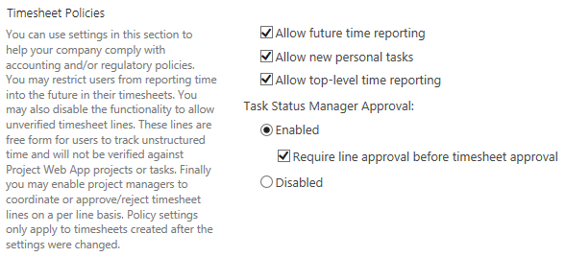

1. Under **Auditing**, select the **Enable Timesheet Auditing** check box to create a detailed record of all changes made to a timesheet.

**Tip** Click **Purge Log** to clear the auditing log.

1. Under **Approval Routing**, select the **Fixed Approval Routing** check box to prevent team members from manually specifying the next approver when they submit their timesheet.
2. Under **Single Entry Mode**, select the **Single Entry Mode** check box if you want to enable team members to report task progress, as well as actual work, on their timesheets.
3. Click **Save**.

## Administrative Time

Time spent on things other than project work can be classified as administrative time. Administrative time may include vacation, sick leave, organizational meetings, training, or travel. Site administrators can set up different categories for administrative time, so that resources can capture those hours on their timesheets to accurately represent what they have done during a given reporting period.

* To add an administrative time category

1. Click Settings  > **PWA Settings**.
2. Under Time and Task Management, click Administrative Time.
3. Click **New Category**. A row is added to the table.

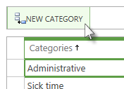

1. Type a name for the new administrative time category in the **Categories** column.
2. In the **Status** column, choose whether the category is currently **Open** for use on timesheets, or **Closed**.
3. In the **Work Type** column, choose whether the category captures **Working** time, such as training or travel, or **Non Work** time, such as vacation or sick leave.
4. In the **Approve** column, choose whether you want time reported in this category to require approval from a manager.
5. Select the check box in the **Always Display** column if you want to display a row for this category, by default, on every timesheet for every user. For example, you might choose to always display a timesheet row for the **Sick time** category, so that team members are reminded to report those hours.
6. Click **Save**.

**Tip** Before clicking **Save**, be sure you have the right set of categories listed. Once you click **Save**, any new categories you have added cannot be deleted.

If you want to make it so that a category that has been saved is no longer available for selection in a timesheet, change the **Status** column for that category to **Closed**, and be sure the check box in the **Always Display** column is cleared.

## Task Settings and Display

Site administrators can use the **Task Settings and Display** page to change how resources report task progress, how actual work can be updated, and other task settings.

* To configure task settings and display options

1. Click Settings  > **PWA Settings**.
2. Under Time and Task Management, click Task Settings and Display.
3. Under **Tracking Method**, select the tracking method that best represents how you want team members to report their progress on project tasks. Options in this section can only be modified if you are not using Single Entry Mode. If you are using Single Entry Mode, the **Hours of work done per period** and **Force project managers to use progress reporting method specified above for all projects** options are automatically selected and cannot be modified.

**Tip** If you want project managers to have the option of displaying different reporting methods for their projects, clear the **Force project managers to use the progress reporting method specified above for all projects** check box. However, requiring the same reporting method provides a consistent user experience throughout all projects in your organization, and may make it easier for team members to report progress.

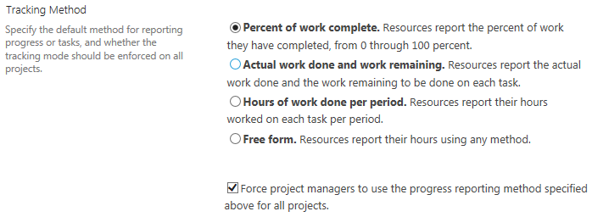

1. Under **Reporting Display**, choose whether you want resources to report their hours daily or weekly. If you choose the **Resources should report their total hours worked for a week** option, select the appropriate day from the **Week starts on** list.

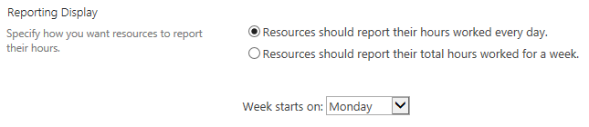

1. Under **Protect User Updates**, specify how you want updates on actuals to occur:

* To prevent the project manager from updating a team member's actual time worked, select the **Only allow task updates via Tasks and Timesheets** check box.
* To import actual work from all timesheet lines, regardless of line classification, select the **Import all timesheet line classifications** check box. If this check box is cleared, only actual work from timesheet lines that have a standard classification will be imported into task status.
* To enable users to provide task updates using periods that they define, select the **Allow users to define custom periods for task updates** check box.

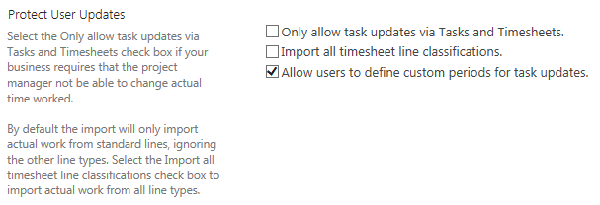

1. In the **Define Near Future Planning Window** section, type the number of reporting periods you want to include in the Near Future Planning Window on the **Tasks** page.

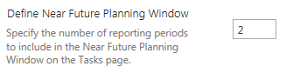

1. Click **Save**.

## Manage Timesheets

The Manage Timesheets page enables administrators to recall timesheets that have been submitted (sending them back to the submitter), or delete timesheets that are no longer needed.

* To recall or delete a timesheet

1. Click Settings  > **PWA Settings**.
2. Under Time and Task Management, click Manage Timesheets.
3. Click the row for the timesheet that you want to recall or delete, and then click the corresponding button.

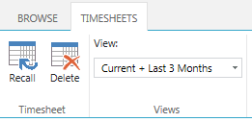

## Timesheet Managers

If fixed approval routing is not enabled, users can select from these timesheet managers when they submit their timesheets for approval. Only people who appear on this list and have the approve timesheet permission can give final approval.

* To add a manager

1. Click Settings  > **PWA Settings**.
2. Under Time and Task Management, click Timesheet Managers.
3. Click Add Manager.

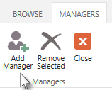

1. Select the person you are adding as a manager on the **Pick Resource** box. Use the **Search** box to help find the person in the list.
2. Click **OK**.

To remove a manager, select the person in the list on the **Timesheet Managers** page, and then click **Remove Selected**.

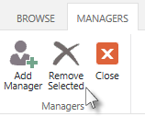

6

# Operational Policies: Project Web App Settings

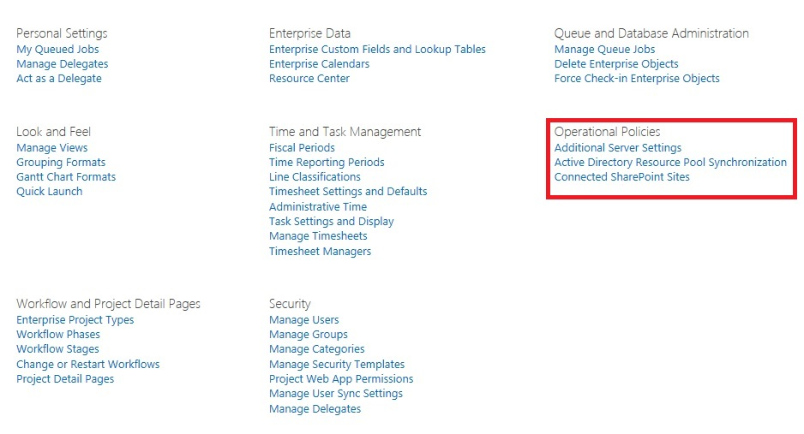

The Operational Policies settings in the Project Web App settings page

This chapter about Operational Policies Management contains the following sections:

* Additional Server Settings
* Active Directory Resource Pool Synchronization
* Connected SharePoint Sites

## Additional Server Settings

The Additional Server Settings page in Project Server 2013 PWA settings allows you to configure settings for:

* Enterprise Settings
* Currency Settings
* Resource Capacity Settings
* Resource Plan Work Day
* Task Mode Settings

### Enterprise Settings

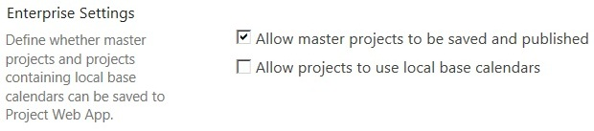

Enterprise settings

Enterprise Settings lets you determine whether Project Server 2013 allows for projects to have the following capabilities:

* **Allow master projects to be saved and published** (By default, this option is enabled.) Enabling this setting enables master projects to be used in Project Server 2013. Master projects are projects that contain sub-projects, and they usually contain tasks that are dependent on one another. Check with your Project Management Office to determine whether your organization prohibits the use of master projects.
* **Allow projects to use local base calendars** Enabling this settings lets users not only use enterprise base calendars that are on the system for their enterprise projects, but to also use local base calendars that users create. Having this setting disabled (which is the default) restricts users to using only enterprise base calendars that are on the system for their projects. Restricting the users to enterprise calendars gives you more control by preventing problems that can occur when projects use local base calendars that contain conflicting data. For example, a project that uses a local base calendar that differs from an enterprise calendar (for example, July 4 as a work day versus a holiday) can lead to faulty calculations and other issues.

Use the following procedure to configure the Enterprise settings.

* To configure the Enterprise Settings:

1. In Project Web App, click the Settings icon, and then click **PWA Settings**.
2. On the PWA Settings page, in the Operational Policies section, click **Additional Server Settings**.
3. On the Additional Server Settings page, in the **Enterprise Settings** section:
   1. Select **Allow master projects to be saved and published to Microsoft Project Server 2013** if you want to enable this setting. (By default, it is enabled.)
   2. Select **Allow projects to use local base calendars** if you want to enable this setting (By default, this option is cleared.)

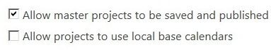

1. Click **Save**.

### Currency Settings

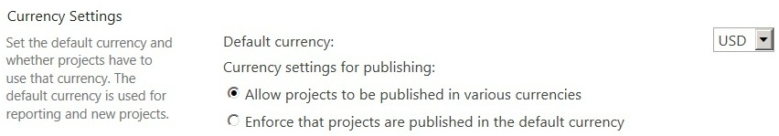

Enterprise settings

Through the currency setting, you can select the default currency setting for projects that are published to the server. (This is used for reports and the default view for new projects.) The default value is based on the default currency of the language that is used for the Project Web App instance.

You can also select the currency settings for publishing:

* **Allow projects to be published in various currencies** Select this option if your organization uses multiple currencies for costs within projects. (This is the default setting).
* **Enforce that projects are published in the server currency** Select this option if your organization only uses a single currency for costs within projects. The currency that is used is the one selected as the default server currency.

Use the following procedure to configure the Currency settings.

* To configure the Currency settings:

1. In Project Web App, click the Settings icon, and then click **PWA Settings**.
2. On the PWA Settings page, in the Operational Policies section, click **Additional Server Settings**.
3. In the Default Currency menu, select the default currency that will be used by projects that are published your Project Server 2013 environment.



1. On the Additional Server Settings page, in the Currency Settings section, select one of the following currency options:

* **Allow projects to be published in various currencies** (Selected by default).
* **Enforce that projects are published in the server currency**  
  If you select **Enforce that projects are published in the server currency**, you see a message. This message box warns you that the change is only being enforced on all successive projects that are published to the server. All projects that are not using the default server currency must be changed to the default currency and republished.

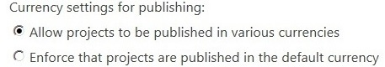

1. Click **OK**.

All projects published to the server that are using a currency that conflicts with the server currency will be displayed in the Currency Settings section of the page in the Project in conflict with the server currency list. You can use this as a reference to note which projects have to have their currency changed to the server currency.

1. Click **Save**.

#### Change currency option for a project

Use the following procedure in Project Professional 2013 to change the currency settings for a project. You can use this procedure to do the following:

* Select the currency for a specific project if the currency setting lets you use multiple currencies.
* Change the currency setting on a project to the server currency if the currency setting only lets you use the server currency.

Use the following procedure to change the currency for a project in Project Professional 2013.

* To change the currency for a project in Project Professional 2013:

1. Open and log on to Project Professional 2013.
2. Check out and open a project from Project Server 2013.
3. Click **File**, and then click **Options**.
4. On the Project Options page, click **Display**.
5. On the Display page, in the **Currency options for this project** section, select the currency and then the currency format (symbol, placement, and decimal digits) that you want to use for this project.
6. Click **OK**.
7. Click **File**, and then click **Save** to save the project.
8. Click **File**, and then click **Publish** to publish the project.

### Resource Capacity Settings

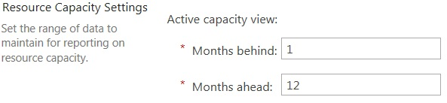

Resource Capacity Settings

Resource Capacity Settings are used to calculate your resources' availability for work over a specified time range. Your resources' capacity data for the specified time range is stored on the Reporting database, and it is updated daily through a processing job that is run at a time that you specify in the settings. You are able to set the Active capacity view by entering a time range in relative terms — months in the past, and months in the future — where the current date is a relative starting point. You can view your resources' availability for work through the Resource Center in Project Web App.

The default **Active capacity view** settings are "1" month behind and "12" months ahead. This means that in the Resource Center you can view a resource's future availability for up to 12 months from the current date, and you can view utilization over the last month. By increasing the **Month ahead** setting, you get more capacity computed for future periods. For example, imagine that a company plans for new projects later in the year and wants to forecast the capacity for resources from 12 months to 24 months. Some customers might want to increase the **Months behind** value to get an accurate report of work completed in the past (for example, to account for any users who might report time long after the work is completed).

Note that increasing either value also increases the time it takes for the daily processing job to run.

Use the following procedure to configure the Resource Capacity setting.

* To configure the Resource Capacity setting:

1. In Project Web App, click the Settings icon, and then click **PWA Settings**.
2. On the PWA Settings page, in the Operational Policies section, click **Additional Server Settings**.
3. On the Additional Server Settings page, in the Resource Capacity Settings section, for **Active capacity view**, enter the following:
   1. In the **Months behind** field, enter the number of months in the past that you want resource data to be calculated from.
   2. In the **Months ahead** field, enter the number of months in the future that you want resource data to be calculated from.

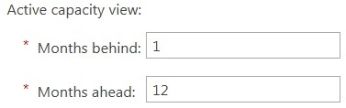

1. Click **Save**.

Resource Capacity information will be process daily at 1:00 AM by default.

### Resource Plan Work Day

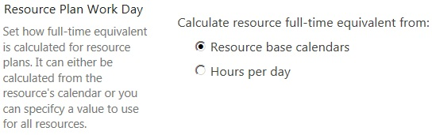

Resource Plan Work Day Setting

**Resource Plan Work Day** lets you specify the length of a work day ("full-time equivalents" or FTE) for all resources in your resource plan. This value can be calculated from the resource’s base calendar or can be manually entered as a value.

Use the following procedure to configure the Resource Plan Work Day setting.

* To configure the Resource Plan Work Day setting:

1. In Project Web App, click the Settings icon, and then click **PWA Settings**.
2. On the PWA Settings page, in the Operational Policies section, click **Additional Server Settings**.
3. On the Additional Server Settings page, in the Resource Plan Work Day section, for Calculate resource full-time equivalent from, select one of the two options:

* **Resource base calendars**  Use this option if you want the full-time equivalents to be calculated from each resources base calendar. This is the default option.
* **Hours per day** Use this option if you want to specify the full-time equivalents for your resources in the resource plan. After selecting this option, enter the value (in hours) of the standard work day for your organization. Note that this value is used for all resources in the resource plan.

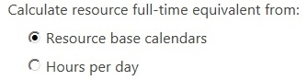

1. Click **Save**.

### Task Mode Settings

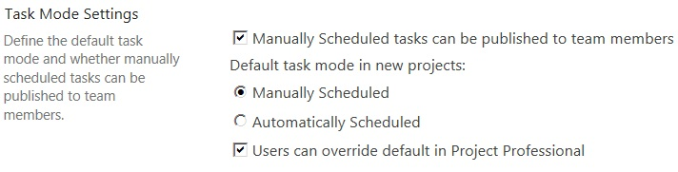

Task Mode Setting

**Task Mode Settings** let you select the default mode in which tasks are scheduled: manually or automatically. Additionally, if you select the default setting (**Manually Scheduled**), you can also configure if you want task to be published to team members.

Manually scheduled tasks (also known as "User-Controlled Scheduling") were introduced in previously in Project Server 2010. In this mode, when a new task is created, the scheduling engine is ignored and Project Server 2013 creates the task without a duration, start date, or finish date. (These values can be entered manually.) It can be useful for scheduling tasks with hard dates that are difficult to move (for example, training).

Use the following procedure to configure the Task Mode setting.

* To configure the Task Mode setting:

1. In Project Web App, click the Settings icon, and then click **PWA Settings**.
2. On the PWA Settings page, in the Operational Policies section, click **Additional Server Settings**.
3. In the Task Mode Settings section:
   1. Select **Manually Scheduled tasks can be published to team members** (which is enabled by default) if you want to allows project managers to publish their manually scheduled task to team members.



* 1. For **Default task mode in new projects**, select one of the two following settings:
* **Manually Scheduled** You have to enter duration, start, and finish dates for your tasks. By default, this option is selected.
* **Automatically Scheduled** The scheduling engine automatically calculates durations and start dates and finish dates for your tasks.

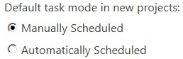

1. Select **Users can override default in Project Professional** (which is enabled by default) if you want to enable your Project Professional 2013 users to override the default task mode settings that you selected.



1. Click **Save**.

## Active Directory Resource Pool Synchronization

Keeping your Project Server 2013 resources synchronized with Active Directory is a good way to ensure that your resources are always current, and to automatically add the newest group’s members to your list of resources.

Project Server 2013 Active Directory Enterprise Resource Pool synchronization is used to create or update multiple Project Server enterprise resources at the same time. For example, new employees in your department can automatically be added as Project Server enterprise resources as long as they are in the Active Directory group selected for synchronization.

Enterprise Resource Pool synchronization also updates enterprise resource properties with the most current data from Active Directory. For example, an employee's name and email address may change because of marriage. As long as the change is made in Active Directory and the user is in the linked group, the change occurs in the user's Enterprise Resource properties when synchronization occurs.

### Changes in Active Directory Resource Pool synchronization for Project Server 2013

It is important to note the following changes in Active Directory Resource Pool synchronization in Project Server 2013:

* No Project Server user accounts will be automatically created for resources that are added to the Enterprise Resource Pool through Active Directory synchronization.
* You can synchronize up to five Active Directory groups with the Enterprise Resource Pool in Project Server 2013. Each Active Directory groups can contain nested groups whose members will also be synchronized.

### User Synchronization scenarios

The following are the two most common actions that occur during the Enterprise Resource Pool synchronization process:

* **A new Project Server enterprise resource can be created based on Active Directory membership** By adding a new member to the Active Directory group that is being used for your Enterprise Resource Pool synchronization, you automatically also create a resource for this user in Project Server..
* **An existing Project Server user account's metadata (for example, name, email address, and so on) can be updated if it has changed in Active Directory** For example, if a resource’s last name was changed in Active Directory, the Project Server 2013 Enterprise Resource Pool synchronization makes sure that the resource name is also changed in the Project Server Enterprise Resource Pool.

The following table describes all Active Directory to Project Server 2013 Enterprise Resource Pool synchronization scenarios, as well as their corresponding actions:

|  |  |
| --- | --- |
| **Scenario** | **Action** |
| User exists in Active Directory and is a member of the Active Directory group mapped to the Enterprise Resource Pool. The user does not exist in Project Server | A new Project Server resource is created for this user.  **Note**: A Project Server User Account is not created based on this synchronization. The Active Directory user needs to be added to a Project Server security group to create a user account. For more information, see the section in this chapter titled “Best practices to configure Active Directory groups for Enterprise Resource Pool synchronization in Project Server 2013”. |
| User exists in Active Directory and is a member of the Active Directory group mapped to the Enterprise Resource Pool. The user exists in Project Server as a user, but not as a resource. | A new Project Server resource is created for this user, and is linked to the existing Project Server user account. |
| User exists in Active Directory and is a member of the Active Directory group mapped to the Enterprise Resource Pool. The corresponding resource already exists in Project Server. | The corresponding Project Server enterprise resource and user information is updated, if any updates were made to the user properties in Active Directory. |
| User exists in Active Directory, but is removed from the Active Directory group mapped to the Enterprise Resource Pool. | The resource is not inactivated in Enterprise Resource Pool.  **Note**: The corresponding Project Server User Account is not deactivated based on this synchronization. If the same Active Directory user is configured to synchronize with a Project Server security group, the Project Server user account will be inactivated when that synchronization occurs. For more information, see the section in this chapter titled “Best practices to configure Active Directory groups for Enterprise Resource Pool synchronization in Project Server 2013”. |
| A user is marked as inactive in Active Directory. | The resource is not inactivated in the Enterprise Resource Pool. The corresponding Project Server User is not deactivated based on this synchronization. |

### Requirements for Enterprise Resource Pool synchronization

Before you perform this procedure, confirm the following:

* You have access to Project Server through Project Web App with an account that has the **Manage Active Directory Settings** and the **Manage users and groups** global settings enabled.
* The Service Application (SA) service account for the Project Server instance has Read access to all Active Directory groups and user accounts involved in the synchronization.   
  You can verify this account in the Service Application properties on the Service Application Administration page on the SharePoint Central Administration website.
* The identity under which the Queue service runs needs to have access to all the forest and domains in which it is expected to find users.
* The SharePoint 2013 People Picker must be able to resolve groups and access user information from Active Directory in order for Project Server 2013 Active Directory ERP synchronization to work. The People Picker allows you to search for Active Directory groups to which you want to synchronize to the ERP. The SharePoint 2013 People Picker is described in more detail later in this article.

### Configure Enterprise Resource Pool Synchronization

In the Project Web App Server Settings, you access the Active Directory Enterprise Resource Pool Synchronization page in which you can configure your settings.

* To configure Enterprise Resource Pool Synchronization:

1. In Project Web App, click the Settings icon, and then click **PWA Settings**.
2. On the PWA Settings page, in the Operational Policies section, click **Active Directory Resource Pool Synchronization**.
3. On the Active Directory Enterprise Resource Pool Synchronization page, in the **Active Directory Group** section, type the name or Service Account Manager (SAM) account of the active directory group or groups you want to synchronize with the Enterprise Resource Pool. If you are unsure of the group name, you can type part of the group name to display groups in Active Directory that contain the text string. The SharePoint 2013 People Picker provides the search functionality that displays the Active Directory groups you are looking for. To select a group from a remote forest, type the fully qualified domain name of the group (for example, group@corp.contoso.com).

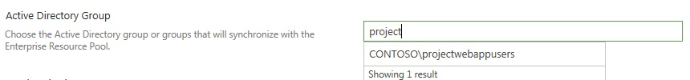

Active Directory Group search box

Note You can synchronize to a security or distribution group of any scope (Local, Global, or Universal).

1. Click **Save** to save the settings and have synchronization scheduled to recur at the default setting (once a day at 12:00 AM). Click **Save and Synchronize Now** if you want to synchronize your Enterprise Resource Pool immediately, save your settings, and have synchronization scheduled to recur at the default setting.

You can check the status of the Enterprise Resource Pool synchronization by returning to the Active Directory Enterprise Resource Pool Synchronization page and reviewing the information in the Synchronization Status section. It contains information such as when the last successful synchronization occurred.



If last synchronization failed for any reason, it will also post a timestamp of when it occurred if you wanted to search for more information in the ULS logs.

### Schedule Enterprise Resource Pool Synchronization

In Project Server 2013, scheduling synchronization of your enterprise resource pool with Active Directory groups is done through the Timer Job Status page in Central Administration.

* To schedule Enterprise Resource Pool Synchronization:

1. In Central Administration, click **Monitoring**.
2. On the Monitoring page, in the Timer Job section, click **Check job status**.
3. On the Timer Job Status page, find and then click **Project Web App: Synchronization of AD with the Enterprise Resource Pool job for <PWA site name>**.

For example: Project Web App: Synchronization of AD with the Enterprise Resource Pool job for http://contoso/pwa.

1. On the Edit Timer Job page, in the **Recurring Schedule** section, you can configure when the synchronization will run on a recurring basis. Under **This timer job is scheduled to run**, you can select one of the following options, based on your company's requirements:
   * **Minutes**: Allows you to specify a frequency in which the job will run —Every x minutes.
   * **Hourly**: Allows you to specify an interval in which the job will randomly run —Starting every hour between x minutes past the hour and no later than y minutes past the hour.
   * **Daily**: Allows you to specify an interval in which the job will randomly run —Starting every day between <time of day> and no later than <time of day>.
   * **Weekly**: Allows you to specify in which the job will randomly run —Starting every week between <day of week and time of day> and no later than <day of week and time of day>.
   * **Monthly**: Provides two options:

* Allows you to specify an interval in which the job will randomly run —**By date: starting every month between <time of day and day of month> and no later than <time of day and day of month>**.
* Allows you to specify an exact time of the month in which the timer job will run —**By day: starting every month <time of day, day of the week, and week of the month. For example, "12:00 AM on the first Sunday"**.

1. Click **OK** to save your configuration changes.

Note You can click **Run Now** at any time to run the timer job immediately.

Note that several options provide a period of execution time to run the job instead of an exact time or frequency. Selecting an option that provides a period of execution time allows the timer service to select a random time within the parameters specified in order to run the job on each application server. Using an option with a period of execution time is appropriate for high-load jobs which run on multiple servers in the farm. Running this type of job on all servers of the servers simultaneously might place an unreasonable load on the farm.

#### Requirements for synchronizing the Enterprise Resource Pool with Active Directory users in a different domain

Imagine that you need to synchronize your Enterprise Resource Pool with Active Directory users that exist in a domain other than the one that Project Server 2013 is installed on. For example, your organization may acquire a new company, or your branch may need to add users from a different branch within your organization. In this scenario, a two-way trust relationship must exist between the domains in order for Active Directory users in one domain to synchronize with the Enterprise Resource Pool in a Project Server 2013 installation that exists on a different domain.

Note Project Server 2013 does not support synchronizing your Enterprise Resource Pool or security groups with Active Directory users across different domains in which only a one-way trust relationship exists between domains.

For more information about trust relationships in Windows Server 2008 and Windows Server 2008 R2, see [Managing Trusts](http://technet.microsoft.com/en-us/library/cc731335.aspx) (http://technet.microsoft.com/en-us/library/cc731335.aspx). For information about creating a two-way trust relationship between domains in Windows Server 2008 or Windows Server 2008 R2, see [Create an External Trust](http://technet.microsoft.com/en-us/library/cc771580.aspx) (http://technet.microsoft.com/en-us/library/cc771580.aspx).

#### SharePoint 2013 People Picker

As mentioned earlier, Project Server 2013 can synchronize a user from Active Directory only if this user can first be found by the People Picker.

People Picker will only be able to return users, groups, and claims in the following topologies:

* The domain in which your SharePoint Server 2013/Project Server 2013 farm is currently installed.
* A domain that has a two-way trust relationship with the domain in which your SharePoint Server 2013/Project Server 2013 farm is currently installed.

By default, People Picker only returns users, groups, and claims from the domain on which SharePoint Server 2013 is installed. If you want People Picker to return query results from more than one forest or domain, you can create a two-way trust between the forests or domains. For both these cases, People Picker functions automatically, and no additional configuration is necessary. When two-way trusts are established, the People Picker automatically returns results found in the trusted domains.

For example, the Contoso.com domain has a two-way trust with Litware.com and Fabrikam.com. The Project Server 2013 ERP synchronization defined in the Contoso.com domain in which the Project Server 2013 farm resides is configured to include Bob (from the Fabrikam.com domain) and Mindy (from the Litware.com domain). People Picker finds both groups in which both Bob and Mindy reside in their domain’s Active Directory, the Project Server 2013 ERP synchronization will synchronize the group and both users successfully. If no trust or a one-way trust existed between the Contoso.com domain and the other domains, the users would not be able to synchronize to the Project Server 2013 ERP.

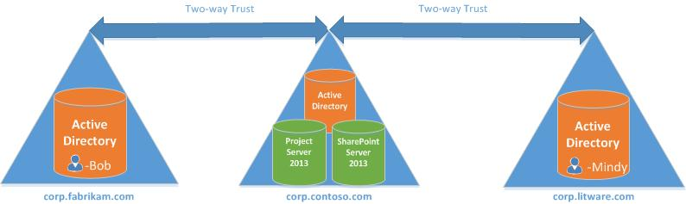

## Supported Active Directory topologies for Project Server 2013 Enterprise Resource Pool synchronization

When planning to synchronize your users from Active Directory groups to resources in your Project Web App Enterprise Resource Pool in Project Server 2013, it is important to understand that only certain Active Directory topologies are supported.

The following topologies are supported when synchronizing your users and groups from Active Directory to your Enterprise Resource Pool for your Project Web App instance in Project Server 2013.

Important Some topologies will require you to install the Project Server 2013 March 12, 2013 Cumulative Update to your Project Server 2013 environment in order to be supported.

* Single Domain topology
* Single Forest Parent-Child Trust topology - (requires the Project Server 2013 March 12 2013 Cumulative)
* Single Forest Tree-Root Trust topology - (requires the Project Server 2013 March 12 2013 Cumulative)
* Forest Trust - (requires the Project Server 2013 March 12 2013 Cumulative)
* External Trust Topology - (requires the Project Server 2013 March 12 2013 Cumulative)

### Single Domain topology

In the single domain topology, Active Directory and Project Server 2013 servers all reside in the same domain. This is the simplest of topologies for Active Directory synchronization to your Enterprise Resource Pool or security groups, since this topology does not require the configuration of trusts between domains.

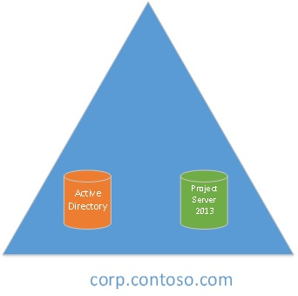

Single Domain Topology

### Single Forest Parent-Child Trust topology

In this single forest topology, a child domain is created off of the parent domain. By default, the relationship between the child and parent domain is automatically two-way and transitive. This relationship ensures that users in the corp.contoso.com domain can be synchronized with the Project Server 2013 Enterprise Resource Pool in usa.corp.contoso.com. Additionally, if you created another child domain off of the usa.corp.contoso.com domain and host an Active Directory there, its users and groups would be able to be resolved by Project Server 2013 hosted in any other domain in the same tree.

Important This topology will require you to install the Project Server 2013 March 12, 2013 Cumulative Update to your Project Server 2013 environment in order to be supported.

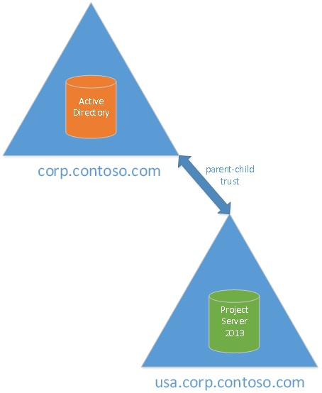

Single Forest Parent-Child Trust Topology

### Single Forest Tree-Root Trust topology

In this single forest topology, when you create a new domain within an existing forest, you create a tree root trust between the new domain and the rest of the forest. By default, this relationship ensures that users in a domain in the tree (for example, usa.corp.contoso.com) can be synchronized to the Project Server 2013 Enterprise Resource Pool if it resided in the new domain (for example, corp.litware.com). Tree-root trusts are always two-way and transitive, so the synchronization could also occur successfully if the Project Server 2013 Enterprise Resource Pool resided in usa.corp.contoso.com, and the Active Directory users resided in the corp.litware.com domain.

Important This topology will require you to install the Project Server 2013 March 12, 2013 Cumulative Update to your Project Server 2013 environment in order to be supported.

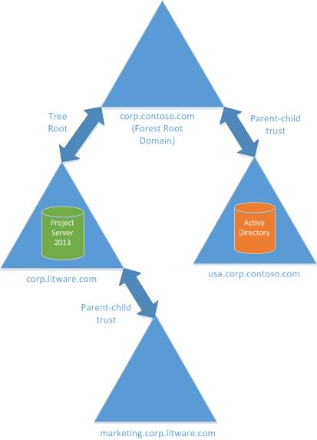

Single Forest Tree-Root Trust Topology

### Forest Trust topology

In this multi-forest topology, two forests exist in which Project Server 2013 resides in one forest, and the Active Directory users reside in another. A forest trust needs to be created between forest root domains for each forest in order for the Project Server 2013 Enterprise Resource Pool to successfully synchronize with Active Directory groups and user in the other forest. Forest trusts are transitive, so any domain within one forest will trust any domain within the other forest. You are not required to setup individual trusts, although if your topology is complex you may need to set up some shortcut trusts. For more information about creating a shortcut trust, see the TechNet article [Create a shortcut trust](http://technet.microsoft.com/en-us/library/cc725721.aspx) (http://technet.microsoft.com/en-us/library/cc725721.aspx).

Important This topology will require you to install the Project Server 2013 March 12, 2013 Cumulative Update to your Project Server 2013 environment in order to be supported.

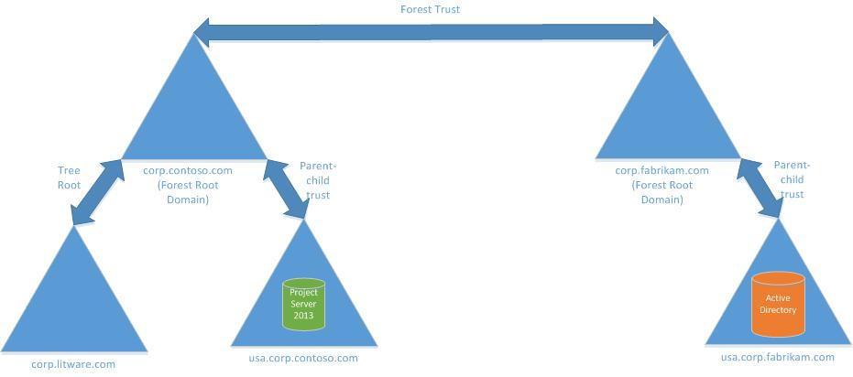

Forest Trust Topology

In the topology graphic above, a forest trust is established between the Contoso and Fabrikam forests. The domain in which Project Server 2013 resides (corp.litware.com) and the domain containing the Active Directory users (usa.corp.fabrikam.com) trust each other because of the transitivity of the forest trust. This trust can be configured to be either one-way or two-way.

### External Trust topology

In this multi-forest topology, you allow synchronization with users in a different forest by creating an external trust between the domain hosting Project Server 2013 and the domain hosting the Active Directory. This is useful if you need to synchronize users who reside in only a single domain, but not the whole forest.

Important This topology will require you to install the Project Server 2013 March 12, 2013 Cumulative Update to your Project Server 2013 environment in order to be supported.

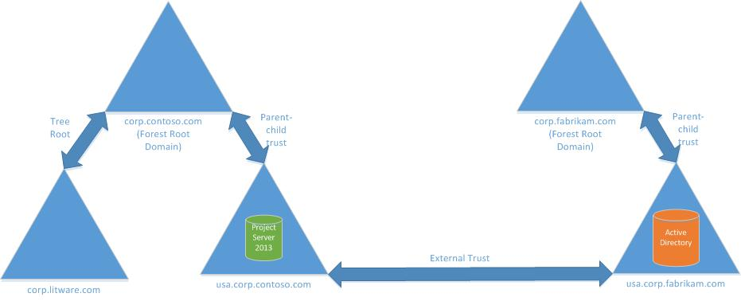

External Trust Topology

In the topology graphic above, Project Server 2013 can synchronize with groups and users in the usa.corp.fabrikam.com domain. Since an external trust is non-transitive, Project Server 2013 will not be able to synchronize with groups or users from any other domain in the Fabrikam forest.

### Unsupported Topologies

All topologies not mentioned in this article as supported topologies are not supported. This includes (but not limited to):

* Topologies using Realm trusts
* Topologies without properly configured trusts

## Best practices to configure Active Directory groups for Enterprise Resource Pool synchronization in Project Server 2013

When configuring synchronization between the Enterprise Resource Pool (ERP) and Active directory groups in Project Server 2013, a key consideration is that after being added as a resource to Project Server, you still need to add the resource as a user in order for the resource to use Project Web App. Unlike the previous version, in Project Server 2013 users accounts are not automatically created for resources that are added to the Enterprise Resource Pool through Active Directory synchronization. This article describes a best practice in which you can configure your Active Directory groups for security group synchronization as well as ERP synchronization in order to add user accounts for your resources.

### Active Directory group configuration for ERP and security group synchronization

It is important to note the following when planning to configure your active directory groups for synchronization with the ERP and with security groups in Project Server 2013:

* + You can synchronize up to five Active Directory groups with the Enterprise Resource Pool.
  + You can only synchronize one Active Directory group with each security group. For example, only one Active Directory group can be configured to synchronize with the default Project Managers security group.

The following graphic displays the method we suggest to configure your Active Directory groups to add your Project Server 2013 users both as resources and as users to their appropriate security groups.

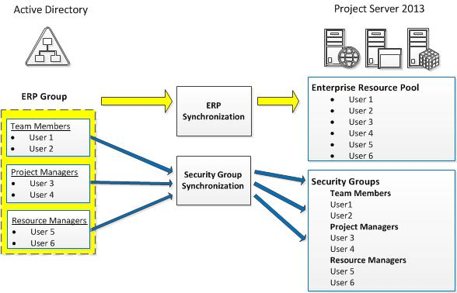

Best practices for Active Directory Synchronization to Project Server 2013 diagram

In the graphic above, Active Directory is configured to contain a single “ERP Group” that also contains nested Active Directory groups for Team Members, Project Managers, and Resource Managers. Although you can synchronize up to five Active Directory Groups with the Enterprise Resource Pool, we synchronize only the single ERP group, which would include all users contained in the subgroups. User 1, User 2, User 3, User 4, User 5, and User 6 would all be synchronized to the Enterprise Resource Pool in Project Server 2013.

In order to add the resources as users in Project Server 2013 to give them Project Server user accounts, we also need to synchronize them from Active Directory to their appropriate security group in Project Server 2013. In the graphic above, each of the nested sub-groups in the ERP Group are synchronized with their appropriate security group in Project Server 2013. For example:

* + The Team Member group in Active Directory is synchronized with the Team Members security group in Project Server 2013.
  + The Project Managers group in Active Directory is synchronized with the Project Managers security group in Project Server 2013.
  + The Resource Managers group in Active Directory is synchronized with the Resource Managers security group in Project Server 2013.

Note You can configure Active Directory synchronization to Project Server 2013 security groups through the Manage Groups page in the Security section of Project Web App Server Settings. For more information, see Chapter 8: Security.

A benefit of this configuration is that any changes to Active Directory can be made in a single location, and will be reflected in both the Enterprise Resource Pool and in security group. For example, if the Team Member “User 1” gets married and her last name is updated in Active Directory, the change in user properties will be reflected in both the Enterprise Resource Pool and the Project User Account when both groups are synchronized with the Active Directory group. Another benefit is that it prevents confusion that can be associated if a user is in two or more active directory groups that are synchronized with the ERP.

## Manage connected SharePoint sites in Project Server 2013

The Connected SharePoint Sites page in the Project Web App Settings lets you manage project sites that are associated with Project Web App projects in Project Server 2013.

You can do the following through the Connected Project Sites page:

* Create a new project site
* Edit a project site address
* Synchronize
* Delete a project site
* Go to Project Site Settings

### Create Site settings

Create Site lets you create a new project site for your project if you did not create one when the project was originally published to Project Server 2013. You can view the Project Sites list on the Connect SharePoint Sites page to determine whether a project has an existing site. A project without a project site does not have a corresponding URL next to it in the Site Address column.

* To create a project site:

1. In Project Web App, click the **Setting** icon, and on the menu click **PWA Settings**.
2. On the Project Server Settings page, in the **Operational Policies** section, click **Connected SharePoint Sites**.
3. On the Connected SharePoint Sites page, from the Project Name list, select a project for which you want to create the project site.
4. Click **Create Site**.

The **Create Project Site** dialog box appears.

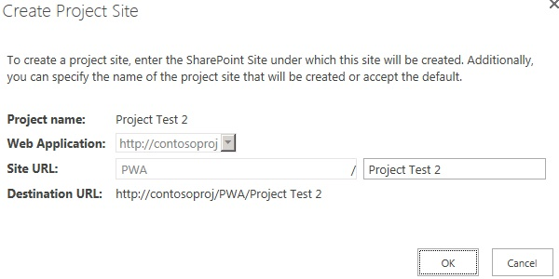

Create Project Site dialog box

1. In the **Web Application** list, select the web application that you want for the project site.
2. In the **Site URL** field, verify the site URL for the project site. You can edit the site URL information, if necessary. The site URL is appended to the web application name to provide the destination URL (as seen in the **Destination URL** field).
3. Click **OK**.

The project site you created now appears next to the project name that you selected in step 2.

### Edit Site Address settings

Edit Site Address settings let you edit the destination URL for a project site to point to a new site address. Changing the site address information breaks the existing link between the project and the existing project site. You can then enter the information for the new project site.

Note Before changing the project site URL for a project, be sure to provision a new project site with a new site template.

* To edit the site address for a new project site:

1. In Project Web App, click the **Setting** icon, and on the menu click **PWA Settings**.
2. On the Project Server Settings page, in the **Operational Policies** section, click **Connected SharePoint Sites**.
3. On the Connected SharePoint Sites page, from the **Project Name** list, select a project for which you want to edit the project site information.
4. Click **Edit Site Address**.

The Edit Site Address dialog box appears.

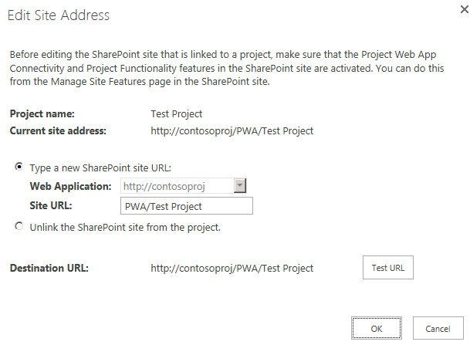

Edit Site Address dialog box

1. To change the project site URL to the new URL, select **Type a new SharePoint site URL**. Select the Web Application in which the new site is located and enter the Site URL for the new site.
2. Click **Test URL** to verify whether the new project site URL can be opened.
3. You optionally can unlink the existing SharePoint site from the project through the Edit Site Address dialog box. To do this, click **Unlink the SharePoint site from the project**.

Note Unlinking a SharePoint Tasks List project from a project site enables the enterprise project feature for the project.

1. Click **OK**.

The project site URL for the project you selected in step five is changed to the new URL.

### Synchronize settings

Note The Synchronize setting is only available in Project Server Permission Mode. This setting is not available in SharePoint Permission Mode.

The Synchronize settings let you manually synchronize the project site's users, permissions, and other Project Server–related information between Project Server 2013 and the Web server that is running SharePoint Foundation 2013.

If you want to automatically run synchronization for your project sites, see the Automatic Provisioning option that is available in the Project Site Provisioning Settings.

* To synchronize your project site information between Project Server and SharePoint Foundation:

1. In Project Web App, click the **Setting** icon, and on the menu click **Project Web App Settings**.
2. On the Project Server Settings page, in the **Operational Policies** section, click **Connected SharePoint Sites**.
3. On the Connected SharePoint Sites page, from the **Project Name** list, select a project for which you want to synchronize your project site information between Project Server 2013 and SharePoint Foundation.
4. Click **Synchronize**.

Note Synchronization will automatically recur at the default schedule of every one minute. You can choose to change the default schedule synchronization setting by configuring the Project Server: Synchronization of SharePoint Server permission to Project Web App permissions timer job in Central Administration.

* To change the synchronization schedule:

1. In Central Administration, click **Monitoring**.
2. On the Monitoring page, in the **Timer Job** section, click **Review job definitions**.
3. On the Job Definitions page, find and click **Project Server: Synchronization of SharePoint Server permission to Project Web App permissions for job <PWAInstance>**.

For example: *Project Server: Synchronization of SharePoint Server permission to Project Web App permissions job for* [*http://contoso/pwa*](http://contoso/pwa).

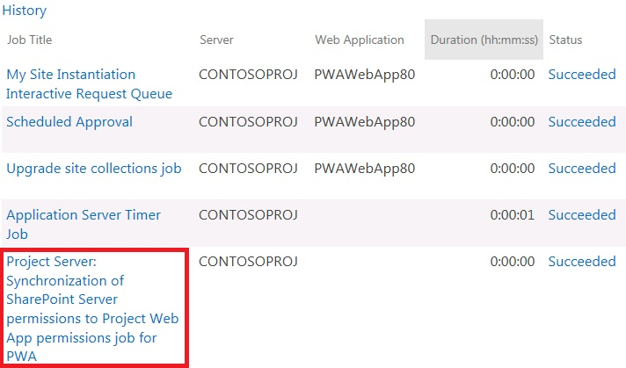

Project Server Synchronization job on the Job Definitions page

1. On the Edit Timer Job page for the job, in the **Recurring Schedule** section, you can specify when the synchronization will run on a recurring basis. Under This timer job is scheduled to run, you can select one of the following options, based on your company’s requirements:

* **Minutes**: Allows you to specify a frequency in which the job will run — Every x minutes.
* **Hourly**: Allows you to specify an interval in which the job will randomly run —Starting every hour between x minutes past the hour and no later than y minutes past the hour.
* **Daily**: Allows you to specify an interval in which the job will randomly run —Starting every day between <time of day> and no later than <time of day>.
* **Weekly**: Allows you to specify in which the job will randomly run —Starting every week between <day of week and time of day> and no later than <day of week and time of day>.
* **Monthly**: Provides you two options:
* Allows you to specify an interval in which the job will randomly run —**By date: starting every month between <time of day and day of month> and no later than <time of day and day of month>**.
* Allows you to specify an exact time of the month in which the timer job will run —**By day: starting every month <time of day, day of the week, and week of the month. For example, 12:00 AM on the first Sunday**.

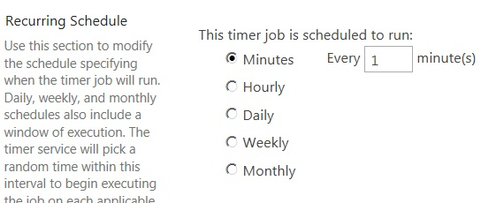

Recurring schedule section of the Edit Timer Jobs page

1. Click **OK** to save your configuration changes.

Note You can click **Run Now** at any time to run the timer job immediately.

### Delete site settings

The Delete Site settings let you permanently remove a project site and its content.

Important Before you proceed, verify that you want to permanently remove a site and its content. Deleted project sites are not recoverable.

Note . When a project site is deleted for a SharePoint Task List project, the enterprise project feature is enabled for the project.

* To delete a project site:

1. Project Web App, click the **Setting** icon, and on the menu click **PWA Settings**.
2. On the Project Server Settings page, in the **Operational Policies** section, click **Connected SharePoint Sites**.
3. On the Connected SharePoint Sites page, from the **Project Name** list, select a project for which you want to delete a project site.
4. Click **Delete Site**.

A message box appears that asks you to confirm whether you want to delete the project site. It also warns you that you will also be deleting all documents, issues, risks, and deliverables that are associated with the site.

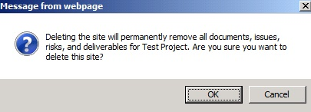

Confirmation message

1. Click **OK** to proceed with deleting the site. Click **Cancel** if you no longer want to delete the site.
2. If you clicked **OK**, the project site is deleted and no longer appears next to the project it was associated with on the Project Sites page.

### Go to Project Site Settings

Go to Project Site Settings lets you go directly to a project site's site settings page where the sites administration settings are located. From the Site Settings page, you can make changes to the site, such as add or remove users, add Web Parts to the site, customize the site’s look and feel, and many others.

* To go to the Site Settings page for a project site:

1. In Project Web App, click the **Setting** icon, and on the menu click **PWA Settings**.
2. On the Project Server Settings page, in the **Operational Policies** section, click **Connected SharePoint Sites**.
3. On the Connected SharePoint Sites page, from the **Project Name** list, select a project for which you want to view the Project Site settings page.
4. Click **Go to Project Site Settings**.
5. The Site Settings page for the selected project site opens. You can make changes to the site settings from this page.

7

# **Workflow and Project Detail Pages: Project Web App Settings**

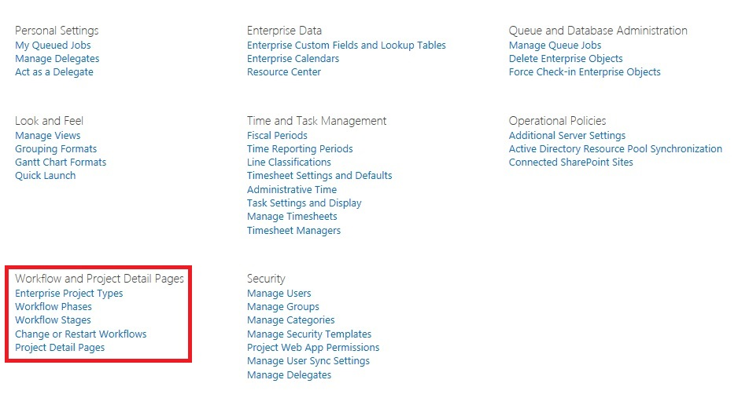

The Workflow and Project Details Pages settings in the Project Web App settings page

This chapter about Workflow and Project Detail Pages contains the following Project Web App settings:

* Enterprise Project Types
* Workflow Phases
* Workflow Stages
* Change or Restart Workflows
* Project Detail Pages (PDPs)

## Enterprise Project Types

An enterprise project type (EPT) is a template that users can select when they create a new project in Project Web App. You can create an EPT for:

* **Enterprise projects**, which are managed in Project Web App. For enterprise projects, the EPT brings together phases, stages, a single workflow, and Project Detail Pages (PDPs).
* **SharePoint task list projects**, which are managed on a SharePoint site and are viewable in Project Web App.

Normally, EPTs are aligned with individual departments: for example, marketing projects, IT projects, or HR projects. Using EPTs helps categorize projects within the same organization that have a similar project life cycle. For a user, the EPTs appear in a drop-down list of project types when the user clicks **New Project** in the Project Center.

* To create an EPT for an enterprise project

1. Click Settings  > **PWA Settings**.
2. Under Workflow and Project Detail Pages, click Enterprise Project Types.
3. Click **New Enterprise Project Type**.
4. Enter a **Name** for the type, and then provide a brief **Description**.
5. Leave the **Create new projects as SharePoint Tasks List Projects** check box cleared.
6. Select a workflow from the **Site Workflow Association** list.

Important Once you associate a site workflow with a project type and save the type, you cannot go back and update the type to use a different workflow.

If you are not seeing any workflows in this list, be sure that your administrator has installed and configured workflows.

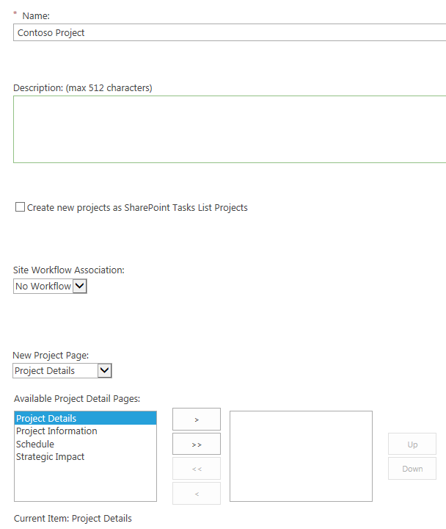

1. Select a project detail page (PDP) from the **New Project Page** list. This is the first page that users will see when they create new projects using this EPT.
2. If you selected **No Workflow** from **the Site Workflow Association** list, select the project detail pages that you want to include in this EPT from the **Available Project Detail Pages** box, and then click **>** to move them to the box on the right. Click **>>** to move all PDPs to the box on the right. You can change the order of the PDPs by selecting a PDP and clicking **Up** or **Down**.
3. If the EPT that you are creating is the one that all new projects should use by default, select the **Use this as the default Enterprise Project Type during Project Creation** checkbox**.**
4. Click the button next to the **Departments** field to select the departments you want to associate with this EPT, if it is appropriate.
5. If you want to associate an image with this project type, provide the URL for the image in the **Type the URL** box.

Note This is the image users will see next to the EPT in the **New Project** list in the Project Center. If you have an image on your computer that you want to use for this EPT, you must first upload it to an online document library (for example, the Shared Documents library in Project Web App).

1. In the **Order** section, choose where you want the EPT to be listed when a user clicks **New Project**.
2. To include this EPT at the end of the list, select the **Position** **this type at the end** check box.
3. To control the placement of this EPT in the list, clear the **Position this type at the end** check box, and then choose the EPT that you want to appear in the list just before your new EPT.
4. Select a template from the **Project Plan Template** list, if appropriate.
5. Select a template from the **Project Site Template** list, if appropriate.
6. Click **Save** to save this EPT. This makes it available for users to select when they create a new project.

* To create an EPT for a SharePoint task list project

1. Click Settings  > **PWA Settings**.
2. Under Workflow and Project Detail Pages, click Enterprise Project Types.
3. Click **New Enterprise Project Type**.
4. Enter a **Name** for the type, and then provide a brief **Description**.
5. Select the **Create new projects as SharePoint Tasks List Projects** check box.
6. Select a project detail page (PDP) from the **New Project Page** list. This is the first page that users will see when they create new projects using this EPT.
7. Select any other PDPs that you want to include in this EPT from the **Available Project Detail Pages** box, and then click **>** to move them to the box on the right. Click **>>** to move all PDPs to the box on the right. You can change the order of the PDPs by selecting a PDP and clicking **Up** or **Down**.
8. If the EPT that you are creating is the one that all new projects should use by default, select the **Use this as the default Enterprise Project Type during Project Creation** checkbox**.**
9. Click the button next to the **Departments** field to select the departments you want to associate with this EPT, if it is appropriate.
10. If you want to associate an image with this project type, provide the URL for the image in the **Type the URL** box.

Note This is the image users will see next to the EPT in the **New Project** list in the Project Center. If you have an image on your computer that you want to use for this EPT, you must first upload it to an online document library (for example, the Shared Documents library in Project Web App).

1. In the **Order** section, choose where you want the EPT to be listed when a user clicks **New Project**.
2. To include this EPT at the end of the list, select the **Position** **this type at the end** check box.
3. To control the placement of this EPT in the list, clear the **Position this type at the end** check box, and then choose the EPT that you want to appear in the list just before your new EPT.
4. Select a template from the **Project Plan Template** list, if appropriate.
5. Select a template from the **Project Site Template** list, if appropriate.
6. Click **Save** to save this EPT. This makes it available for users to select when they create a new project.

## Workflow Phases

In Project Web App, a phase represents a collection of stages grouped to identify a common set of activities in the project life cycle. Examples of phases are project creation, project selection, and project management. Phases have no direct technical effect on the behavior of an Enterprise Project Type. That is, changing the order of phases does not affect how the system reacts. The main purpose of these phases is to easily organize stages into logical groups.

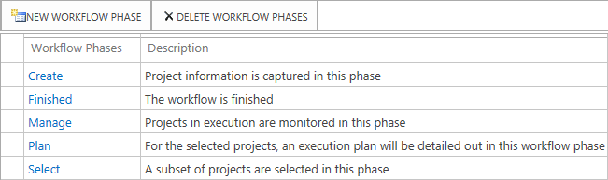

Default Workflow Phases

* To create a new workflow phase

1. Click Settings  > **PWA Settings**.
2. Under Workflow and Project Detail Pages, click Workflow Phases.
3. Click the **New Workflow Phase** button on the toolbar.
4. Enter the **Name** of the desired phase and optionally enter a **Description** of the phase.
5. Click Save.

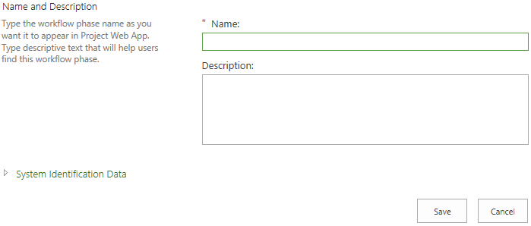

Add Workflow Phase

* To edit a workflow phase

1. Click Settings  > **PWA Settings**.
2. Under Workflow and Project Detail Pages, click Workflow Phases.
3. Click the existing workflow phase in the **Workflow Phases** column that you want to change.
4. Under **Name**, change the name to the phase name that you want, and optionally change the **Description** of the phase.
5. Click Save.

## Workflow Stages

A stage represents one step in a project life cycle in Project Web App. A stage is composed of one or more Project Detail Pages (PDPs) linked by common logic or theme. Stages are displayed to users as steps in a project. At each step, data must be entered, changed, reviewed, or processed.

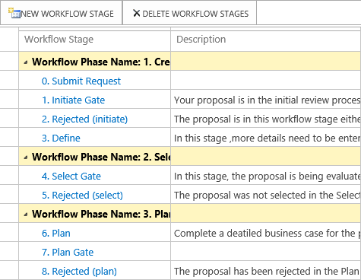

Workflow Stages

* To create a workflow stage

1. Click Settings  > **PWA Settings**.
2. Under Workflow and Project Detail Pages, click Workflow Stages.
3. Click the **New Workflow Phase** button on the toolbar.
4. Enter the **Name** of the desired stage, and optionally, enter a **Description** of the stage.
5. Under **Description for Submit**, type the description that will be displayed to end-users when they submit the stage to the workflow. By default, this description will be displayed in the following places:
   1. As a Tool Tip when users rest the pointer on the **Submit** button in a PDP.
   2. As part of the confirmation dialog box that is shown to users when they click the **Submit** button on a PDP.
6. Under **Workflow Phase**, select the phase that corresponds to this stage.
7. Under **Workflow Stage Status Project Detail Page**, select the PDP that will be displayed as the introduction page when the project enters this workflow stage.
8. Under **Visible Project Detail Pages**, select the PDPs you want to be visible for this workflow stage in the **Available** box, and then click **>** to move them to the **Selected Project Detail Pages** box.

Note By default no PDPs are visible for workflow stages but at least one page should be selected for a workflow stage.

1. Under **Additional Settings for the Visible Project Detail Page**, use the text box to edit the descriptions of the PDPs so that they are specific to this stage. Click the name of a PDP in the **Selected Project Detail Pages** box, and then type the description for that PDP in the text box in this section. You may also select the **The Project Detail Page requires attention** check box to highlight the PDP on the **Workflow Status** page. Repeat this for each PDP in the **Selected Project Detail Pages** box.
2. Under **Required Custom Fields**, select the custom fields that are required for the workflow to enter this stage, and then click **>** to move them to the box on the right. The custom fields that you select here are required only for this workflow stage, not for all the successive stages in the workflow.
3. Under **Read Only Custom Fields**,select the custom fields that are read-only for this workflow stage, and then click **>** to move them to the box on the right.
4. Under **Strategic Impact Behavior**, select whether the strategic impact values for the project are **Read Only**, **Read Write**, or **Required** in this workflow stage. If **Strategic Impact Behavior** is set to **Required**, then a strategic impact value has to be specified for every business driver. This is typically achieved by using the Strategic Impact Web Part on a PDP.
5. Under **Project Check In Required**, select whether this workflow stage requires the project to be checked in. If project check-in is required for the current stage, the user can’t submit the project to the workflow without first checking it in. This option is typically selected if, during this workflow stage, any project updates are expected that will be blocked if the project is not checked in.
6. Click **Save**.

## Change or Restart Workflows

The **Change or Restart Workflow** section enables you to change a project’s in-progress workflow or change a project’s current stage in a workflow.

* To Change or Restart a Workflow

1. Click Settings  > **PWA Settings**.
2. Under Workflow and Project Detail Pages, click Change or Restart Workflows.
3. Under **Choose Enterprise Project Type**, select the Enterprise Project Type that you are changing or restarting.

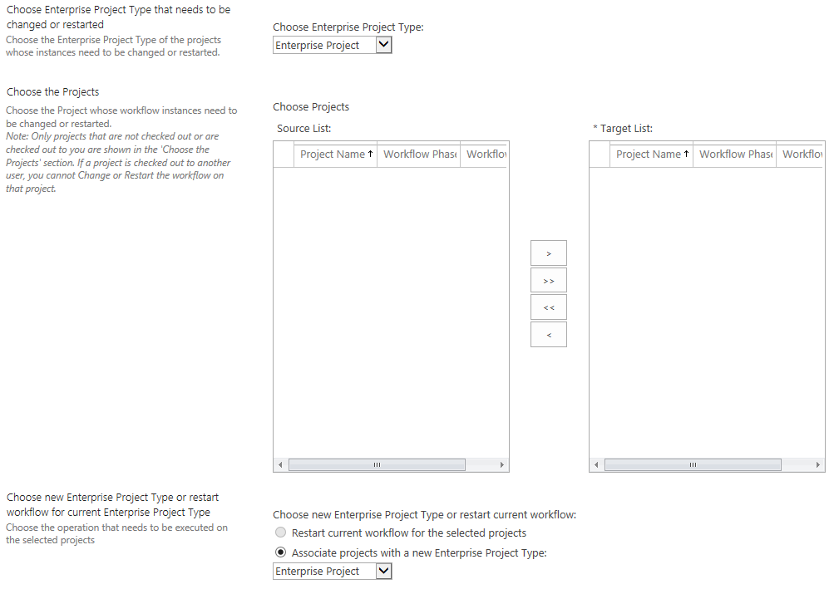

Restart Enterprise Project Type

1. Under **Choose Projects**,select the project with the workflow instances that you are changing or restarting, and add it to the **Target List**.

Note   Only projects that are not checked out or that are checked out to you are shown in the **Choose Projects** list. If a project is checked out to another user, the workflow cannot be changed or restarted on that project.

1. Under **Choose new Enterprise Project Type or restart workflow for current Enterprise Project Type**,select whether to restart the current workflow for the selected projects, or to associate the projects with a new Enterprise Project Type. If you are associating a new Enterprise Project Type, you must select the new type from the drop-down list.
2. Under **Choose Workflow Stage to Skip to**, you can select the target workflow stage that this workflow will go to.

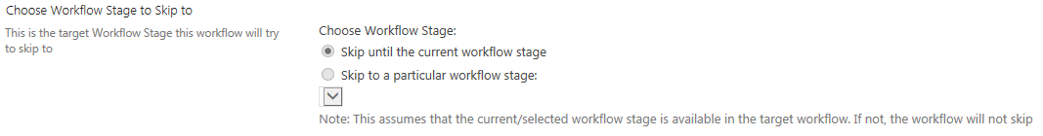

Choose Workflow Stage to Skip to

1. Click **OK**.

## Project Detail Pages

Project Detail Pages (PDPs) represent a single Web Part Page in Project Web App. PDPs can be used to display or collect information from the user. You can create PDPs much as you create any Web Part Page in a SharePoint site, where you can add Web Parts that provide the experience you want. You can add individual Web Parts from the standard Web Part galleries or create custom Web Parts.

Project Web App Web Parts and custom Web Parts used in demand management all contain custom fields. Web Parts can make calls to the Project Server Interface (PSI), query the database, or integrate with external systems.

There are three types of Project Detail Pages that can be created:

* **New Project**  Used for creating a project. This type of PDP is required with an enterprise project template that has a workflow for portfolio analysis.
* **Workflow Status** Shows the current stage and status for a project proposal.
* **Project** Used for editing.
* To create a project detail page

1. Click Settings  > **PWA Settings**.
2. Under Workflow and Project Detail Pages, click Project Detail Pages.
3. Click **Files** > **New Document**.
4. Type a file name for the new PDP in the **Name** box, and then choose a design for the page in the **Layout** section.

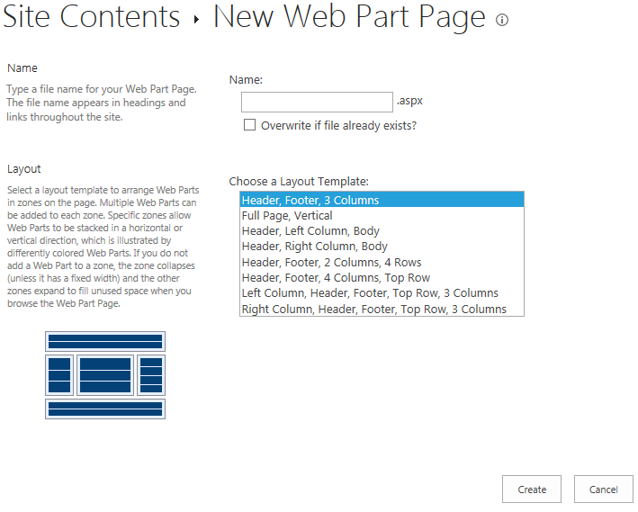

Choose a New Layout section of the New Web Part page

1. Click **Create**.
2. On the newly created blank page, click **Add a Web Part**.
3. Under **Parts**, select the Web Part you want to add, and then click **Add**.

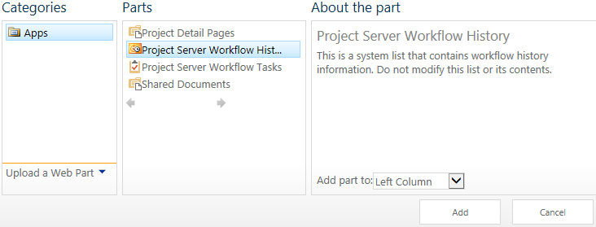

The Parts column of the Add a New Web Part page

1. Depending on the Web Part you selected, you may have to choose which project fields to include. Click the down arrow in the upper-right corner of the Web Part, and then click **Edit Web Part**.

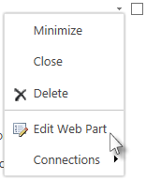

1. Click **Modify**.
2. Choose the project data you want the selected Web Part to display, and then click **OK**.
3. Under **Appearance**, enter a **Title**, and then click **OK**.
4. Click **Page** > **Stop Editing**.
5. Click **Page** > **Edit Properties** to update the **Display Name** and **Page Type** for your newly created PDP.

8

# **Security: PWA Settings**

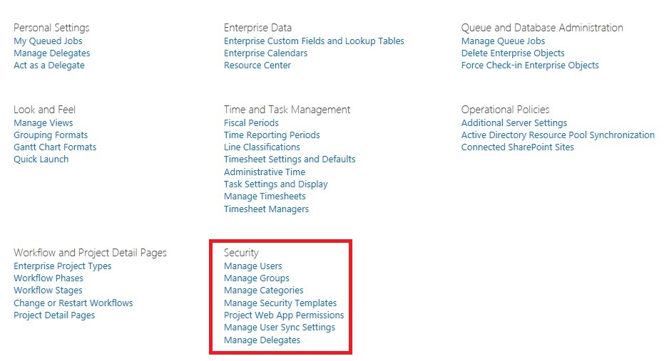

The Security settings in the Project Web App settings page

This Security section of the Project Web App settings page allows you to manage the security settings for users, groups, and categories. The topics described in this chapter include:

* Permissions modes
  + SharePoint permission mode
  + Project Server permission mode
* Permissions
  + Manage Users
  + Manage Groups
    - Security Group Synchronization with Active Directory
  + Manage Categories
  + Manage Security Templates
  + Project Web App Permissions
  + Manage Delegates

## Permission modes

Project Server 2013 offers two security modes for controlling the kind of access that users have to sites and projects:

SharePoint permission mode In this mode, which is new in Project Server 2013, a special set of SharePoint security groups are created in sites associated with Project Server 2013. These groups are used to grant users varying levels of access to projects and Project Server functionality. SharePoint permission mode is new for Project Server 2013.

Project Server permission mode In this mode, Project Server provides a set of customizable security groups and other functionality that is distinct from SharePoint groups. This is the same security mode that was available in Project Server 2010.

The following table illustrates the features available in each security mode.

| Feature | SharePoint  permission mode | Project Server  permission mode |
| --- | --- | --- |
| Unified security management through SharePoint Server | X |  |
| Permissions inheritance for PWA and Workspaces | X |  |
| Direct authorization against Active Directory security groups | X |  |
| Claims-based authorization | X | X |
| Manage authorization by role-based groups | X | X |
| Extensible and customizable | X | X |
| User delegation |  | X |
| Ability to secure work resources |  | X |
| Impersonation |  | X |
| Security filtering using the Resource Breakdown Structure |  | X |
| Custom Security Categories |  | X |

New Project Web App instances use the SharePoint permission mode by default. In an on-premises installation, the mode can be changed for a given instance of Project Web App by using the Set-SPProjectPermissionModeWindows PowerShell cmdlet. In Project Online, the mode can be changed in the Microsoft Office 365 portal site.

Warning Switching between SharePoint permission mode and Project Server permission mode deletes all security-related settings. If you switch from SharePoint permission mode to classic Project Server permission mode, you have to manually configure your security permissions structure in Project Server 2013. Switching from Project Server permission mode back to SharePoint permission mode deletes your security permissions information from Project Server 2013.

## SharePoint permission mode

SharePoint permissions mode creates SharePoint groups that directly correspond to the default security groups found in Project Server permission mode.

The following table describes the Project Server 2013 SharePoint groups and what user functionality they enable in Project Web App.

| SharePoint group | Function |
| --- | --- |
| Administrators | Users have all global permissions as well as category permissions through the My Organization category. This allows them complete access to everything in Project Web App. |
| Portfolio Viewers | Users have permissions to view Project and Project Web App data. This group is intended for high-level users who need visibility into projects but are not themselves assigned project tasks. |
| Project Managers | Users have permissions to create and manage projects. This group is intended for project owners who assign tasks to resources. |
| Portfolio Managers | Users have assorted project-creation and team-building permissions. This group is intended for high-level managers of groups of projects. |
| Resource Managers | Users have most global and category-level resource permissions. This group is intended for users who manage and assign resources and edit resource data. |
| Team Leads | Users have limited permissions around task creation and status reports. This group is intended for persons in a lead capacity that do not have regular assignments on a project. |
| Team Members | Users have general permissions for using Project Web App, but limited project-level permissions. This group is intended to give everyone basic access to Project Web App. |

These Project Server 2013 SharePoint groups have the same global and category permissions that are assigned to them in Project Server permission mode. In SharePoint permissions mode, you cannot create additional custom groups, categories, Resource Breakdown Structure (RBS) nodes, or edit the default permissions assigned to any of these objects.

### Adding users

There are two methods of adding users to the SharePoint groups:

* Add user accounts individually
* Add one or more Active Directory groups

You can use one or both of these methods for each group.

#### Adding individual users to SharePoint groups

When you add individual users to one of the SharePoint groups, that user is synchronized to Project Web App automatically. User synchronization runs on a SharePoint timer job, by default every ten minutes.

#### Using Active Directory groups to add users to SharePoint groups

When you add Active Directory groups to one of the Project Server-specific SharePoint security groups, the users are not automatically added to the list of users in Project Web App. Each user is individually added to Project Web App the first time she or he accesses the Project Web App site.

Because users in Active Directory groups do not appear on the list of Project Web App resources until they have accessed the Project Web App site, we recommend that you configure Active Directory synchronization in Project Web App to prepopulate your resource list. This allows you to have a complete resource list and to assign work to resources before they have accessed the Project Web App site.

## Project Server permission mode

Project Server permission mode provides permissions, groups, categories, templates, and a hierarchical resource structure (the Resource Breakdown Structure) to help you organize your Project Server users and resources. This security platform operates independent from the SharePoint permissions in the farm and allows you to fine tune the permission levels for Project Web App users. This is the same permission mode that was available in Project Server 2010.

The remainder of this chapter describes the security features of Project Server permission mode.

## Permissions

In Project Server permission mode, a permission is the authority to perform a specific action within the context of Project Web App. In Project Server permission mode, you can Allow, Deny, or not configure (select neither Allow nor Deny) each permission in Project Web App. For example, the Log On permission can be allowed or denied for any given user or group. There are two types of permissions in Project Web App:

* Global Permissions grant users and groups the ability to perform actions throughout an instance of Project Web App. Global Permissions are assigned on a user or group level.
* Category Permissions grant users and groups the ability to perform actions on specific projects and resources. Category Permissions also grant permissions to Views in Project Web App. Category Permissions are assigned on a category level.

Permissions can be set in a number of different places within the Project Web App administration menu. You can allow or deny permissions by selecting the check boxes in the Allow and Deny columns. If neither the Allow nor the Deny check boxes are selected, the default state is Not Allow. The Not Allow state does not prevent users from accessing the feature associated with the permission if they are granted permission in some other way. For example, a user might belong to one group for which permission is not configured (Not Allowed), but might be granted permission by means of membership in a group for which the permission is allowed. However, if the permission is explicitly denied anywhere, permission is denied everywhere for a particular user or group.

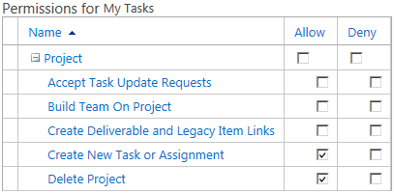

Project Web App permissions

You can configure all Project Web App permissions from the Project Web App Server Settings page. Permissions can be configured in the following ways:

* Allow Enables users or group members to perform the actions associated with the permission.
* Deny Prevents a user or group from performing the actions associated with the permission. Use caution when denying permissions. Note that if a user is denied a specific permission, the deny setting supersedes any Allow settings that might apply to other groups to which the user belongs. No permissions are set to Deny by default.
* Not Allow If you select neither Allow nor Deny for a permission, the default state is Not Allow. If a user belongs to more than one group, and a permission is set to Not Allow for one group and is set to Allow (but not Deny) for another group, then the user is allowed to perform the actions associated with the permission.

It is important to consider when you are configuring a permission to Deny that the Deny setting supersedes any Allow settings that apply to the user for that permission by means of other group memberships. Limiting your use of the Deny setting can simplify permissions management for large groups of users.

Important The Deny setting enables you to deny access to functionality, because this setting overrides the Allow setting. Therefore, use caution when selecting the Deny check box. Select the Deny check box to prevent a user from outside the organization from accessing Project Server security objects or to deny functionality to a user or group).

For organizations that include a large number of users, assigning and administering permissions on an individual basis can be an overwhelming task. You can use groups to assign permissions to multiple users with a single action. Create the groups and define the set of permissions to associate with the groups as part of your initial Project Server 2013 deployment planning process, before you assign users to groups and groups to categories. After you define groups, the permissions associated with the groups, and group memberships, the day-to-day administration of users, groups, and categories involves adding users to or removing users from security groups. This helps to reduce the volume of required day-to-day administrative tasks, and can simplify troubleshooting permissions issues.

## Manage Users

When you make the initial connection to Microsoft Project Server 2013 through the Project Web App site, you must be logged on using the account used to provision the Project Web App site. You can use this initial account to create other user accounts that can access Project Web App. For example, this initial account can be used to create the user accounts for Project Web App administrators, who can create other user accounts and do additional post-installation configuration.

You can use the Manage Users page that is available in Project Web App Settings to add new individual users, modify existing users, deactivate user accounts, and reactivate inactive user accounts. You can also assign permissions to users by adding them to one of the built-in groups or by adding them to a custom group that you created, and assigning specific permissions to the custom group.

Note If you have more than 2,000 users in Project Web App, the Manage Users page will not display users until you select one of the Show options at the top of the page.

### Add or Edit a User

To add a new user account, perform the following procedure.

* To add a user

1. On the Server Settings page, in the Security section, click Manage Users.
2. On the Manage Users page, click New User.
3. On the New User page, fill out the required information for the user. See the following sections for details on each option.
4. Click Save.

To edit an existing user account, perform the following procedure.

* To edit a user account

1. On the Server Settings page, in the Security section, click Manage Users.
2. On the Manage Users page, click the user that you want to edit.
3. On the Edit User page, fill out the required information for the user. See the following sections for details on each option.
4. Click Save.

#### Identification Information

Use the Identification Information section to specify user information such as name, email address, and account status.

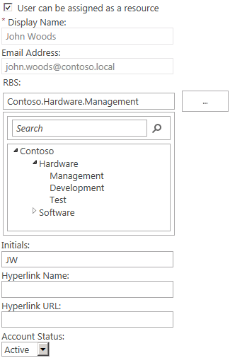

Project Web App user identification information

The following table describes the user identification options.

|  |  |
| --- | --- |
| Attribute | Description |
| User can be assigned as a resource | The status of the user as an Enterprise Resource. Select User can be assigned as a resource to enable this user account to be assigned tasks as a resource. Selecting this entry makes the user an Enterprise Resource. This setting is the default selection. Once a user account becomes an Enterprise Resource it cannot be changed back to a non-Enterprise Resource even if the check box is cleared. |
| Display Name | The name for the user account. This is a required field. |
| E-mail address | The email address for the user. This field is required to synchronize tasks with Exchange Server. |
| RBS | The user’s position in the Resource Breakdown Structure hierarchy. |
| Initials | The user’s initials. |
| Hyperlink Name | The name of the user’s web site (for example, a team web site) if applicable. |
| Hyperlink URL | The URL of the user’s web site, if applicable. |
| Account Status | Can be set to Active or Inactive. If the value is set to Active, the user account functions normally. If the value is set to Inactive, the user is unable to access the account and they are no longer available for adding to teams or being assigned to work, but their existing assignments remain in Project Web App. |

#### User Authentication

Use the User Authentication section to specify the user’s login account and whether the user account should be synchronized with Active Directory.



Project Web App user account information

The following table describes the user account options.

|  |  |
| --- | --- |
| Attribute | Description |
| User logon account | If you are using Integrated Windows authentication, type the user's account name in the form of DomainName\UserAccountName.  If you are using Forms authentication, type the user account name in the form of MembershipProviderName:UserAccount. |

#### Assignment Attributes

Use the Assignment Attributes section to define information associated with the user’s assignment to tasks. This includes calendar, booking type, timesheet manager, assignment owner, and cost and availability information.

Note If you have not selected the User can be assigned as a resource check box, these options are not available.

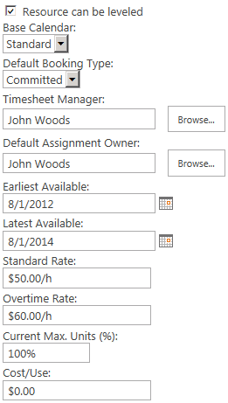

Project Web App assignment attributes

The following table describes the Project Web App user assignment attribute options.

| Attribute | Description |
| --- | --- |
| Resource can be leveled | Indicates whether the resource can be leveled. Leveling is the process that is used to resolve resource conflicts or over-allocations by delaying or splitting certain tasks. When Project Web App levels a resource, its selected assignments are distributed and rescheduled. |
| Base Calendar | A base calendar is a calendar that can be used as a project and task calendar that specifies default working and non-working time for a set of resources. |
| Default Booking Type | The configuration of a user's booking type as either Committed or Proposed. A committed resource is formally allocated to any task assignment in a project. A proposed resource has a pending resource allocation to a task assignment that has not yet been authorized. This resource assignment does not detract from the availability of the resource to work on other projects. |
| Timesheet manager | The timesheet manager, if there is one, for the user.  If you set this value to this user, all submitted timesheets will be automatically approved. |
| Default Assignment Owner | The enterprise resource who is responsible for entering progress information in Project Web App. This person can differ from the person first assigned to the task. For example, a material resource cannot log on to Project Web App but the assignment owner field allows an enterprise resource to enter progress for the resource within Project Web App. |
| Earliest Available | The earliest date that the user is available as a resource. This date corresponds to the resource availability dates for a resource that can be seen in Project Professional 2013. |
| Latest Available | The latest date that the user is available as a resource. This date corresponds to the resource availability dates for a resource that can be seen in Project Professional 2013. |
| Standard Rate | The rate for the work on an assignment that is scheduled during the regular working hours of an assigned resource. To establish variable rates, open the enterprise resource in Project Professional 2013 and set this information in the Cost Rate tables. |
| Overtime Rate | The rate for the work on an assignment that is scheduled beyond the regular working hours of an assigned resource. To establish variable rates, open the enterprise resource in Project Professional and set this information in the Cost Rate tables. |
| Current Max. Units (%) | The percentage of time that the resource is available for assignments. The current max units is tied to the early and late availability dates, if set. For example, if today is 1/1/2014 and the earliest available date is 1/2/2014 then the max units value is 0% and text next to the field says “Custom availability detected, edit in Project Professional.” |
| Cost/Use | The per-use cost of the resource if applicable. For work resources, a per-use cost accrues every time that the resource is used. For material resources, a per-use cost is accrued only one time. |

#### Departments

Use the Departments section to define whether the user is a member of a particular department. You define departments for your organization by populating the Departments custom lookup table.

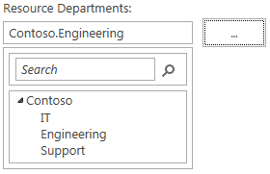

User department configuration

If the user is a member of a department, click the expand button (...) and select the department from the displayed hierarchy.

#### Security Groups

Use the Security Groups section to specify the user’s membership in security groups.

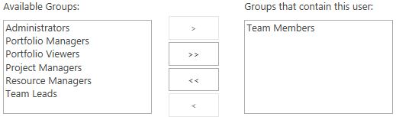

Security group configuration

To add the user to a security group, select the group in the Available Groups list, and then click Add.

The following table describes the security group configuration options for a user.

|  |  |
| --- | --- |
| Attribute | Description |
| Available Groups | The Available Groups list contains the groups that the user is not currently a member of. |
| Groups that contain this user | The Groups that contain this user list contains the groups that the user is currently a member of. |

#### Security Categories

Use the Security Categories section to specify the user’s membership in security categories.

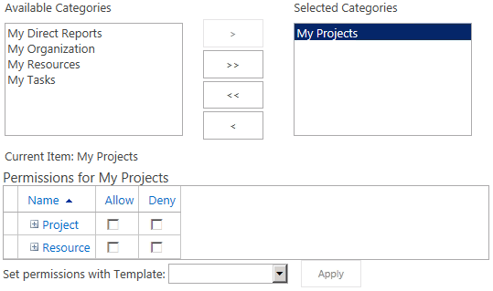

Security category configuration

To add the user to a category, select the category in the Available Categories list, and then click Add. To modify the category permissions for this user in a category, select the category in the Selected Categories list, and then select Allow for the permissions that you want to enable.

Important We recommend that you do not set category permissions for a single user. Instead, assign the user to a group and set category permission for the group. This allows for easier maintenance.

The following table describes the security category configuration options for a user.

|  |  |
| --- | --- |
| Attribute | Description |
| Available Categories | The Available Categories list contains the categories that the user is not a member of. |
| Selected Categories | The Selected Categories list contains the categories that the user is a member of. |
| Permissions for <category> | The Permissions for <category> area lets you configure category permissions for this user for the selected category. |
| Set permissions with Template | The Set permissions with Template option can be used to prepopulate a set of category permissions based on a predefined template for the user’s role (such as Portfolio Viewer or Project Manager). |

#### Global Permissions

Use the Global Permissions section to configure global permissions for the user.

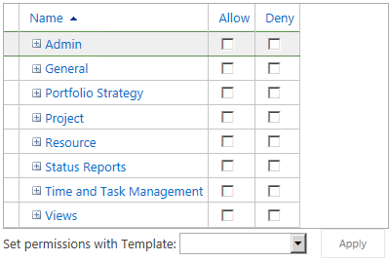

Global permissions configuration

To allow or deny a global permission for the user, select the Allow or Deny check box for the permission.

We recommend that you do not configure global permission for a single user. Instead, configure permissions at the group level and add users to the appropriate group. Doing this allows for much easier administration and helps in troubleshooting permissions issues.

For a complete list of global permissions, see Appendix B, “Project Web App Global Permissions.”

#### Group Fields

Use the Group Fields section to define group and cost information for the user. Group fields are not tied to Project Web App security, but are a way to specify that a user belongs to a particular group in your organization. These fields appear in the Project Web App reporting database and can be used for reporting. Cost Type can be added to the resource and assignment OLAP cubes.

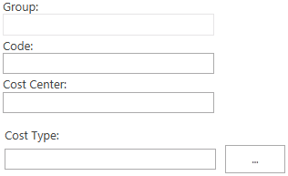

Group fields configuration

If your organization uses group names, codes, or cost center information for people, type the information in the Group Fields area. The values available for Cost Type are those that are defined in the Cost Type custom lookup table. By default, the Group field is synchronized with Active Directory if you use Active Directory synchronization.

#### Team Details

Use the Team Details section to define a team association for the user. To use teams, you must first do the following:

1. Create a custom lookup table and populate it with the team names that you want to use.
2. Edit the Team Name custom field to use the new lookup table.

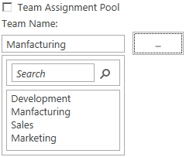

Team details configuration

You can use teams to pool assignments under a single resource where they can be later reassigned to other resources. For example, you could create a team resource named "Development" to which you assign software development tasks. By assigning this resource to the Development team and selecting the Team Assignment Pool check box, you enable other users on the Development team to see any tasks assigned to the Development resource and to accept the assignments in Project Web App. You could also select Team Assignment Pool for a team lead and have all assignments go through that person for distribution to team members.

#### System Identification Data

The System Identification Data section displays user metadata, such as when the account was created, updated, or checked out.

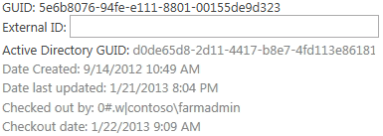

System identification data

In the System Identification Data section, type additional identifying information for the user in the External ID box. This information can be used to link the person to corresponding information elsewhere in the organization, or to facilitate the consolidation of reporting of resource use beyond what Project Web App provides.

The following table describes the system identification data fields.

|  |  |
| --- | --- |
| Attribute | Description |
| GUID | The unique ID associated with this user. |
| External ID | An identifier that can be used to link this user to external data. |
| Active Directory GUID | The unique ID for this user’s Active Directory account. |
| Date Created | The date this user account was created. |
| Date last updated | The date this user account was last updated. |
| Checked out by | The user who currently has this user account checked out. |
| Checkout date | The date this user account was checked out. |

### Deactivate a user account

At times, you may need to make Project Web App user accounts unavailable. When you deactivate a user account, that user’s information and data remains in the database, but the user is unavailable for new assignments. The user account is inactive until it is reactivated.

Deactivating a user account means that it can no longer be used to log on to Project Web App. Users cannot use this account to send assignment updates, request status reports, or delegate tasks.

Once a user is deactivated, the Project Manager is prompted to reassign the user’s remaining work. This prompt occurs when the Project Manager opens the project in Microsoft Project Professional 2013.

User accounts, when deactivated, are not actually deleted from the Project Web App database. This is to ensure that any relationships that resource might have with project data can be preserved in case the account is reactivated later. The option to delete a user is available in the Database Administration section in Project Web App Settings. However, deactivating a user to preserve data is recommended.

After an account is deactivated, the account cannot access Project Web App until it has been reactivated. The Manage users and groups global permission in Project Web App is required to complete this procedure.

When you are using Active Directory synchronization, Project Web App users not found in the Active Directory group being synchronized will be deactivated. If a user is to be removed from the Active Directory directory service but you do not want the account deactivated, select the Prevent Active Directory synchronization for this user check box in the User Authentication section on the Edit User page.

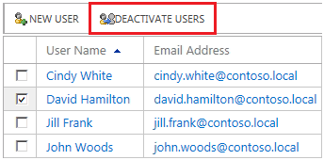

Deactivate users

Use this procedure to deactivate an active Project Web App user account. After this procedure has been performed, the account will be unable to access Project Web App until it has been reactivated.

* To deactivate a user account

1. On the Project Web App home page, on the Settings menu, click PWA Settings.
2. On the Server Settings page, in the Security section, click Manage Users.
3. On the Manage Users page, in the Users list, find the user account that you want to deactivate. (You can use the Search box to search for a specific user.) Click the check box next to the user name of the account that you want to deactivate. Note that you can select multiple user accounts.
4. Click Deactivate Users.
5. A message box appears and asks for confirmation. Click OK to deactivate the user account or user accounts.

### Reactivate a user account

After you deactivate a user account, you may need to reactivate it at some later time. Because the user information still exists in the Project Web App database, you simply need to change the account status from Inactive to Active.

Use this procedure to reactivate a deactivated Project Web App user account. After you have performed this procedure, the reactivated account is able to access Project Web App.

* To reactivate a user account

1. On the Project Web App home page, on the Settings menu, click PWA Settings.
2. On the Server Settings page, in the Security section, click Manage Users.
3. On the Manage Users page, in the Users list, find the user account you want to reactivate. (You can use the Search box to search for a specific user.) Click the user name of the account.
4. On the Edit User page for the selected user, in the Identification Information section, select Active from the Account Status drop-down list.

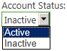

1. Click Save.

## Manage security groups

A group is a container for users that can be assigned permissions in Project Web App. Users automatically inherit the permissions of any group to which they belong. By adding users to groups, you can significantly reduce the amount of time spent managing user permissions. You can manage groups from the Project Web App Server Settings page.

Avoid creating unnecessary groups. Having lots of groups and categories in an organization can lead to additional management complexity. Additionally, having many groups and categories can stress the authorization system, which can affect performance.

You can modify the information associated with any security group in Project Web App. For example, you may have to modify the group for changes to users or categories, or for changes to the Active Directory group to which it is currently being synchronized.

We recommend not modifying the default Project Web App groups, but instead creating a new group that has the same permissions and modifying the new group.

By default, the following groups are available in a Project Web App running in Project Server permission mode:

* Team Members Users have general permissions for using Project Web App, but limited project-level permissions. This group is intended to give everyone basic access to Project Web App. All new users are automatically added to the Team Members group automatically. This group is associated with the My Tasks category.
* Project Managers Users have most global and category-level project permissions and limited resource permissions. This group is intended for users who maintain project schedules daily. This group is associated with the My Organization and My Projects categories.
* Resource Managers Users have most global and category-level resource permissions. This group is intended for users who manage and assign resources and edit resource data. This group is associated with the My Direct Reports, My Organization, My Projects, and My Resources categories.
* Portfolio Viewers Users have permissions to view project and Project Web App data, but cannot make changes. This group is intended for high-level users who need visibility into projects but are not themselves assigned project tasks. This group is associated with the My Organization category.
* Team Leads Users have limited permissions around task creation and status reports. This group is intended for people in a lead capacity who do not have regular assignments on a project. This group is associated with the My Projects category.
* Portfolio Managers Users can create and edit data, but cannot perform Project Web App administrative tasks such as adding users or creating groups. Portfolio Managers are able to view and edit all projects and resources in the organization. This group is associated with the My Organization category.
* Administrators This group is granted all available Project Web App permissions. It is associated with the My Organization category.

These default groups are designed to be used together with the five default categories.

### Create or modify a security group

Seven default security groups are available in Project Web App in Project Server permission mode. To better meet the security requirements of your own organization, you can also create custom groups by using the Manage Groups page on the Project Web App Server Settings page.

Perform the following procedure to create a custom group in Project Web App.

* To create a security group

1. On the Server Settings page, in the Security section, click Manage Groups.
2. On the Manage Groups page, click New Group.
3. Complete the required fields on the Add or Edit Group page. See the following sections for information about each area.
4. Click Save.

You can modify the information associated with any security group in Project Web App. For example, you may need to modify the group for changes to users or categories, or for changes to the Active Directory group to which it is currently being synchronized.

We recommend not modifying the default Project Web App groups, but rather creating a new group with the same permissions and modifying the new group.

Perform the following procedure to modify an existing group in Project Web App.

* To modify a security group

1. On the Server Settings page, in the Security section, click Manage Groups.
2. On the Manage Groups page, in the Group Name list, click the name of the group you want to modify.
3. On the Add or Edit Group page for the selected group, make your changes to the group information. See the following sections for information about each area.
4. Click Save.

#### Group Information

Use the Group Information section to specify a name and description for the group.

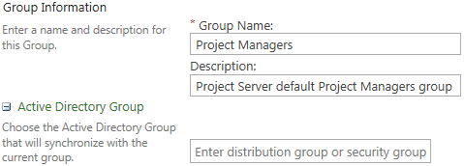

Group information

If you want to synchronize the membership of this group with an Active Directory group, type the name of the group in the text box. To stop synchronizing an existing group, delete the group from the text box.

The following table describes the group information options.

|  |  |
| --- | --- |
| Attribute | Description |
| Group Name | The name of the group. |
| Description | A description of the group. |
| Active Directory Group to Synchronize | The name of the Active Directory group from which this group gets its membership. If you configure this group to synchronize with an Active Directory group, the membership of this group will be synchronized with the Active Directory group specified on the schedule that you configure. |

#### Users

Use the users section to specify which Project Web App users are a member of this group.

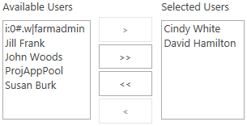

Available users and users in the group

To add users to the group, select the users in the Available Users list, and then click Add. To remove users from the group, select the users in the Selected Users list, and then click Remove.

If you have configured Active Directory synchronization for this group, the group membership is maintained by that mechanism. Any changes you make manually may be overwritten the next time the group is synchronized with Active Directory.

The following table describes the options for users in the group.

|  |  |
| --- | --- |
| Attribute | Description |
| Available Users | The users in Project Web App that are not members of this group. |
| Selected Users | The users in Project Web App that are members of this group. |

#### Categories

Use the Categories section to define which security categories area associated with this group.

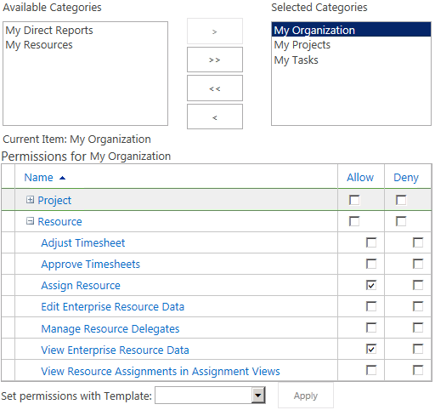

Categories options

To associate a category with this group, select the category in the Available Categories list, and then click Add.

To set the category-level permissions for a particular category, select the category in the Selected Categories list, and then click Allow for the permissions that you want to enable for this category/group combination.

The following table describes the categories options for a group.

|  |  |
| --- | --- |
| Attribute | Description |
| Available Categories | The categories that are not associated with this group. |
| Selected Categories | The categories that are associated with this group. |
| Permissions for <category> | The permissions that members of this group have within the selected category. This option appears when you select a category in the Available Categories list. |
| Set permissions with Template | To set the category permissions for the selected category from a template – such as Project Manager or Team Member – select the desired template from the list, and then click Apply. |

#### Global Permissions

Use the Global Permissions section to configure global permissions for this group.

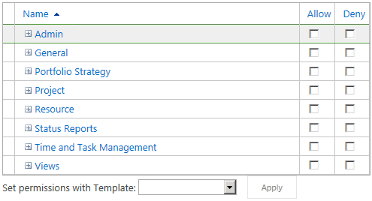

Global permissions

To allow a permission for the group, select the Allow check box for that permission.

To deny a permission for the group, select the Deny check box for that permission.

To set the global permissions from a template, select the template from the Set permissions with Template dropdown list, and then click Apply.

For a complete list of global permissions, see Appendix B, “Project Web App Global Permissions.”

Note If neither check box is selected for a permission, the user is not allowed the permission unless it is allowed in another group that the user is a member of, or it is allowed at the user level. If the Deny check box is selected for a permission, that permission is denied for all users in the group and cannot be enabled through other group or user settings.

### Delete a security group

If you no longer need a security group in Project Web App, you can delete it. Before you delete a group, ensure that no other users or groups are dependent on it for required permissions.

Security groups are permanently deleted, unlike deactivated user accounts (which can be reactivated). If you delete a security group and then find that you want to have it again, you must recreate it. The Manage users and groups global permission in Project Web App is required to complete this procedure.

Important We highly recommend not deleting the default Project Web App groups. The Team Members group cannot be deleted.

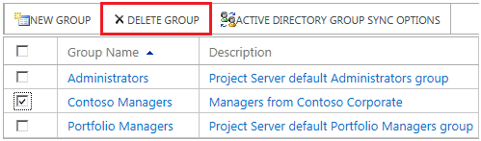

Delete a custom security group

Perform the following procedure to delete a group in Project Web App.

* To delete a custom group

1. On the Server Settings page, in the Security section, click Manage Groups.
2. On the Manage Groups page, in the Group Name list, find the group you want to delete. Select the check box next to the group that you want to delete. Note that you can select multiple groups.
3. Click Delete Group.
4. A message box appears, asking for confirmation and noting that the group will be permanently removed. Click OK to delete the group.

### Security group synchronization with Active Directory

Project Server 2013 security group synchronization controls Project Server security group membership by automatically adding and removing users from specified Project Server security groups based on group membership in the Active Directory directory service. Each Project Server security group can be mapped to a single Active Directory group. Additionally, an Active Directory group can contain nested groups whose members are also synchronized.

The following actions can occur during a Project Server security group synchronization process:

* A new Project Server user account can be created based on an Active Directory account.
* An existing Project Server user can be removed from a Project Server security group.
* An existing Project Server user can be added to a Project Server security group.
* An existing Project Server user account's metadata (name, e-mail address, and so on) can be updated if it has changed in Active Directory.

Before you perform this procedure, confirm the following:

* The account with which you are accessing Project Server through Project Web App (PWA) has both the **Manage Active Directory Settings** and the **Manage users and groups** global permissions enabled.
* The Service Application service account for the Project Server instance has Read access to all Active Directory groups and user accounts involved in the synchronization. You can verify this account on the Service Application page on the SharePoint Central Administration website.

#### Security Group Synchronization scenarios

The following are possible scenarios and corresponding actions that occur when security group synchronization takes place:

|  |  |
| --- | --- |
| **Scenario** | **Action** |
| The user exists in Active Directory and is a member of the Active Directory group mapped to the current Project Server security group. The user does not exist in Project Server. | A new corresponding user account is created in Project Server and is granted membership to the current Project Server security group. |
| The user is not a member of the Active Directory group mapped to the current Project Server security group. The user also exists in Project Server and is a member of the current Project Server security group. | The existing Project Server user is removed as a member of the current Project Server security group. |
| The user exists in Active Directory and is a member of the Active Directory group mapped to the current Project Server security group. The user also exists in Project Server, but is not a member of the current Project Server security group. | The existing Project Server user is given membership to the current Project Server security group. |
| The user exists in Active Directory and is a member of the Active Directory group mapped to the current Project Server security group. The user also exists in Project Server and is a member of the current Project Server security group. User information has been updated in Active Directory. | The corresponding Project Server user information is updated (if applicable). |
| The user exists in Active Directory and is a member of the Active Directory group mapped to the current Project Server security group. The user also exists in Project Server, but as an inactive account. | If the **Automatically reactivate currently inactive users if found in Active Directory during synchronization** option is selected in Project Server, the account is reactivated and is added to the current Project Server security group. If the option is not selected, the account remains inactive in Project Server. |

#### Configure security group synchronization with Active Directory groups

Project Web App security group synchronization with Active Directory groups is done through the Manage Groups page of your Project Web App Server Settings.

* To configure security group synchronization:

1. On the Project Web App Settings page, in the Security section, click **Manage Groups**.
2. On the Manage Groups page, in the **Group Name** column, click the name of the security group that you want to synchronize.
3. On the Add or Edit page for the group that you selected, in the **Active Directory Group** section, type the name or SAM account of the Active Directory group to which you want to synchronize with this PWA group. As you type the group name, Active Directory groups that contain the text string will appear in the results. Select the Active Directory group that you want to synchronize from the results.

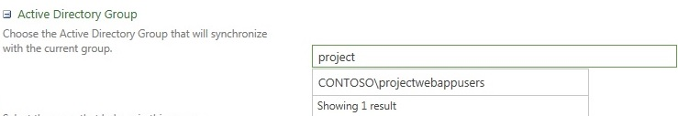

Active Directory Group search field

To select a group from a remote forest, type the fully qualified domain name of the group (for example, group@corp.contoso.com).

Note You can synchronize to a security or distribution group of any scope (Local, Global, or Universal).

1. Click **Save** to save the settings.
2. On the Manage Groups page, click **Active Directory Group Sync Options**.
3. On the Sync Project Web App security groups with Active Directory dialog page, you can enable inactive user accounts to be reactivated if they are found in the Active Directory group during synchronization. To do so, select **Automatically reactivate currently inactive users if found in Active Directory during sync**. For example, if you enabled this option, it would ensure that if an employee were rehired, the employee's user account would be reactivated.

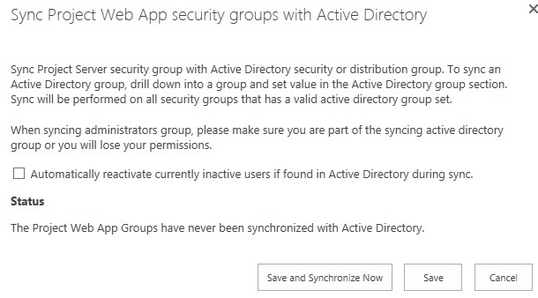

Automatically reactive currently inactive uses if found in Active Directory during sync check box

1. Click **Save** to save the settings. Click **Save and Synchronize Now** if you want to synchronize your Project Server security groups immediately. The Status section describes the last time Project Web App groups were synchronized with Active Directory.

Note Clicking the **Save and Synchronize Now** button will synchronize all security groups to configured Active Directory groups. Do not select individual security groups at the manage groups page before clicking **Active Directory Group Sync Options**, as this does not affect which groups are synchronized.

You can view the Manage Groups page to see which PWA security groups are synchronized to Active Directory groups and the last time synchronization occurred for each security group.

* The Active Directory Group column shows which Active Directory groups are configured to synchronize with a PWA security group.
* The Last Sync column shows the last time synchronization occurred successfully for each group.

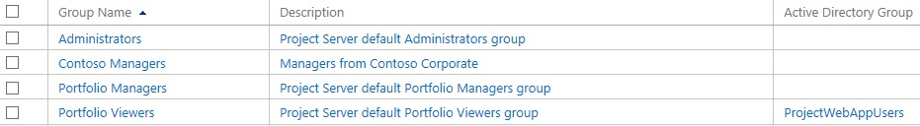

Active Directory Groups column in the Manage Groups page

#### Schedule Active Directory synchronization to PWA security groups

You can schedule the frequency that Active Directory synchronization to PWA security groups occurs by using the **Project Server: Synchronization of AD with security groups** timer job configuration settings in Central Administration. This can be scheduled over a defined period of minutes, days, weeks, or months. The following procedure shows you how to access the **Project Server: Synchronization of AD with security groups** timer job configuration settings in Central Administration and describes the scheduling options that are available.

* To schedule Active Directory synchronization to PWA security groups:

1. In Central Administration, click **Monitoring**.
2. On the Monitoring page, in the Timer Job section, click **Review job definitions**.
3. On the Job Definitions page, find and click **Project Web App: Synchronization of AD with the security groups for <PWAInstanceName>**.

For example: Project Web App: Synchronization of AD with security groups for http://contoso/pwa.

1. On the Edit Timer Job page, in the **Recurring Schedule** section, you can configure when the synchronization will run on a recurring basis. Under **This timer job is scheduled to run**, you can select one of the following options, based on your organization’s requirements:
   * **Minutes**: Allows you to specify a frequency in which the job will run —**Every x minutes**.
   * **Hourly**: Allows you to specify an interval in which the job will randomly run —**Starting every hour between x minutes past the hour and no later than y minutes past the hour**.
   * **Daily**: Allows you to specify an interval in which the job will randomly run —**Starting every day between <time of day> and no later than <time of day>**.
   * **Weekly**: Allows you to specify in which the job will randomly run —**Starting every week between <day of week and time of day> and no later than <day of week and time of day>**.
   * **Monthly**: Provides two options:

* Allows you to specify an interval in which the job will randomly run —**By date: starting every month between <time of day and day of month> and no later than <time of day and day of month>**.
* Allows you to specify an exact time of the month in which the timer job will run —**By day: starting every month <time of day, day of the week, and week of the month. For example, "12:00 AM on the first Sunday"**.



Recurring Schedule section of the Edit Timer Jobs page

1. Click **OK** to save your configuration changes.

Note You can click **Run Now** at any time to run the timer job immediately.

Notice that several options provide you a period of execution time to run the job instead of an exact time or frequency. Selecting an option that provides a period of execution time allows the timer service to select a random time within the parameters specified in order to run the job on each application server. Using an option with a period of execution time is appropriate for high-load jobs which run on multiple servers in the farm. Running this type of job on all servers of the servers simultaneously might place an unreasonable load on the farm.

Various factors may help you determine the frequency in which you choose to run the **Project Server: Synchronization of AD with security groups** timer job. You may want to choose to run this timer job more frequently if, in your environment, users frequently move to different groups, or if your company frequently hires or releases employees. You may also want to choose to run the job more frequently if your Project Server users are working with sensitive data.

## Manage categories

In Project Server permission mode, categories are the collections of projects, resources, and views to which users and groups in Project Web App are granted access. Categories define which collections of specific data (projects, resources, and views) that these users and groups have access to. Categories also allow the administrator to filter data using security rules, like Resource Breakdown Structure (RBS), that can help organize and display data in specific ways.

You can add projects and resources to categories manually by choosing them from lists, or you can use dynamic filters to automatically add them to categories. Any user associated with a category can be granted permission to the projects and resources in that category.

You must have the Manage users and groups global permission to add, modify, or delete a category.

Avoid creating unnecessary categories. Having a large number of groups and categories within an organization can stress the authorization system, which can affect performance.

Project Web App creates five default categories during installation. These default categories enable Project Web App to provide the most common layer of security for a hierarchical organization or matrix organization.

The Manage users and groups global permission in Project Web App is required in order to create, modify, or delete a category.

|  |  |  |
| --- | --- | --- |
| Default category | Default groups in the category | Description |
| My Tasks | Team Members | Primarily used by project resources who have assigned tasks. |
| My Projects | Project Managers  Resource Managers  Team Leads | Provides access to all projects that a user owns. |
| My Resources | Resource Managers | Intended for resource managers and is useful only after the Resource Breakdown Structure (RBS) is defined. |
| My Direct Reports | Resource Managers | Intended for users who need to be able to approve timesheets. |
| My Organization | Portfolio Viewers  Portfolio Managers  Project Managers  Resource Managers  Administrators | Used to grant access to all information in the organization. This category is intended for members of a Project Management Office (PMO), Portfolio Viewers in an organization, and other key users who require the ability to view projects and resources across the entire organization. |

### Create or modify a category

In Project Web App, you can add custom security categories as necessary to create a Project Web App security model that meets the specific needs of users and groups in your organization.

Avoid creating unnecessary categories. Having lots of groups and categories within an organization can lead to greater administrative complexity. Additionally, having many groups and categories can stress the authorization system, which can affect performance.

If there are many users at the highest level of the Resource Breakdown Structure (RBS), consider adding them to a custom category that enables them to view all projects (avoiding dynamic rules). Top-level RBS users probably have access to all projects, so assigning them to this category avoids unnecessary work by the authorization system.

The Manage users and groups global permission in Project Web App is required to complete these procedures.

To create a new category, perform the following procedure.

* To create a category

1. On the Project Web App home page, on the Settings menu, click PWA Settings.
2. On the Server Settings page, in the Security section, click Manage Categories.
3. On the Manage Categories page, click New Category.
4. Complete the Add or Edit Category page. See the following sections for information about each setting.
5. Click Save.

To modify an existing category, perform the following procedure.

* To modify a category

1. On the Server Settings page, in the Security section, click Manage Categories.
2. On the Manage Categories page, click the category that you want to modify.
3. Complete the Add or Edit Category page. See the following sections for information On the Project Web App home page, on the Settings menu, click PWA Settings.
4. about each setting.
5. Click Save.

#### Name and Description

Use the Name and Description section to specify a name and description for the category.

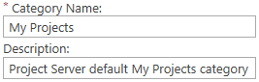

Category name and description

The following table describes the name and description options for a category.

|  |  |
| --- | --- |
| Attribute | Description |
| Category Name | The name of the category. This name must different be than that of other categories. |
| Description | Description of the category. |

#### Projects

Use the Projects section to specify the projects that users associated with this category can view.

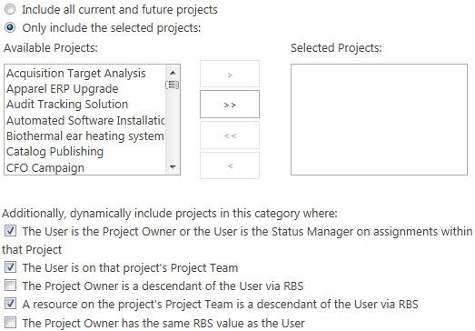

Category / project association

Users access to projects in this category are governed by the defined group and category permissions. You can also use one of the dynamic security options to have projects made available to users based on their relationship to the project or their RBS value.

|  |  |
| --- | --- |
| Attribute | Description |
| Include all current and future projects | When this option is selected, users in this category can see all projects in this instance of Project Web App. |
| Only include the selected projects | When this option is selected, users in this category can view the projects in the Selected Projects list and any projects from the Available Projects list that the user has permissions to see with the dynamic permissions options. The dynamic permissions features only work when this option is selected. |
| Available projects | Projects that are not explicitly part of this category. Users may still be able to view these projects if any of the dynamic permissions options are configured to enable it. |
| Selected projects | Projects that users in this category can view. |
| The User is the Project Owner or the User is the Status Manager on assignments within that Project. | Gives users permissions on any project they own. Also gives Status Managers permissions on projects that contain assignments that they manage. |
| The User is on that project's Project Team | Gives users permissions on any project where they are on the project team. Users do not need to have assignments on the project. |
| The Project Owner is a descendant of the User via RBS | Gives users permissions on any project that is managed by resources subordinate to them in the Resource Breakdown Structure (RBS) hierarchy. |
| A resource on the project's Project Team is a descendant of the User via RBS | Allows a user to view any project where a resource subordinate to the user in the RBS is a member of the project team.  Avoid using this rule for users who have many resources under them in the RBS. If the resources under them are on many projects involving many categories, this stress on the authorization system can affect performance (for example, delay the loading of the Project Center page). |
| The Project Owner has the same RBS value as the User | Allows a user to view projects managed by persons that have the same RBS value that the user has. |

#### Resources

Use the Resources section to specify which resources the users associated with this category can view.

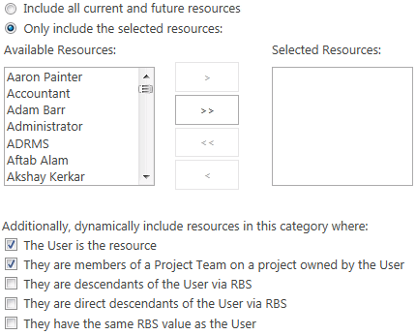

Category / resource association

Users access to resources in this category are governed by the defined group and category permissions. You can also use one of the dynamic security options to have resources made available to users based on their relationship to the resource or their RBS value.

|  |  |
| --- | --- |
| Attribute | Description |
| Include all current and future resources | When this option is selected, users in this category can see all resources in this instance of Project Web App. |
| Only include the selected resources | When this option is selected, users in this category can view the resources in the Selected Resources list and any resources from the Available Resources list that the user has permissions to see with the dynamic permissions options. |
| Available Resources | Resources that are not explicitly part of this category. Users may still be able to view these resources if any of the dynamic permissions options are configured to allow it. |
| Selected Resources | Resources that users in this category can view. |
| The User is the resource | Gives users permissions to view information about themselves (such as assignments). |
| They are members of a Project Team on a project owned by the User | Gives users permissions to view information for all resources in projects they own. |
| They are descendants of the User via RBS | Gives users permissions to view information for all resources under them in the RBS. |
| They are direct descendants of the User via RBS | Gives users permissions to view information about resources that are directly under them in the RBS. |
| They have the same RBS value as the User | Gives user permissions to view information about resources that have the same RBS value. |

#### Views

Use the Views section to specify views that users associated with this category can see.

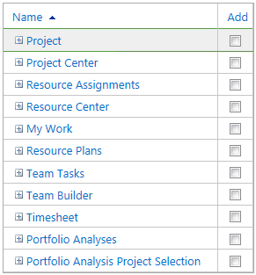

Views

To add a view to the category, select the Add check box for that view. To remove a view, clear the Add check box for that view.

#### Permissions

Use the Permissions section to specify which users and groups are associated with this category.

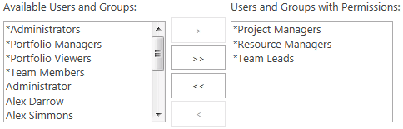

Category permissions

To associate a user or group with this category, select the user or group in the Available Users and Groups list, and then click Add.

To remove the association between a user or group and this category, select the user or group in the Users and Groups with Permissions list and then click Remove.

For easiest administration, only associate groups with categories.

|  |  |
| --- | --- |
| Attribute | Description |
| Available Users and Groups | Users and groups that are not associated with this category. |
| Users and Groups with Permissions | Users and groups that are associated with this category. |

To select the category permissions for each user or group, select the user or group in the Users and Groups with Permissions list. This will display the category permissions for the selected group in this category.

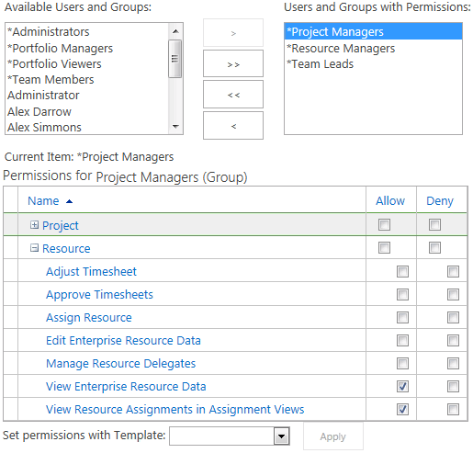

Category permissions for the Project Managers group

Each user or group can be assigned distinct permission within a category.

For a complete list of category permissions, see Appendix A, “Project Server 2013 Category Permissions.”

### Delete a category

In Project Web App, you can delete any existing custom category from the Manage Categories page in Project Web App.

Note Default Project Web App categories cannot be deleted.

The Manage users and groups global permission in Project Web App is required to complete this procedure.

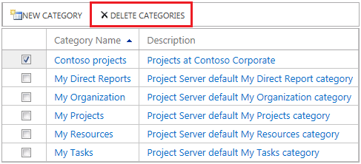

Delete a custom category

Perform the following procedure to delete an existing category in Project Web App.

Caution Verify that the category you are deleting is the one you intend to delete. If you accidentally delete the wrong category, it is permanently deleted and will need to be recreated.

* To delete a category

1. On the Project Web App home page, on the Settings menu, click PWA Settings.
2. On the Server Settings page, in the Security section, click Manage Categories.
3. On the Manage Categories page, in the Category Name list, find the category that you want to delete. Select the check box next to the category that you want to delete. Note that you can select multiple categories.
4. Click Delete Categories.
5. A warning message appears, noting that the category will be permanently removed. Click OK.

## Manage security templates

Security templates provide a means for you to quickly apply or reset predefined permission profiles to new or existing users, groups, and categories. By applying security templates, you can easily standardize the permissions that you assign according to user's role in the organization. A number of predefined security templates are available in each Project Web App instance. These align with the predefined groups. You can customize these security templates or create new security templates according to your needs.

Creating custom templates requires planning. You must first identify the common Project Server usage patterns in your organization that are not reflected in the default Project Server security templates. This helps you identify your requirements for custom security templates. Then, determine the permissions that the users who share the common Project Server usage patterns require. This defines the security template. Next, determine the set of projects, resources, views, and so on, that the users and groups require access to. This defines the security category. Create the custom security template and apply it to the group of users who share the common usage pattern. The permissions that you define in the custom security template will enable users to access the Project Server security objects that they require.

Security templates are available in Project Server permission mode. There are eight default security templates available in Project Web App:

* Administrators
* Portfolio Viewers
* Portfolio Managers
* Project Managers
* Proposal Reviewers
* Resource Managers
* Team Leads
* Team Members

Each security template is given a set of default category and global permissions, based on the functions that each group typically does in an organization. As mentioned previously, when you create new security templates, you are allowed to copy the permissions for a default security template and then customize it to suit your needs.

The Manage users and groups global permission in Project Web App is required to create, modify, or delete a security template.

### Create or modify a security template

In Project Web App, you can group commonly used permissions into a security template and then use it to assign permissions to users, groups, and categories.

The Manage users and groups global permission in Project Web App is required to complete this procedure.

Perform the following procedure to create a template in Project Web App.

* To create a template

1. On the Project Web App home page, on the Settings menu, click PWA Settings.
2. On the Server Settings page, in the Security section, click Manage Templates.
3. On the Manage Templates page, click New Template.
4. Complete the Add or Edit Template page. See the following sections for information about each setting.
5. Click Save.

In Project Web App, you can modify the permissions for any existing template in the Manage Templates page in Project Web App Server Settings.

As a best practice, do not make any changes to the default Project Web App templates.

The Manage users and groups global permission in Project Web App is required to complete this procedure.

Note Modifying a template does not make any changes to users, groups, or categories to which the template was applied in the past.

Perform the following procedure to modify an existing template in Project Web App.

* To modify a template

1. On the Project Web App home page, on the Settings menu, click PWA Settings.
2. On the Server Settings page, in the Security section, click Manage Templates.
3. On the Manage Templates page, in the Template Name list, click the template that you want to edit.
4. On the Add or Edit Template page, make your changes to the template. See the following sections for information about each setting.
5. Click Save.

#### Name

Use the Name section to specify a name and description of the template and, optionally, to select an existing template to copy the settings from an existing template into the new template.

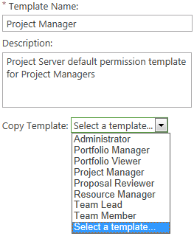

Template name and Copy Template options

If you choose a template from the Copy Template dropdown list, the values from that template are copied to this template.

Important The values from the copied template will overwrite any existing values in this template.

After you copy the template, you can modify the values as needed to meet your needs.

If you do not copy a template, this template will be blank and you can modify the values as needed.

#### Category Permissions

Use the Category Permissions section to set the category permissions for this template.

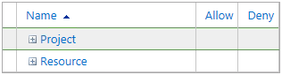

Category Permissions

To allow a category permission for this template, select the Allow check box for that permission. If you do not select the Allow check box for a permission, that permission will not be allowed in the categories where you use this template, but could be allowed in other categories.

To deny a category permission for this template, select the Deny check box for that permission.

#### Global Permissions

Use the Global Permissions section to set the global permissions for this template.

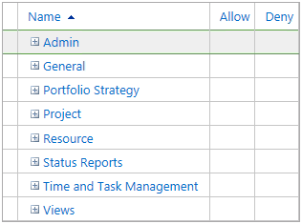

Global Permissions

To allow a global permission for this template, select the Allow check box for that permission. If you do not select the Allow check box for a permission, that permission will not be allowed in the groups where you use this template, but could be allowed in other groups.

To deny a global permission for this template, select the Deny check box for that permission.

### Delete a security template

In Project Web App, you can delete any existing security templates from the Manage Templates page on the Project Web App site.

As a best practice, do not delete any of the default Project Web App templates.

The Manage users and groups global permission in Project Web App is required to complete this procedure.

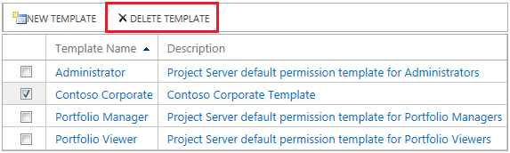

Delete a template

Perform the following procedure to delete a template.

* To delete a template

1. On the Project Web App home page, on the Settings menu, click PWA Settings.
2. On the Server Settings page, in the Security section, click Manage Templates.
3. On the Manage Templates page, in the Template Name list, select the check box next to the templates that you want to delete.
4. Click Delete Template. A warning message appears, noting that the template will be permanently removed.
5. Click OK.

## Manage Project Web App permissions

In Project Server permission mode, you can use the Project Web App Permissions page to control which global and category permissions are enabled on a given Project Web App instance. An administrator can use the Project Web App Permissions page to deny access to all Project Web App users for a particular feature in Project Professional or a Project Web App instance. If a Project Web App permission is disabled on this page, the equivalent global or category permission is disabled for users throughout Project Web App. All permissions on this page are enabled by default.

For example, if you deny the Delete project permission, users throughout Project Web App cannot delete projects, regardless of whether they have the Delete project category permission.

Important Before disabling a Project Web App permission, thoroughly consider the effects on your organization of doing so. If you want to turn off a permission for only some Project Web App users, verify whether you can do it by creating a custom group and denying the permissions you want to restrict.

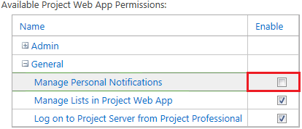

Disable Project Web App Permission

The Manage users and groups global permission in Project Web App is required to complete this procedure. Perform the following procedure to disable a Project Web App organizational permission in Project Web App.

* To disable a Project Web App permission

1. On the Project Web App home page, on the Settings menu, click PWA Settings.
2. On the Server Settings page, in the Security section, click Project Web App Permissions.
3. On the Project Web App Permissions page, in the Available Project Web App Permissions list, clear the Enable check box next to the permission that you no longer want to make available to Project Web App users. (All Project Web App permissions are enabled by default.)
4. Click Save.

Enabling a previously disabled permission is simply done by selecting the Enable check box next to the permission that has been disabled.

## Manage Delegates

Project Server 2013 enables *user delegation* throughout all of Project Web App. This means that one user can act as another user in every part of Project Web App, regardless of the permission level difference of one user compared to the other.

### Enable the Delegation feature

When user delegation is turned on, you can set permissions to control the specific behavior of the feature in Project Web App.

* To turn delegation on

1. On the Project Web App home page, on the Settings menu, click PWA Settings.
2. On the Server Settings page, in the Security section, click Project Web App Permissions.
3. On the Project Web App Permissions page, in the Available Project Web App Permissions list, under Resource, enable the **Manage Resource Delegates** permission to turn on the user delegation feature within Project Web App.
4. Choose any additional delegation permissions that meet your organization’s needs:

* **Manage My Resource Delegations** - Select this check box to enable users to set up delegations for other users.
* **Manage My Delegations** - Select this check box to enable users to create delegations for themselves.
* **Can be Delegates** - Select this check box to enable a user to become a delegate for another user, after a delegation has been created.

1. Click Save.

### Set up which users and groups can act as delegates

In Project Web App, there are user or group-level permissions that enable you to determine which users or groups can act as delegates for other people. By default, the only group that has these permissions turned on is the administrators group. Therefore, if you want users in your organization to be able to act as delegates, you have to set the appropriate permissions.

* To set permissions for a specific user

1. In Project Web App, click the Settings icon, and click PWA Settings.
2. In the Security section, click Manage Users.
3. On the Manage Users page, click the name of the user for which you are setting permissions.
4. On the Edit User page, expand the Global Permissions section.
5. In the Global Permissions section, under Resource, choose the appropriate permissions for this user.

* Can be Delegate   Select the Allow check box for this permission to enable this user to become a delegate for another user.
* Manage My Delegations   Select the Allow check box for this permission to enable this user to create his or her own delegations.
* Manage My Resource Delegations   Select the Allow check box for this permission to enable this user to set up delegations for other users.

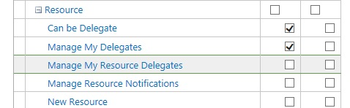

1. Click Save to save the permissions on the server.

* To set permissions for a group

1. In Project Web App, click the Settings icon, and then click PWA Settings.
2. In the Security section, click Manage Groups.
3. On the Manage Groups page, click the name of the group for which you are setting permissions.
4. On the Add or Edit Group page, expand the Global Permissions section.
5. In the Global Permissions section, under Resource, choose the appropriate permissions for this group.

* Can be Delegate   Select the Allow check box for this permission to enable members of this group to become a delegates for another group.
* Manage My Delegations   Select the Allow check box for this permission to enable members of this group to create their own delegations.
* Manage My Resource Delegations   Select the Allow check box for this permission to enable members of this user to set up delegations for other users.

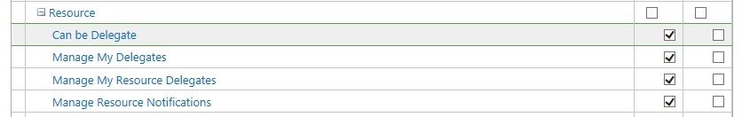

1. Click Save to save the permissions on the server.

### Set up which users and groups can have delegates

Categories are used in Project Web App to determine which users or groups can have delegates do work on their behalf. In order for a delegation to work correctly, the user requesting the delegation must have the correct category permissions, and the user who will act as the delegate must have the correct individual user or group permissions.

* To set up who can have delegates assigned to them

1. In Project Web App, click the Settings icon, and then click PWA Settings.
2. In the Security section, click Manage Categories.
3. On the Manage Categories page, click the name of the category that contains the user or group for which you want to enable user delegation.
4. In the Permissions section, click the name of the group or a specific user in the Users and Groups with Permissions box.
5. In the permissions box that appears, scroll down the Resources section, and select the Manage Resource Delegate permission to turn on the user delegation feature for that user or group.

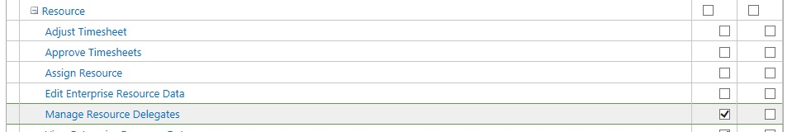

1. Click Save to save the permissions on the server.

### To create a delegation

Creating a new delegation in Project Web App enables one user to work on behalf of another user, such as submitting a second user’s timesheet.

* To create a delegation

1. In Project Web App, click the Settings icon, and then click PWA Settings.
2. In the Security section, click Manage Delegates.
3. On the Manage Delegates page, click New.



1. In the Set Delegetion Period section, select the date range for the period in which the delegate will be able to manage work.



1. In the Set Delegation section, select the delegate that you want to manage work during the specific period.



1. In the Working on Behalf of section, select the user who requires a substitute.



1. Click Save to save the permissions on the server.

Part II

# **SharePoint Central Administration Project Web App Settings**

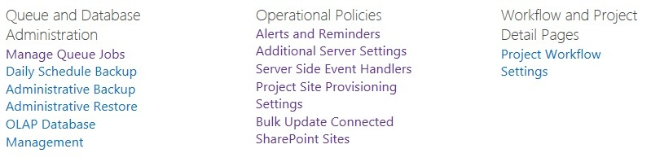

Part II of this book includes all Project Web App settings that are available in SharePoint Central Administration. These are different from the Project Web App settings that are available in Project Server 2013 (covered in the first half of this guide) since these settings are more for farm administrators. The Project Web App settings available in SharePoint Central Administration are described in the following chapters:

* Chapter 9, “Queue and Database Administration”
* Chapter 10,  “Operational Policies”
* Chapter 11,  “Workflow and Project Detail Pages”
* Chapter 12,  “Queue Settings”

The least-privileged permission required to access the SharePoint Central Administration Project Web App settings is a Service Application Administrator for the Project Application Service.

Use the following procedure access the SharePoint Central Administration Project Web App Settings:.

* To access the PWA Settings in SharePoint Central Administration

1. In SharePoint Central Administration, in the Application Management, in the Service Applications section, click **Manage service applications**.
2. On the Service Applications page, click the name of the Project Application Service.
3. On the Manage Project Web Apps page, click the drop-down menu of the Project Web App instance, and then click **Manage** to open the PWA Settings page.

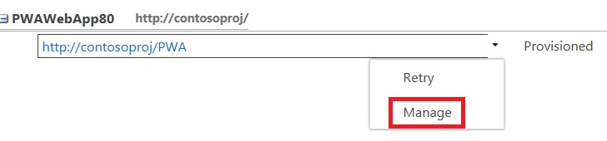

9

# **Queue and Database Administration OLAP Database Management: SharePoint Central Administration PWA Settings**

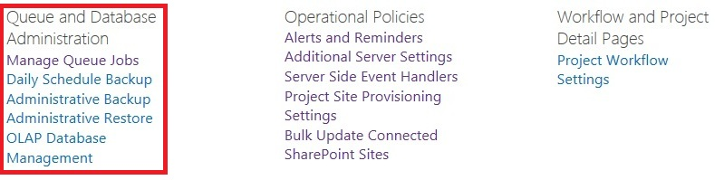

Queue and Database Administration Settings for Project Web App in SharePoint Central Administration

The Queue and Database Administration settings located in the Project Web App Server Settings page in SharePoint Central Administration allow you to manage the following server settings:

* Manage Queue Jobs
* Daily Schedule Backup
* OLAP Database Management

Note that on the Project Web App Settings page within Project Server 2013 also contains Queue and Database Administration. Those settings are more related to PWA administration (such as item level backup and restore) and are covered in the Chapter titled Operational Policies – Project Web App.

## Manage Queue Jobs

The Manage Queue Jobs page lets you view Project Server 2013 operations ("jobs") that have been processed by the queue system. You can use the configuration options to filter jobs and only see the jobs that you are interested in viewing. You can also retry or cancel jobs through this page.



The Manage Queue Jobs page

The Project Server 2013 Manage Queue Jobs settings are available through both the Project Server 2013 Project Web App settings and in the SharePoint Central Administration page in the General Application Settings. They were previously located in the Project Web App (PWA) Server Settings page in Project Server 2010.

### Use the Manage Queue Jobs settings

The Manage Queue Jobs page lets you view, retry, or cancel jobs in the queue through the Jobs Grid. Viewable jobs are displayed according to the settings you select in the Manage Queue Jobs page. The configuration settings on the Manage Queue Job page include the following:

* Filter Type
* Job Types
* Job History
* Job Completion States
* Columns
* Advanced Options

#### Filter Type

The Filter Type configuration option lets you select filters to query for specific types of jobs that will appear in the Jobs Grid. The filters available in the Filter Type drop-down list are as follows:

* **By Status** Displays jobs in the queue in order by status. This is the default setting.
* **My Jobs** Displays only the jobs initiated by you.
* **By Project** Displays jobs in the queue in order by project.
* **By ID** Displays jobs in the queue in order by Job ID.
* **Active** Displays all jobs that have a status of **Active**.
* **Blocked** Displays all jobs that have a status of **Blocked**.



Filter Type

Use the following procedure to select a filter type.

* To select a filter

1. On the Manage Queue Jobs page, in the **Filter Type** section, click the **Filter Type** drop-down list and select the type of filter you want to use to determine which jobs display in the Jobs Grid.
2. In the Jobs Grid, select **Refresh Status**.

Jobs in the Jobs Grid appear according to the filter type that you select. For example, if you select the By Status filter, jobs are listed alphabetically by status.

#### Job History

This configuration option enables you to select the date range of jobs that appear in the Jobs Grid. Use the From and To fields to select a beginning and end data. The default selection is to select the one-day date range for the present date.

You can use the Maximum Number of Jobs field to limit the number of jobs that appear for a given date range. If the selected date range contains a very large number of jobs that have to appear in the Jobs Grid, the load time for the Manage Queue Jobs page can be very long. The Maximum Number of Jobs field lets you limit the jobs that appear. The default setting is 500.



Job History

Use the following to configure the Job History settings.

* To configure the Job History setting

1. On the Manage Queue Jobs page, in the **Job History** section, specify the following values:

* In the **From** field, specify the start date for which you want jobs to appear in the Jobs Grid. You can also click the calendar icon to select a start date.
* In the **To** field, specify the end date for which you want jobs to appear in the Jobs Grid. You can also click the calendar icon to select an end date.

1. In the Maximum number of jobs per queue box, you can specify the maximum number of jobs that you want to display. The default value is 500.
2. In the Jobs Grid, click **Refresh Status**.

#### Job Types

The Job Types configuration option lets you select the type of job (for example, Project Create, Timesheet Submit, Notifications, and so on) that you want to appear in the Jobs Grid. By default, all job types are listed in the Selected Jobs list.



Job Types

Use the following procedure to configure the Job Types setting.

* To configure the Job Types setting

1. On the Manage Queue Jobs page, in the **Job Types** section:

* If you want to keep certain job types from appearing in the Jobs Grid, from the **Selected Jobs** list, select the job types that you do not want to appear in the Jobs Grid, and then click **Remove**. (This action moves the selected job types to the **Available Jobs** list.) Click **Remove All** if you want to remove all job types from the **Selected Jobs** list.
* If you want to add jobs types to the Jobs Grid, from the **Available Jobs** list, select the job types that you want to appear in the Jobs Grid, and then click **Add**. This action moves the selected job types to the **Selected Jobs** list. Click **Add All** if you want to add all job types to the **Selected Jobs** list.

1. In the Jobs Grid, click **Refresh Status**.

#### Job Completion States

The Job Completion States configuration option lets you select the job states (for example, Success, Blocked Due to a Failed Job, Processing, and so on) of the jobs that you want to appear in the Jobs Grid. By default, all job types except Success are listed in the Selected Jobs list, since Project administrators would be more interested in job types that signify a failure or blocking issue.

You can add or remove different job states to and from the Selected Job States list and the Available Job States list. The Jobs Grid will query for jobs in the job stats listed in the Selected Job States list.

This setting can be helpful for troubleshooting jobs that are not completing successfully in the queue. For example, some users might have experienced problems over the past several days. You can see specifically which jobs are not completing successfully by going to the Job Completion States setting and adding all job states except Success. You can also select a Job History date range that begins shortly before the problems occurred (for example, seven days). In this scenario, the Jobs Grid should display information about all jobs that are in a non-successful job status that have occurred over the past week.

The Job Completion states that you can select for this setting are as follows:

* Blocked Due to a Failed Job
* Cancelled
* Failed and Blocking Correlation
* Failed but not Blocking Correlation
* Getting Queued
* Processing
* Skipped for Optimization
* Success
* Waiting to be Processed
* Waiting to be Processed (On Hold)
* Waiting to be Processed (Ready for Launch)
* Waiting to be Processed (Sleeping)



Job Completion States

Use the following procedure to configure the Job Completion States setting.

* To configure the Job Completion States setting

1. On the Manage Queue Jobs page, in the **Job Completion States** section, add all job states that you want to display in the Jobs Grid to the **Selected Job States** list. Job states that are shown in the **Available Job States** list will not appear in the Job Grid.

* To move an available job state in the **Available Job States** list to the **Selected Job States** list, select the job and then click **Add**.
* To remove a job state from the **Selected Job States** list, select the job and then click **Remove**. To select multiple job states press the Ctrl key while making your selections.

1. In the Jobs Grid, click **Refresh Status**.

#### Columns

The Columns configuration option lets you select the columns that appear in the Jobs Grid. It also lets you configure the order of the columns in the Jobs Grid.

The column options available to you are as follows:

* % Complete
* Completed Time
* Correlation ID
* Correlation Priority
* Entry Time
* Error
* Job ID
* JobGroup ID
* JobInfo ID
* Job State
* Job Type
* Last Admin Action
* Owner
* Position
* Priority
* Project Name
* Queue Type
* Wait Time (secs)
* Wakeup Time



Job Grid Columns

Use the following procedure to configure the columns setting for the Job Grid.

* To configure the Columns setting

1. On the Manage Queue Jobs page, in the **Columns** section, add all columns that you want to display in the Jobs Grid to the **Selected Columns** list. Columns that are shown in the **Available Columns** list will not appear in the Job Grid.

* To move a column in the Available Columns list to the Selected Columns list, select the column name and then click the **Add** button (“**>**”).
* To remove a column from the Selected Columns list, select the column and then click the **Remove** button (“**<**”). To select multiple columns, press the Ctrl key while making your selections. You can also move all columns from one list to another by using the **Add All** (“**>>**”) or the **Remove All** (“**<<**”) buttons.

1. In the Jobs Grid, click **Refresh Status**.

Note that you can change the order of the columns as they display in the Job Grid by selecting a column name in the Selected Columns list and using the **Up** or **Down** button to move the column to a different position.

#### Advanced Options

The Advanced Options queue setting applies to the way that jobs in the queue are canceled.

The Cancel jobs getting enqueued option allows you to cancel all jobs that remain in a “getting enqueued” state for a prolonged time. When a job is in this state, it means that the queue has been told to start to receive a job that will be processed later. But it has not received a tag telling it that all the data for the job has been received. Until the full job has been received, the job will remain in the getting enqueued state. If a job remains in the getting enqueued state for a prolonged time, it is likely that something is preventing the job from finishing. If the job continues to remain in this state after you re-run it, review your ULS logs to troubleshoot why they problem is occurring.

Saving a project from Project Professional to Project Server is a job that typically enqueues. When you save a project from Project Professional to the Project Server, the job synchronizes with the server. If the synchronization is not completed, then the job remains in the enqueued state.

By default, this setting is enabled.

Make sure to click Refresh Status in the Jobs Grid after you make any changes.

Note In Project Server 2010, the Advanced Options page also included an option to **Cancel Subsequent Jobs in Correlation**. This option in not available in Project Server 2013.



Manage Queue Jobs Advanced Options

### Jobs Grid

The Jobs Grid provides a view of the jobs that meet the criteria listed in the Manage Queue Jobs page. Options within this section let you select a job or group of jobs and to apply the following options to them, if applicable:

* **Retry Job** Allows you to rerun selected jobs in the queue that were not completed successfully.
* **Cancel Job** Allows you to cancel selected jobs in the queue that were not completed successfully.
* **View Related Jobs** Allows you to view jobs that have a dependency relationship (for example, jobs in the same correlation) with a selected job in the queue.
* **Refresh Status** Allows you to update the jobs in your job grid with the latest status.



Queue Jobs Grid

Use the following procedure to retry a job in the Jobs Grid.

* To retry a job

1. In the Jobs Grid, find the job you want to retry, and then select the check box to the far left column of this job.
2. Click **Retry Job**. Recheck the status of the job in the Jobs Grid to verify the results of retrying the job.

Use the following procedure to cancel a job in the Jobs Grid.

* To cancel a job

1. In the Jobs Grid, find the job you want to cancel, and then select the check box to the far left column of this job. Note that a job that has already completed successfully cannot be cancelled.
2. Click **Cancel Job**.

Use the following procedure view other jobs that are related to a specific job in the Jobs Grid.

* To view related jobs

1. In the Jobs Grid, find the job for which you want to find related jobs, and then select the check box to the far left column of this job.
2. Click **View All Jobs**. All jobs that have a dependency relationship with this job will appear in the Jobs Grid.

### Understanding Jobs

This section describes how the queue processes jobs in Project Server 2013. The following will provide you a better understanding of how to use the job grid.

* Queue groupings
* Parent/Child relationship between submitted jobs
* Queue States

#### Queue groupings

There are three distinct levels of grouping for queued data:

* **Jobs**A job is a trackable packet of work that gets executed by Project Server (for example, project save, project publish, timesheet submit). Some jobs are not explicitly initiated by the user (for example, email notifications, reporting data synch-up). Jobs are the level at which queuing is tracked (using a Job ID).
* **Correlated Job Group**A correlated job group is a categorization of jobs imposed by internal rules of Project Server. Jobs within a correlated job group are always processed together and in order (with some exceptions). In the example below, Project 1 is edited and saved from Project Professional and then checked in. Project 1 is then checked out by another user, who then publishes it. Publishing Project 1 triggers Reporting and a Reporting job is added to the queue as well. Project Server assembles a correlation group comprised of the four jobs related to Project 1. It then will attempt to process the jobs in sequence since the Project Server internal rules dictates that there is a dependency between the jobs. The dependency that exists is that the Project 1 publish and the Reporting database update cannot occur until Project 1 is saved. Also, if any of the jobs in the correlation fail, the other jobs after it in the correlation group will be blocked. For example, if the Save Project 1 job (job ID 12) fails, the Checkin Project 1 job (job ID 13) should get blocked. If the Checkin Project 1 job were executed, this would lead to problems because someone else may then checkout Project 1 and then attempt to modify it which may be in an inconsistent state due to the failed save.
* **Sub-jobs**Each job can be broken down further into smaller segments called sub-jobs. If a job is very large (such as saving a 10 MB project) it will be broken into multiple sub-jobs. Sub-jobs are not exposed to the PSI or the Project Web App user. However, sub-jobs may be noted in ULS logs (depending on the verbosity option that is selected).



#### Parent/Child Relationships between submitted Jobs

It is important to realize that parent/child relationships can exist for submitted jobs which require that further processing be done. For example, if a user publishes Project 1, a reporting request for Project 1 will be generated, as well as notification requests regarding Project 1. Note that Notifications for Project 1 will always be generated, but since Reporting Project 1 is generated only if the Publish of Project 1 is successful, should the publish job fail, the Reporting Project 1 job will not be generated.



Similarly, a child job may fail without any effect to the parent job. For example, if Notification Project 1 should fail, there will be no effect on Publish Project 1 since it will have already occurred. It is important to note that although the user may be aware that the publish of Project 1 was processed through the queue, he/she may not be aware that a child job may have failed. If you would like to verify what child jobs were spawned from a parent job that they had entered into the queue as well as their status, you can do this through the My Queued Jobs page in Project Web App. Administrators can use the Queue Management UI and see all jobs in the queue.

#### Queuing states

When a job is submitted to the queue it can transition through various states. The table below describes each of these states:

| **State** | **Description** |
| --- | --- |
| Getting queued | Job is put into the queue. A job ID is issued. |
| Waiting to be Processed | Job is in the queue and is waiting to be processed. |
| Processing | Job is being processed. |
| Success | Job has been successfully processed. This is a terminating state in which the job can go no further. |
| Blocked | Job has been blocked by failure of another job before it in the same correlation group. The user will need to retry or cancel. |
| Failed and Not Blocking Correlation | Job has failed, but is not blocking any other jobs in its group. This is a terminating state in which the job can go no further. |
| Failed and Blocking Correlation | Job has failed and may be blocking one or more dependent jobs. |
| Skipped for optimization | Job has been skipped because a duplicate job has been found after it within the group. For example, a project manager may attempt the following in sequence when working with a project:   1. Saves Project 1 2. Publishes Project 1 3. Changes a task in Project 1 4. Save Project 1 5. Publishes Project 1 6. Changes the start date of Project 1 7. Save Project 1 8. Publishes Project 1   All three incremental saves to Project 1 will be processed. However, all three publish attempts do not need to be processed. If the last publish job is processed, it would produce the same results as if all three publish jobs were processed. For optimization, the first two publish attempts are skipped. |
| Cancelled | Job has been cancelled. A job can be cancelled from any state except the two terminating states (Success, Failed and Not Blocking Correlation). |
| Sleeping | Job could not process immediately because of another conflicting job and is temporarily in an inactive mode. The job will be retried. |

#### Changes in queue state

As jobs are entered into the queue and processed, it is important to understand the possible changes in queue state that can occur. The following flowchart describes the possible paths through each state.

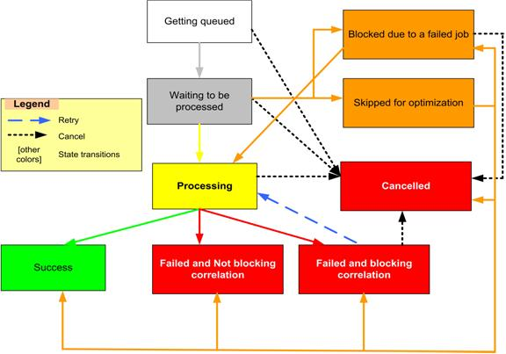

| **State** | **Next Possible State** |
| --- | --- |
| Getting Queued | * Waiting to be Processed * Cancelled |
| Waiting to be Processed | * Processing * Cancelled * Blocked * Skipped for optimization |
| Processing | * Success * Failed and Not Blocking Correlation * Failed and Blocking Correlation * Cancelled |
| Success | * End |
| Blocked | * Processing * Cancelled |
| Failed and Not Blocking Correlation | * End |
| Failed and Blocking Correlation | * Cancelled * Processing |
| Skipped for Optimization | * Blocked (due to a failed job) * Cancelled * Success * Failed and Not Blocking Correlation * Failed and Blocking Correlation * Processing |
| Cancelled | * End |

## OLAP Database Management

Through Project Web App, multiple OLAP databases can be delivered that contain the specific resources, projects, and custom fields that each group within your organization requires for its particular group reporting needs.

In Microsoft Project Server 2013, you can create multiple OLAP databases that have the following characteristics:

* They only contain data for projects and resources that they administer
* They only contain facts and dimensions that they select from the new integrated OLAP database management user interface
* They support departmental filtering to restrict which projects and resources are loaded into the OLAP database
* They include data for Inactive Tasks and User Scheduled Tasks
* They have support for Multiple Measure groups in a single OLAP database
* They contain field names in multiple languages to enable multi-language report creation

Also, when a new OLAP database is created, the necessary Office Data Connections and Excel Reporting templates are created in the Business Intelligence Center in the Reports folder. This data-connected blank template will help you quickly create new reports that are based on the new OLAP database.

### Create an OLAP cube

OLAP cubes are managed in SharePoint Central Administration in the Project Server service application. There is a separate OLAP Database Management page for each Project Web App site.

To create an OLAP cube, you must be a service application administrator for the Project Server service application, or a Farm Administrator. Perform the following procedure to create a new OLAP cube.

Use the following procedure to create an OLAP cube.

* To create an OLAP cube

1. In Central Administration, in the Application Management section, click Manage service applications.
2. Click the Project Server service application.
3. Point to the Project Web App instance where you want to build the cube, click the arrow that appears, and then click Manage.
4. On the Server Settings page, in the Queue and Database Administration section, click OLAP Database Management.
5. On the OLAP Database Management page, click New.
6. Configure the settings on the OLAP Database Build Settings page. See the following sections for details on each setting.
7. Click Save.

#### Analysis Services Settings

Use the Analysis Services Settings area to specify server and database name information along with, optionally, an extranet URL and description.

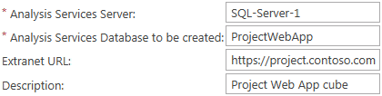

Analysis Services Settings

The following table describes the server and network settings for an OLAP cube.

|  |  |
| --- | --- |
| Attribute | Description |
| Analysis Services Server | The name of the instance of SQL Server Analysis Services (SSAS) where you want to build the cube. |
| Analysis Services Database to be created | The name of the database that you want to create. |
| Extranet URL | The URL for the extranet site, if applicable. |
| Description | A description of this OLAP cube. |

#### Project Department

Use the Project Department area to specify which department to use to filter project data in the OLAP cube.

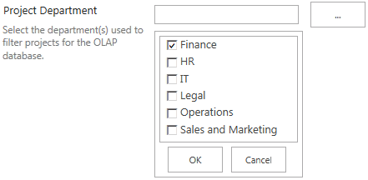

OLAP Department settings (example)

If you have projects assigned to departments, you have the option of selecting the departments that you want to have included in the cube. If no department is selected, then no departmental filtering occurs.

The selection of departments available is controlled by the Department custom lookup table.

#### Resource Department

Use the Resource Department area to specify which department to use to filter resource data in the OLAP cube.

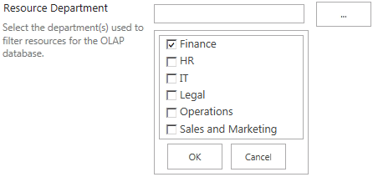

OLAP Resource settings (example)

If you have resources assigned to departments, you have the option of selecting the departments that you want to have included in the cube. If no department is selected, then no departmental filtering occurs.

The selection of departments available is controlled by the Department custom lookup table.

#### Database Date Range

Use the Database Date Range area to specify the date range of projects, based on project start date, to include in the OLAP cube.

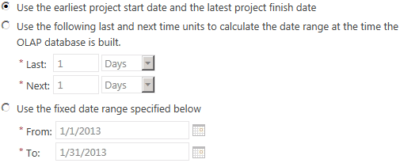

OLAP database date range settings

The following table describes the database date range options for an OLAP cube.

| Attribute | Description |
| --- | --- |
| Use the earliest project start date and the latest project finish date | Select this option if you want to base the date range of the cube on the earliest start date of any project and the latest finish date of any project. |
| Use the following last and next time units to calculate the date range at the time that the OLAP database is built | Select this option if you want the date range to be configured automatically based on a delta from the date on which the cube is built. In the Last and Next boxes, type the number of days, weeks, or months that you want to use for the delta. |
| Use the fixed date range specified below | Select this option if you want to use a fixed date range. In the From and To boxes, type the dates that you want to use. |

#### OLAP Database Update Frequency

Use the OLAP Database Update Frequency area to specify when and how often you want to build the OLAP cube. We recommend you choose a time of low system use because building cubes can be resource intensive.

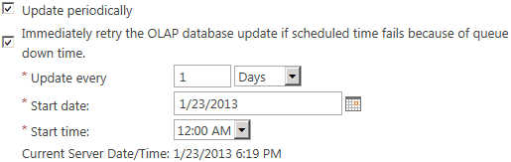

OLAP database update settings

The following table describes the database update settings for an OLAP cube.

|  |  |
| --- | --- |
| Attribute | Description |
| Update periodically | Select this option if you want to schedule an update frequency. If this option is not selected, the cube is not updated automatically. |
| Immediately retry the OLAP database update if scheduled time fails because of queue down time | If the scheduled cube build fails because the queue is not available, selecting this option causes the build job to start automatically when the queue becomes available instead of waiting for the next scheduled time. |
| Update every | Select the number of hours, days, weeks, or months for the cube to be rebuilt. |
| Start date | Select the start date for the first automated cube build. |
| Start time | Select the start time for each automated cube build. |

### Configure an OLAP cube

OLAP cubes are managed in SharePoint Central Administration in the Project Server service application. There is a separate OLAP Database Management page for each Project Web App site.

To configure an OLAP cube, you must be a service application administrator for the Project Server service application, or a Farm Administrator.

You can configure OLAP cube dimensions and measures, or you can configure the build settings of a cube.

There are two sets of parameters that can be configured on an existing OLAP cube:

* Dimensions and measures
* Cube build settings

Use the following procedure to configure the build settings of an existing OLAP cube.

* To configure OLAP cube build settings

1. In Central Administration, in the Application Management section, click Manage service applications.
2. Click the Project Server service application.
3. Point to the Project Web App instance where you want to build the cube, click the arrow that appears, and then click Manage.
4. On the Server Settings page, in the Queue and Database Administration section, click OLAP Database Management.
5. On the OLAP Database Management page, in the OLAP Database Name column, click the database that you want to configure.
6. Configure the settings on the OLAP Database Build Settings page:
7. Click Save.

Use the following procedure to configure the dimensions and measures of an existing OLAP cube.

* To configure OLAP cube dimensions and measures

1. In Central Administration, in the Application Management section, click Manage service applications.
2. Click the Project Server service application.
3. Point to the Project Web App instance where you want to build the cube, click the arrow that appears, and then click Manage.
4. On the Server Settings page, in the Queue and Database Administration section, click OLAP Database Management.
5. On the OLAP Database Management page, select an OLAP database from the list, and then click Configuration.
6. Configure the settings on the Database Configuration page:
7. Click Save.

#### Cube dimensions

Use the Cube dimensions area to specify the custom fields that you want to add to the OLAP cube as dimensions.

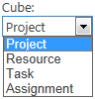

Cube selector

Select a cube from the drop-down list to display the available and selected dimensions.

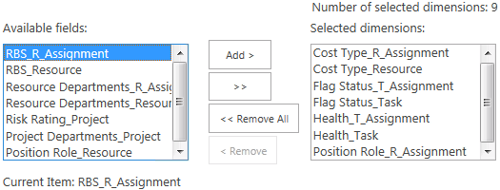

Cube dimension selector

Select the dimensions that you want to include in that cube in the Available fields list and click Add to include them in the cube. Do this for each cube in the Cube drop-down list.

#### Cube measures

Use the Cube measures area to specify the custom fields that you want to add to the OLAP cube as measures.



Cube selector

Select a cube from the drop-down list to display the available and selected measures.

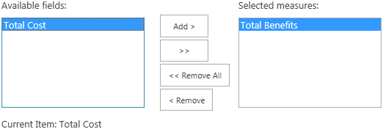

Cube measure selector

Choose the measures that you want to include in that cube in the Available fields list and click Add to include them in the cube. Do this for each cube in the Cube drop-down list.

#### Built-in measures

Use the Built-in measures area to select the build-in measures that you want to include in the OLAP cubes.

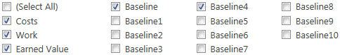

Cube built-in measure selector

The fields that you select are added to the Project, Task, and Assignment cubes as measures.

#### Inactive tasks

Use the Inactive tasks area to specify if you want to include inactive tasks in the OLAP cubes.



Inactive tasks selector

If you want the cube to include inactive tasks, select the Include Inactive Tasks check box.

#### Calculated measures

Use the Calculated measures area to specify an MDX expression to define a calculated measure.

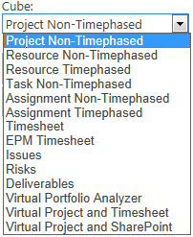

Cube selector

Select the cube that you want to define an expression for from the Cube dropdown list.

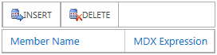

MDX expression tool

Click Insert to add a custom MDX expression.

### Copy an OLAP cube

OLAP cubes are managed in SharePoint Central Administration in the Project Server service application. There is a separate OLAP Database Management page for each Project Web App site.

To copy an OLAP cube, you must be a service application administrator for the Project Server service application, or a Farm Administrator. Perform the following procedure to copy an existing OLAP Cube.

Copying a cube creates a new cube with the same settings and configuration as the cube that you copied. Copying a cube does not copy the Analysis Services database, but instead copies all the cube settings from which you can build a new Analysis Services database.

Note You must specify a new name for the Analysis Services database after you copy the cube.

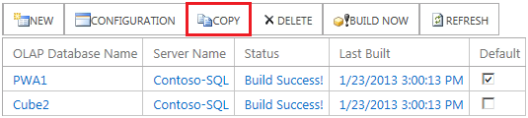

Copy an OLAP cube

Use the following procedure to copy an OLAP cube.

* To copy an OLAP cube

1. In Central Administration, in the Application Management section, click Manage service applications.
2. Click the Project Server service application.
3. Point to the Project Web App instance where you want to build the cube, click the arrow that appears, and then click Manage.
4. On the Server Settings page, in the Queue and Database Administration section, click OLAP Database Management.
5. On the OLAP Database Management page, select the cube that you want to copy, and then click Copy.
6. On the OLAP Database Build Settings page, type the name of the server and the database that you want created and adjust any other desired settings.
7. Click Save.

Note This procedure copies the cube configuration but does not build the cube. You can build the cube manually or wait for it to build on the schedule that you set.

### Delete an OLAP cube

OLAP cubes are managed in SharePoint Central Administration in the Project Server service application. There is a separate OLAP Database Management page for each Project Web App site.

To delete an OLAP cube, you must be a service application administrator for the Project Server service application, or a Farm Administrator. Perform the following procedure to delete an OLAP Cube.

Note Deleting an OLAP cube in Project Server does not delete the OLAP database from Analysis Services.

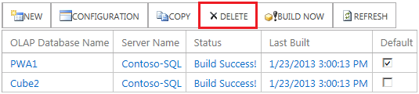

Delete an OLAP cube

Use the following procedure to delete an OLAP cube.

* To delete an OLAP cube

1. In Central Administration, in the Application Management section, click Manage service applications.
2. Click the Project Server service application.
3. Point to the Project Web App instance where you want to build the cube, click the arrow that appears, and then click Manage.
4. On the Server Settings page, in the Queue and Database Administration section, click OLAP Database Management.
5. On the OLAP Database Management page, select the cube that you want to delete, and then click Delete.

Note This procedure deletes the cube and its associated configuration from Project Web App. The actual OLAP database is not deleted from SQL Server Analysis Services.

### Build an OLAP cube

OLAP cubes are managed in SharePoint Central Administration in the Project Server service application. There is a separate OLAP Database Management page for each Project Web App site.

OLAP cubes can be scheduled to be built on a regular basis. For more information, see Configure an OLAP cube (Project Server 2013). You can also start the build process manually.

To build an OLAP cube, you must be a service application administrator for the Project Server service application, or a Farm Administrator. Perform the following procedure to build an existing OLAP cube.

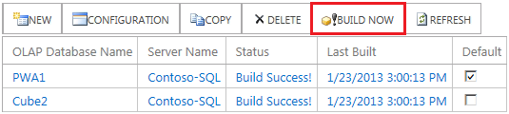

Build an OLAP cube

Use the following procedure to build an OLAP cube.

* To build an OLAP cube

1. In Central Administration, in the Application Management section, click Manage service applications.
2. Click the Project Server service application.
3. Point to the Project Web App instance where you want to build the cube, click the arrow that appears, and then click Manage.
4. On the Server Settings page, in the Queue and Database Administration section, click OLAP Database Management.
5. On the OLAP Database Management page, select the cube that you want to build, and then click Build Now.

10

# Operational Policies: SharePoint Central Administration PWA Settings

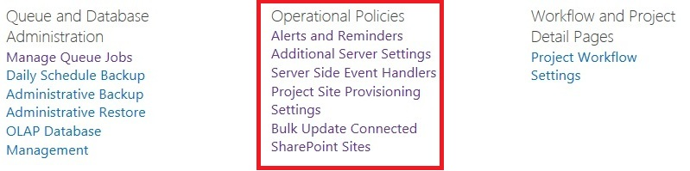

Operational Policies Settings for Project Web App in SharePoint Central Administration

The Operational Policies settings located in the Project Web App Server Settings page in SharePoint Central Administration allow you to manage the following server settings:

* Alerts and Reminders
* Additional Server Settings
* Server-Side Event Handlers
* Project Site Provisioning Settings
* Bulk Update Connected SharePoint Sites

Note that on the Project Web App Settings page within Project Web App also contains Operational Policies. Those settings are more related to PWA administration and are covered in the Chapter titled Operational Policies – Project Web App.

## Alerts and Reminders

The Alerts and Reminders Project Server settings page in SharePoint Central Administration is used to configure notification email settings in your Project Server 2013 environment. There settings on the Alerts and Reminders page are for the two types of notification emails that Project Server sends:

* **Alerts**: This is an email that is sent based on a triggering event. For example, an alert email can be generated for a resource when a project manager assigns a new task to it.
* **Reminders**: This is an email that is sent daily noting events that are upcoming or overdue. For example, a reminder email for a team member can include a task that it owns that is scheduled to start tomorrow.

Configuration of the Alerts and Reminders page is required for Project Server 2013 to use the automated notification system. On the Alerts and Reminders page, you can:

* Configure a connection to an SMTP mail server and associated port number.
* Specify the default sender email address and message information that is automatically included with each email notification or reminder that is sent by Project Server.

In order to access and use the Alerts and Reminders Project Server settings page in SharePoint Central Administration, you must be a farm administrator.

### Notification Email Settings

The Notification Email Settings allows the Project Server Administrator to maintain the default sender e-mail address and message information that is automatically included with each email notification or reminder sent by Project Server. It also allows you to specify the SMTP server and associated port number.

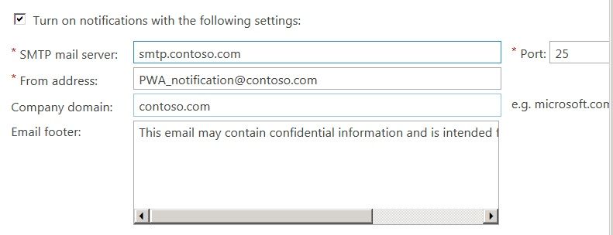

Notification Email Settings

Use the following procedure to configure your Notification Email settings.

* To configure the Notification E-mail setting:

1. On the PWA Settings page in SharePoint Central Administration, in the Operational Policies section, click **Alerts and Reminders**.
2. On the Alerts and Reminders page:
   1. Select **Turn on notification with the following settings** to maintain all of your notification email settings. You must select this option for your settings on this page to apply. Deselecting this option allows you to keep your configuration settings on the page, but have them be non-applicable.
   2. For the **SMTP mail server** field, enter the server name. Verify the port used in the **Port** field (default value of 25). Change the Port value if your SMTP server uses a port other than the default port for SMTP (Port 25).
   3. In the **From address** field, enter the default email address from which the email will be sent. This address is the reply-to address for all notification and reminder emails.
   4. In the **Company domain** field, type the domain name of your company (for example, Contoso.com).
   5. In the **E-mail footer** field, type the default message that you want appended to all notification emails. For example: *This email message may contain confidential information and is intended for the recipients named above*.
3. Click **Save**.

## Additional Server Settings

The Additional Server Settings page allows you to configure settings for:

* Project Professional Versions
* Enterprise Settings
* Currency Settings
* Resource Capacity Settings
* Resource Plan Work Day
* Exchange Server Details
* Task Mode Settings

### Project Professional Versions

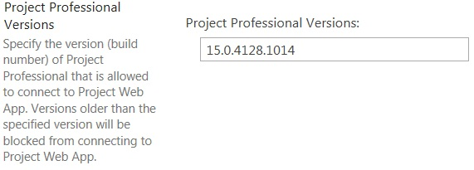

Project Professional Versions setting

Project Professional Versions lets you specify which versions (build numbers) of the Project Professional client will be able to connect to your Project Server 2013 environment. This setting lets you ensure that Project Professional client connections to the server are all at a required base level. For example, if you recently updated both Project Server 2013 and Project Professional 2013 to the same cumulative update, you can verify that all clients that connect to the server are at least at this level by entering the build number. All Project Professional 2013 clients that have not been updated to the specified cumulative update or a newer version will be unable to connect.

Note Project Professional 2013 is the only Project Professional client that can connect to Project Server 2013.

Use the following procedure to configure your Project Professional Versions setting.

* To configure the Project Professional Versions Setting:

1. On PWA Settings page in SharePoint Central Administration, in the Operational Policies section, click **Alerts and Reminders**.
2. On the Server Settings page, in the Operational Policies section, click **Additional Server Settings**.
3. On the Additional Server Settings page, in the Project Professional Versions section, type the build number of each Project Professional version that you want to connect to Project Server 2013. Use a comma as a separator between multiple version numbers.
4. Versions older than the lowest build number that you enter will be unable to connect to your Project Server 2013 environment.
5. Click **Save**.

Use the following procedure to determine the build number (version) of Project Professional 2013.

* To find your Project Professional 2013 build number:

1. In Project Professional 2013, click the **File** tab.
2. On the left pane, click **Account**.
3. On the Account page, in the Product Information section, click **About Microsoft Project**.
4. On the About Microsoft Project page, the build number is located at the top of the page (for example, 15.0.4453.1504).

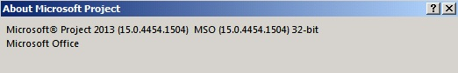

Project Professional 2013 About page displaying the build number

### Enterprise Settings



Enterprise settings

Enterprise Settings lets you determine whether Project Server 2013 allows for projects to have the following capabilities:

* **Allow master projects to be saved and published** (By default, this option is enabled.) Enabling this setting enables master projects to be used in Project Server 2013. Master projects are projects that contain sub-projects, and they usually contain tasks that are dependent on one another. Check with your Project Management Office to determine whether your organization prohibits the use of master projects.
* **Allow projects to use local base calendars** Enabling this settings lets users not only use enterprise base calendars that are on the system for their enterprise projects, but to also use local base calendars that users create. Having this setting disabled (which is the default) restricts users to using only enterprise base calendars that are on the system for their projects. Restricting the users to enterprise calendars gives you more control by preventing problems that can occur when projects use local base calendars that contain conflicting data. For example, a project that uses a local base calendar that differs from an enterprise calendar (for example, July 4 as a work day versus a holiday) can lead to faulty calculations and other issues.

Use the following procedure to configure the Enterprise settings.

* To configure the Enterprise Settings:

1. On PWA Settings page in SharePoint Central Administration, in the Operational Policies section, click **Additional Server Settings**.
2. On the Additional Server Settings page, in the **Enterprise Settings** section:
   1. Select **Allow master projects to be saved and published to Microsoft Project Server 2013** if you want to enable this setting. (By default, it is enabled.)
   2. Select **Allow projects to use local base calendars** if you want to enable this setting (By default, this option is cleared.)
3. Click **Save**.

### Currency Settings



Enterprise settings

Through the currency setting, you can select the default currency setting for projects that are published to the server. (This is used for reports and the default view for new projects.) The default value is based on the default currency of the language that is used for the Project Web App instance.

You can also select the currency settings for publishing:

* **Allow projects to be published in various currencies** Select this option if your organization uses multiple currencies for costs within projects. (This is the default setting).
* **Enforce that projects are published in the server currency** Select this option if your organization only uses a single currency for costs within projects. The currency that is used is the one selected as the default server currency.

Use the following procedure to configure the Currency settings.

* To configure the Currency settings:

1. On PWA Settings page in SharePoint Central Administration, in the Operational Policies section, click **Additional Server Settings**.
2. On the Additional Server Settings page, in the Currency Settings section, select one of the following currency options:

* **Allow projects to be published in various currencies** (Selected by default).
* **Enforce that projects are published in the server currency**  
  If you select **Enforce that projects are published in the server currency**, you see a message. This message box warns you that the change is only being enforced on all successive projects that are published to the server. All projects that are not using the default server currency must be changed to the default currency and republished.

1. Click **OK**.

All projects published to the server that are using a currency that conflicts with the server currency will be displayed in the Currency Settings section of the page in the Project in conflict with the server currency list. You can use this as a reference to note which projects have to have their currency changed to the server currency.

1. Click **Save**.

#### Change currency option for a project

Use the following procedure in Project Professional 2013 to change the currency settings for a project. You can use this procedure to do the following:

* Select the currency for a specific project if the currency setting lets you use multiple currencies.
* Change the currency setting on a project to the server currency if the currency setting only lets you use the server currency.

Use the following procedure to change the currency for a project in Project Professional 2013.

* To change the currency for a project in Project Professional 2010:

1. Open and log on to Project Professional 2013.
2. Check out and open a project from Project Server 2013.
3. Click **File**, and then click **Options**.
4. On the Project Options page, click **Display**.
5. On the Display page, in the **Currency options for this project** section, select the currency and then the currency format (symbol, placement, and decimal digits) that you want to use for this project.
6. Click **OK**.
7. Click **File**, and then click **Save** to save the project.
8. Click **File**, and then click **Publish** to publish the project.

### Resource Capacity Settings



Resource Capacity Settings

Resource Capacity Settings are used to calculate your resources' availability for work over a specified time range. Your resources' capacity data for the specified time range is stored on the Reporting database, and it is updated daily through a processing job that is run at a time that you specify in the settings. You are able to set the Active capacity view by entering a time range in relative terms — months in the past, and months in the future — where the current date is a relative starting point. You can view your resources' availability for work through the Resource Center in Project Web App.

The default **Active capacity view** settings are "1" month behind and "12" months ahead. This means that in the Resource Center you can view a resource's future availability for up to 12 months from the current date, and you can view utilization over the last month. By increasing the **Month ahead** setting, you get more capacity computed for future periods. For example, imagine that a company plans for new projects later in the year and wants to forecast the capacity for resources from 12 months to 24 months. Some customers might want to increase the **Months behind** value to get an accurate report of work completed in the past (for example, to account for any users who might report time long after the work is completed).

Note that increasing either value also increases the time it takes for the daily processing job to run.

Use the following procedure to configure the Resource Capacity setting.

* To configure the Resource Capacity setting:

1. On PWA Settings page in SharePoint Central Administration, in the Operational Policies section, click **Additional Server Settings**.
2. On the Additional Server Settings page, in the Resource Capacity Settings section, for **Active capacity view**, enter the following:
   1. In the **Months behind** field, enter the number of months in the past that you want resource data to be calculated from.
   2. In the **Months ahead** field, enter the number of months in the future that you want resource data to be calculated from.
3. Click **Save**.

Resource Capacity information will be process daily at 1:00 AM by default.

### Resource Plan Work Day



Resource Plan Work Day Setting

**Resource Plan Work Day** lets you specify the length of a work day ("full-time equivalents" or FTE) for all resources in your resource plan. This value can be calculated from the resource’s base calendar or can be manually entered as a value.

Use the following procedure to configure the Resource Plan Work Day setting.

* To configure the Resource Plan Work Day setting:

1. On PWA Settings page in SharePoint Central Administration, in the Operational Policies section, click **Additional Server Settings**.
2. On the Additional Server Settings page, in the Resource Plan Work Day section, for Calculate resource full-time equivalent from, select one of the two options:

* **Resource base calendars**  Use this option if you want the full-time equivalents to be calculated from each resources base calendar. This is the default option.
* **Hours per day** Use this option if you want to specify the full-time equivalents for your resources in the resource plan. After selecting this option, enter the value (in hours) of the standard work day for your organization. Note that this value is used for all resources in the resource plan.

1. Click **Save**.

### Exchange Server Details

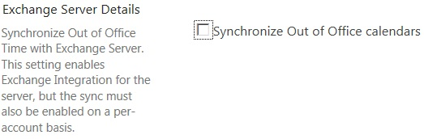

Exchange Server Details Setting

The Exchange Server Details setting allows you to enable or disable Microsoft Exchange Server integration with Project Server 2013. When enabled, it allows you to synchronize your resources out-of-office time between Exchange Server and Project Server 2013. This is done at an individual resource level in the resource properties page.

Disabling the setting will disable Microsoft Exchange integration with Project Server. This setting is disabled by default.

Note A requirement for this feature is that the Project queue is required to run under a mail-enabled user account.

Use the following procedure to configure the Exchange Server Details setting.

* To configure the Exchange Server Details setting:

1. On PWA Settings page in SharePoint Central Administration, in the Operational Policies section, click **Additional Server Settings**.
2. On the Additional Server Settings page, in the Exchange Server Details section, click **Synchronize Out of Office calendars** if you want to automatically synchronize out-of-office time in resource calendars between Project Server 2013 and Exchange Server 2007 with Service Pack 1, Exchange Server 2010, or Exchange Server 2013.
3. Click **Save**.

### Task Mode Settings



Task Mode Setting

**Task Mode Settings** let you select the default mode in which tasks are scheduled: manually or automatically. Additionally, if you select the default setting (**Manually Scheduled**), you can also configure if you want task to be published to team members.

Manually scheduled tasks (also known as "User-Controlled Scheduling") were introduced in previously in Project Server 2010. In this mode, when a new task is created, the scheduling engine is ignored and Project Server 2013 creates the task without a duration, start date, or finish date. (These values can be entered manually.) It can be useful for scheduling tasks with hard dates that are difficult to move (for example, training).

Use the following procedure to configure the Task Mode setting.

* To configure the Task Mode setting:

1. On PWA Settings page in SharePoint Central Administration, in the Operational Policies section, click **Additional Server Settings**.
2. In the Task Mode Settings section:
   1. Select **Manually Scheduled tasks can be published to team members** (which is enabled by default) if you want to allows project managers to publish their manually scheduled task to team members.
   2. For **Default task mode in new projects**, select one of the two following settings:

* **Manually Scheduled** You have to enter duration, start, and finish dates for your tasks. By default, this option is selected.
* **Automatically Scheduled** The scheduling engine automatically calculates durations and start dates and finish dates for your tasks.

1. Select **Users can override default in Project Professional** (which is enabled by default) if you want to enable your Project Professional 2013 users to override the default task mode settings that you selected.
2. Click **Save**.

## Server Side Event Handlers

Project Server 2013 provides public events that enable development of custom processes such as adding and enforcing business rules, validation, data processing, notification services, and workflow. These custom processes are written as server-side event handlers by developers in an organization and can be associated to Project Server 2013 events through the Server Side Event Handlers page in Project Web App Server Settings. For example, developers in your organization can create an event handler that starts a custom workflow. Through the Server Side Event Handlers page, you can associate that event handler with the Project Published event so that a workflow starts when the event occurs.

For more information about Project Server event handlers, see the MSDN article, [How to: Create a Project Server Event Handler and Log an Event](http://msdn.microsoft.com/en-us/library/gg615466.aspx) (http://msdn.microsoft.com/en-us/library/gg615466.aspx).

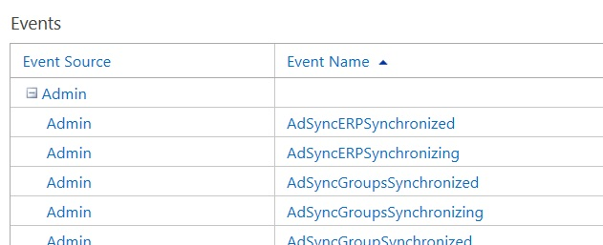

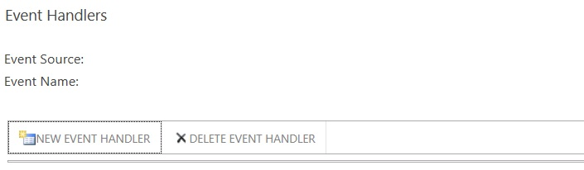

Server Side Event Handlers page

Use the following procedure to associate an event handler with a server side event.

* To associate an event handler with a server side event:

1. On PWA Settings page in SharePoint Central Administration, in the Operational Policies section, click **Server Side Event Handlers**.
2. On the Server Side Event Handlers page, in the Events list, find the event that you want to associate your new event handler with, and then click the Event Source listed next to the Event Name (for example, click the **Project** event source for the **Published** event name).

In the Event Handlers section, the Event Source and Event Name should be populated with the event that you selected. Any event handlers that are currently associated with the event appear in the Event Handlers list.

1. Click **New Event Handler**.
2. In the New Event Handler page, enter the following information for the event handler that you want to associate with the selected event:
   1. In the Display Information section, enter the event handler name. You can also optionally enter a description of the event handler.
   2. In the System Information section, in the Assembly Name field, enter the full name of the strongly named event handler assembly. For example:

TestCreatingProject, Version=1.0.0.0, Culture=neutral, PublicKeyToken=92978aaaab03ff98

* 1. In the Class Name field, enter the fully qualified name of the class that implements the event handler functionality. For example: Microsoft.SDK.Project.Samples.TestCreatingProject.CheckProjectDepartment.
  2. In the Order field, provide the order number of the event handler. If it is the only event handler associated with the event, enter 1. If there are multiple event handlers associated with the event, enter the order number in which this event handler will be executed.

1. In the Endpoint URL field, enter the Windows Communication Foundation (WCF) Endpoint URL. If you are adding a legacy on-premises event handler, you can leave this field blank.
2. Click **Save**.

## Project Site Provisioning Settings

The Project Site Provisioning Settings page allows you to configure settings for the Project Sites that are created for projects. You can configure the following settings:

* Site URL
* Default Site Properties
* Site Creation Settings

### Site URL

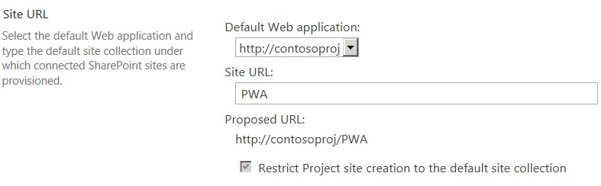

Site URL setting

The Site URL settings let you set the default Web application in which your project sites are created. The default site URL information on this page is based on the information provided during the provisioning of the Project Web App instance.

Use the following procedure to specify site URL information for your project sites.

* To specify Site URL information:

1. On PWA Settings page in SharePoint Central Administration, in the Operational Policies section, click **Project Site Provisioning Settings**.
2. On the Project Site Provisioning Settings page, in the Site URL section, specify a default Web application that your project sites will be created from. Select the Web application from the Default Web application menu.
3. In the Site URL field, type the URL path (for example, PWA).
4. Select Restrict Project site creation to the default site collection if you only want project sites to be created in the site URL settings you specify.
5. Click **Save**.

### Default Site Properties

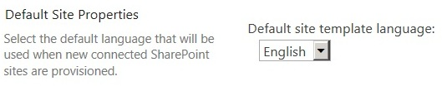

Default Site Properties setting

The Default Site Properties settings let you select the default site template language that will be used to create your project sites.

Use the following procedure to specify site URL information for your project sites.

* To configure default site properties for your Project Sites:

1. On PWA Settings page in SharePoint Central Administration, in the Operational Policies section, click **Project Site Provisioning Settings**.
2. On the Project Site Provisioning Settings page, in the Default Site Properties section, select the default language for your project sites from the Default site template language drop-down list.

Note The languages available to you in the Default site template language drop-down list are:

-The language of your base installation of Project Server 2013

-The language of any installed Project Server 2013 language packs.

For example, if you install the Project Server 2013 Spanish language pack on a Project Server 2013 English base installation, you can choose English or Spanish from the Default site template language drop-down menu. Selecting one or the other will determine the default language the Project Web App user interface will display in for newly provisioned instances of Project Web App.

1. Click **Save**.

### Site Creation Settings

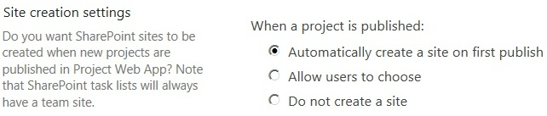

Site Creation settings

The Site Creation setting lets you indicate whether you want to have Project Server 2013 create project sites for projects when the projects are newly published to the server. The settings can be configured to not create a project site. Additionally, you could provide users the option select either option.

Note If you choose not to create a site, you can create a site for your project later through the Project Sites page in the Project Web App Server Settings page.

Use the following procedure to configure the Site Creation settings.

* To configure the site creation settings:

1. On PWA Settings page in SharePoint Central Administration, in the Operational Policies section, click **Project Site Provisioning Settings**.
2. On the Project Site Provisioning Settings page, in the Site creation settings section, select one of the three Provisioning mode options:

* Automatically create a project site on first publish
* Allow users to choose
* Do not create a site

1. Click **Save**.

## Bulk Update Project Sites

The Bulk Update Project Sites page allows you to change site path information for project sites in one Web application to a different one (for example, when migrating). It allows you to break the original links between projects and their corresponding project sites in one site collection and then relink to the new project sites in the new site collection.

* Update Site Paths
* Update Content Types
* Project Site Permissions

### Update Site Paths

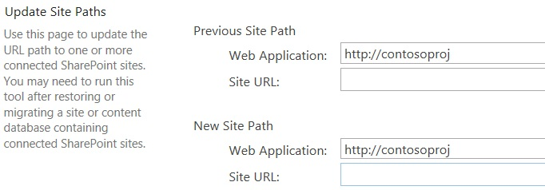

Update Site Paths

The Update Site Paths setting lets you break links between projects and project sites that are contained in one site collection and relink with the new Project Sites in a different site collection.

Use the following procedure to update project site paths to a new site collection.

* To update project site paths to a new site collection:

1. On PWA Settings page in SharePoint Central Administration, in the Operational Policies section, click **Bulk Update Project Sites**.
2. On the Bulk Update Project Sites page, in the Update Site Paths section, for Previous Site Path:
   1. Select the Web application for your project sites that you want to break the link to. If you are migrating project sites on the same server, the Web application that you need to select may appear as a URL. If you are migrating projects sites from a different server, the Web application you need to select may appear as a globally unique identifier (GUID).
   2. In the **Site URL** field, type the site URL information (for example, PWA).
3. For **New Site Path**:
   1. Select the Web application that contains the project sites that you want to link to (for example, http://hr1.contoso.com).
   2. In the **Site URL** field, type the site URL information (for example, PWA).
4. Click **Save**.

### Update Content Types

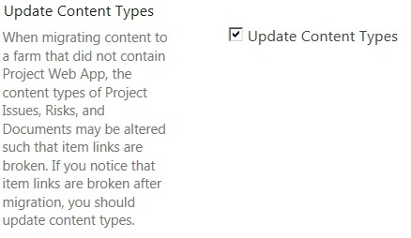

Update Content Types

The Update Content Types setting allows you to ensure that when you migrate content from one farm to another, the content types of Project Issues, Risks, and Documents are updated in the new location so that item links will remain functional.

Use the following procedure to enable the Update Content Types setting.

* To enable the Update Content Types setting:

1. On PWA Settings page in SharePoint Central Administration, in the Operational Policies section, click **Bulk Update Project Sites**.
2. On the Server Settings page, in the Operational Policies section, click **Bulk Update Project Sites**.
3. On the Bulk Update Project Sites page, in the Update Content Types section, select **Update Content Types**.
4. Click **Save**.

11

# Workflow and Project Detail Pages: SharePoint Central Administration PWA Settings

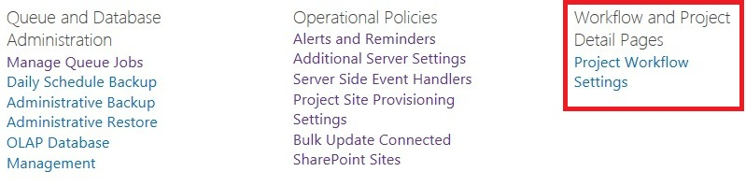

Workflow and Project Detail Pages Settings for Project Web App in SharePoint Central Administration

You can specify the Workflow Proxy User account that you plan to use for Project Server 2013. The account that you enter is the identity with which all the PSI calls in a workflow will be made.

* To set the Workflow Proxy User account

1. On the **SharePoint Central Administration** page, click **General Application Settings**.
2. Under **PWA Settings**, click **Manage**.
3. Under **Workflow and Project Detail Pages**, click **Project Workflow Settings**.

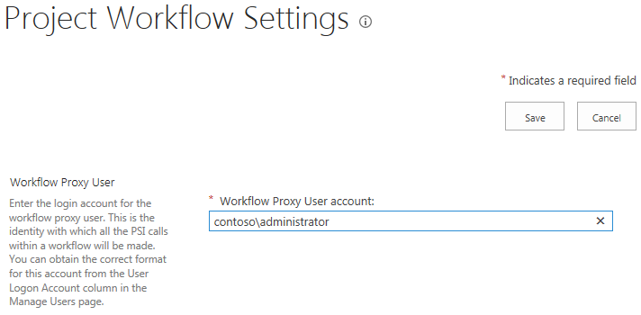

Project Workflow Settings

1. Type the **Workflow Proxy User account** that you want to use to make all PSI calls within Project Web App workflows.

Tip   If you’re not sure of the correct format to use for this account, check the **User Logon Account** column on the **Manage Users** page.

12

# Manage Queue Settings

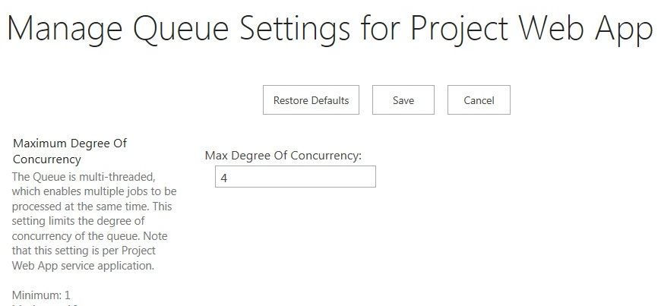

Manage Queue Settings page

Queue Settings options allow you to configure the way the Queue operates in Project Server 2013. In Project Server 2013, Queue settings are no longer applicable to individual Project Web App instances, but now apply to all Project Web App instances that are created in the Project Service Application. Additionally, because the Queue is now located at the Project Service level, the Manage Queue Settings page can be accessed in the SharePoint Central Administration website instead of Project Web App.

Important Project Server 2013 Queue performance has increased significantly from the previous version because of many changes that were implemented for this release. The default values are the recommended queue settings for optimal performance.

## Requirements

If you are sure you need to change the default Queue settings, you need to be at least a Service Application Administrator for the Project Server service application. This is the least privileged permission level required.

The Manage Queue Settings page can be accessed in the Project Service Application page in Central Administration. Use the following procedure to access the Manage Queue Setting page in the Project Service Application page:

* To access the Manage Queue Settings page

1. In SharePoint Central Administration, click **Application Management**.
2. On the Application Management page, in the Service Application section, click **Manage Service Applications**.
3. On the Service Applications page, click the Project Application Service that contains the Project Web App instance for which you want to access the Manage Queue Jobs settings.

On the Manage Project Web Apps page, click the drop-down menu for the PWA instance for which you want to access the Manage Queue Jobs settings, and click **Manage**.



1. On the Project Server Settings page, in the Queue and Database Administration page, click Manage Queue Jobs.

Important Project Server 2013 Queue performance has increased significantly from the previous version because of many changes that were implemented for this release. The default values are the recommended queue settings for optimal performance.

.

## Configure Queue Settings

The Queue Settings page contains the following configuration options:

* Maximum Degree of Concurrency
* Retry Interval
* Retry Limit
* SQL Timeout
* Cleanup Age Limit for Successful Jobs
* Cleanup Age Limit for Unsuccessful Jobs
* Bookkeeping Interval
* Queue Timeouts

The SQL Retry Interval and SQL Retry Limit settings that display on this page are obsolete in Project Server 2013 and will be removed in a future update. Do not use these settings.

### Maximum Degree of Concurrency

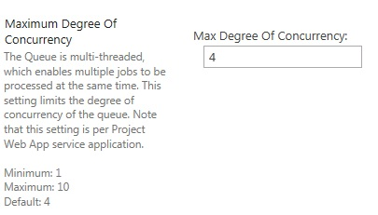

Maximum Degree of Concurrency setting

Since the Queue is multi-threaded, multiple jobs that are sent to the queue can be processed simultaneously. The Maximum Degree of Concurrency setting limits the number of jobs that can be processed at the same time, by setting the maximum number of job processor threads that are available in the Queue. The valid range is 1 through 10, with a default value of 4.

In Project Server 2013, the value for this setting acts as a multiplier of the number of cores on the application server. For example, if your application server is using a dual-core processor, and the Maximum Degree of Concurrency is set at the default value of 4, the maximum number of jobs that can be processed at the same time is 8. If you have multiple application servers, this setting applies to each server. For example, if you have two application servers with dual-core processors, and the Maximum Degree of Concurrency is set at the default value of 4, each server can process up to 8 jobs at the same time.

### Retry Interval

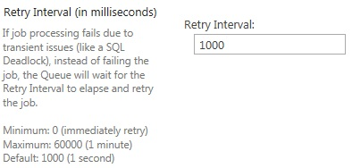

Retry Interval setting

The Retry Interval setting lets you set the length of time (in milliseconds) between retries for jobs that have failed because of transient issues, such as a SQL time-out. If the processing job fails, instead of failing the job, the Queue will wait for the time set by the Retry Interval value, and then will retry the job. The valid range is 0 (immediate retry) to 60000 (1 minute), with a default value of 1000 (1 second).

### Retry Limit

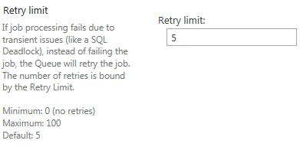

Retry Limit setting

The Retry limit setting lets you set the maximum number of times a failed processing job will be retried. If the job does not process because of transient issues, such as a SQL time-out, instead of failing the job, the Queue will retry the job. The number of retries attempted is set by the value entered for this setting. Note that the amount of time between retries is set by the Retry Interval setting. The valid range is 0 (no retries) to 100. The default value is 5.

### SQL Timeout

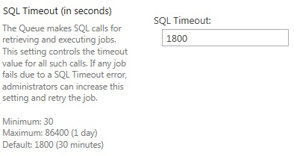

SQL Timeout setting

The queue makes SQL calls for retrieving and executing jobs. This SQL Timeout setting lets you set the time-out value (in seconds) for these calls. If any job fails because of a SQL Timeout error, you can increase the value for this setting and retry the job. The valid range is 30 to 86400 (one day), with a default value of 1800 (30 minutes).

### Cleanup Age Limit for Successful Jobs

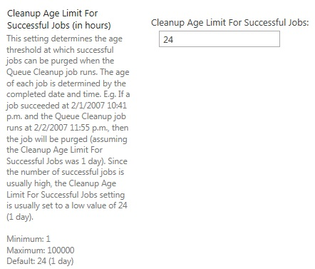

Cleanup Age Limit for Successful Jobs setting

The Cleanup Age Limit for Successful Jobs setting lets you configure when a job that has been completed successfully is removed from the system. Successfully completed jobs can be removed from the system through the Queue Cleanup job, which can be configured so that it removes successfully completed jobs after they reach a certain age threshold. You can configure this setting by entering the value (in hours) in the Cleanup Age Limit for Successful Job field. The value that you enter configures the queue to delete the job when the Queue Cleanup job is scheduled to run, only if the age of the successfully created job is equal to or greater than that value. The valid range for this setting is 1 hour through 100,000 hours. The default value for this setting is 24 hours (one day).

### Cleanup Age Limit for Non-Successful Jobs

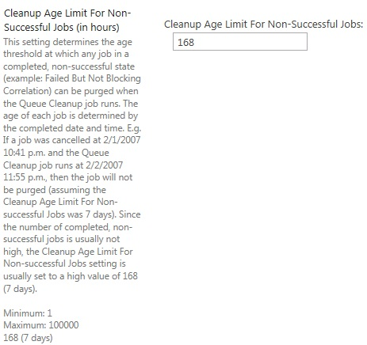

Cleanup Age Limit for Non-Successful Jobs setting

The Cleanup Age Limit for Non-Successful Jobs setting lets you configure when a job that has completed in an unsuccessful state is removed from the system. You can configure this setting by entering the value (in hours) in the Cleanup Age Limit for Non-Successful Jobs field. The value that you enter configures the Queue to delete the job during the cleanup interval, only if the age of the non-successful job is equal to or greater than that value. The method in which unsuccessful jobs are removed from the system is identical to the way successfully completed jobs are removed from the system.

Note Jobs that are in an Unsuccessful and blocking correlation state stay in the history until they are successfully retried or cancelled. The cleanup for non-successful jobs does not affect jobs in this state.

The default value of this setting is 168 hours (7 days). Since job status information is important in helping to troubleshoot problems when a job has not completed successfully, we recommend not setting this value to less than the default setting.

### Bookkeeping Interval

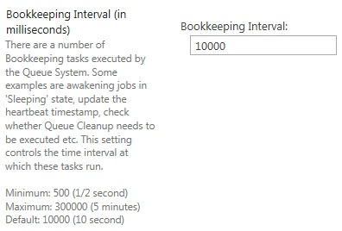

Bookkeeping Interval setting

There are a number of Bookkeeping tasks that are executed by the Queuing System. For example, these include awakening jobs in a "sleeping" state, updating the heartbeat timestamp, checking whether the Queue Cleanup job needs to be executed, etc. The Bookkeeping Interval setting controls the time interval (in milliseconds) in which these tasks are run.

The valid range is 500 (1/2 second) to 300000 (five minutes), with a default value of 10000 (ten seconds).

### Queue Timeout

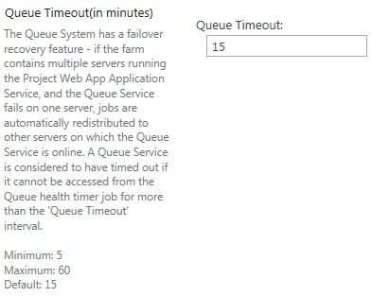

Queue Timeout setting

In a farm that contains multiple Application servers that are running the Project Server Application Service, if the Queue Service fails on one of the servers, jobs are automatically distributed among the remaining Application servers on which the Queue Service is online. A Queue Service is considered to have timed out if it cannot be accessed from the Queue health timer job for longer than the Queue Timeout value (in minutes).

The valid range is 5 to 60 minutes, with a default value of 3 minutes.

Note The Queue Timeout value cannot be less than four times the Bookkeeping Interval at any time. If this rule is violated, the Queue Timeout value will automatically be changed to four times the Bookkeeping value.

Appendices

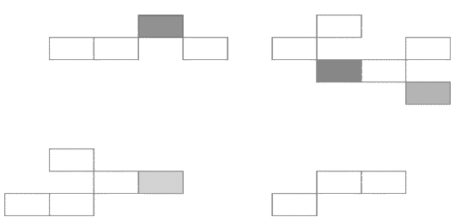

A

# Project Server 2013 Category Permissions

Important    The Project Server 2013 environment must be in Project Server Permission Mode in order to view category permissions and other security settings. For more information about Permission Modes, see the Security chapter.

The following tables contain descriptions of all category permissions for Project Server 2013. The category permission descriptions are provided in two tables (Projects and Resources), because category permissions apply to either projects or resources that are associated to a specific category.

The table includes columns with the following information:

* **Permission** Name of the category permission.
* **Description**   Describes what the permission lets you do.
* **Dependencies**   Lists any other permissions (global or category) or requirements to allow the permission to function.
* **New for Project Server 2013**   Displays an **X** symbol if the permission is new for Project Server 2013.

**Category Permissions - Projects**

| **Permission** | **Description** | **Dependencies** | **New for Project Server 2013** |
| --- | --- | --- | --- |
| Accept Task Update Requests | Allows a user to accept updates on projects without requiring that the user have the Save Project to Project Server permission |  |  |
| Adjust Timesheet | Allows a Project Web App user to adjust a team member’s submitted timesheet entries. Grant this permission to any member of your organization who requires the ability to adjust a resource’s timesheet entry after that resource has submitted the entry. | User must have the **View Resource Timesheet** permission to use this permission. |  |
| Build Team On Project | Allows a user to add resources to a project that has already been saved to the Project Server database. Grant this permission to project managers who want to use the Build Team feature in Project Professional to staff their projects before they save (and publish) them to the Project Server database. Or, grant this permission to resource managers who want to use the Build Team feature in the Project Center of Project Web App to add resources to a project that has already been saved to the Project Server database. | * User must have the **View Enterprise Resource Data and Assign Resources** category permissions in order to see resources that are part of the Enterprise Resource Pool in the Build Team feature in Project Professional and Project Web App. * User must have permission (at the category level) to access the specific projects and resources that have to be accessed to build the project team or assign resources. |  |
| Create Deliverable and Legacy Item Links | Allows a user to create, modify, or delete links between Project tasks and items in the project site (documents, issues, deliverables, and risks). |  | X |
| Create New Task or Assignment | Determines which projects are available when you are creating new tasks. Grant this permission to any group of projects that individual users will be able to create new tasks in by using the Create a new task page in Project Web App. | User must be granted the **New Task Assignment** global permission in order to access the New task page in Project Web App. |  |
| Delete Project | Allows users of Project Professional to delete a project saved to the Project Server database from the **Open from Microsoft Project Server** dialog box in Project Professional. Grant this permission to members of your organization to enable them to more closely manage the projects he or she has saved to the Project Server database from Project Professional or by using the "Delete Enterprise Objects" link in Project Web App. Before letting users delete projects, you should consider how your organization will recover those projects, if you have to do so. |  |  |
| Edit Project Summary Fields | Allows a user to edit only the enterprise project fields shown in the new project fields Web Part. If you do not have this permission, but have "Save Project to Project Server" permissions, you can still edit project-level fields/custom fields in the project field Web Part. |  |  |
| Manage Basic Project Security | Controls whether a specific Project Permission can be set on a single project through the Project Permissions feature. |  |  |
| Manage Resource Plan | Allows a user to edit a resource plan. |  |  |
| Open Project | Allows a user to open a project from the Project Server database in read-only mode using Project Professional. Grant this permission to any member of your organization who has to use the **Open from Microsoft Project Server** dialog box in Project Professional or in the Project Center in Project Web App to open projects that have been saved to the Project Server database. If users are not assigned the **Save Project to Project Server** permission, then the project will only be open in read-only mode. |  |  |
| Publish Project | Allows a user to Publish projects to the Project Server database using Project Professional and Project Web App. Grant this permission to all members of your organization who will be publishing projects. | User must be granted the **Open Project** category permission on any project that has to be checked out from the Project Server database. If the project has changed since opening, the user will be required to have the **Save Project to Project Server** permission on that project. If not, when a publish occurs, it will only publish the outdated version. |  |
| Save Project to Project Server | Allows a user to save projects to the Project Server database using Project Professional. Also gives Project Web App users the permission to save schedules and strategic impact data. Grant this permission to all members of your organization who will be saving projects from Project Professional to the Project Server database using the **Save to Project Server** dialog box or through Server-side projects. | * User must be granted the **New Project** permission in order to create the project. * User must be granted the **Open Project** category permission on any project that has to be checked out from the Project Server database. |  |
| Save Protected Baseline | Allows a user to save a protected baseline or clear a protected baseline associated with an enterprise project published to the Project Server database. Grant this permission to project managers who have to save baselines in their projects. Baselines are saved by using the Set Baseline functionality accessed from the Project Professional ribbon on the **Project** tab in the **Schedule** group. Click the **Set Baseline** button and then select **Save Baseline** or **Clear Baseline**. Protected Baselines are in the range of Baseline 0-5 inclusive. Only users who have Save Unprotected Baseline, Open Project and Save Project Category permissions are able to save Baselines in Baseline 6-10. | User must be granted the **Save Project to Project Server** category permission. |  |
| View Project Schedule in Project Web App | Allows a user to view project information for a specific project from the Project Center in Project Web App. Grant this permission to users who have to view project details in the Project Center. |  |  |
| View Project Site | Allows users to view Risks, Issues, and Documents areas in Project Web App and Project Professional. Grant this permission to any user of Project Professional who has to select Project site, Documents, Issues, or Risks from the Info page in the Backstage or any user of Project Web App who has to access the Project site, Documents, Issues, or Risks top-level navigation links. |  |  |
| View Project Summary in Project Center | Allows a user to access a specific project in the Project Center from Project Web App. Grant this permission to any member of your organization who has to view projects summaries in the Project Center. | . |  |
| View Resource Assignments in Assignment Views | Allows a user to view assignment details using assignment views in the Resource Center. Grant this permission to project managers and resource managers who have to view resource assignment details in the Resource Center from Project Professional or Project Web App. |  |  |
| View Enterprise Resource Data | Allows a user to view resources and resource data that is stored in the Enterprise Resource Pool. Grant this permission to any user who has to view resources and resource data that is stored in the Enterprise Resource Pool. |  |  |

**Category Permissions - Resource**

| **Permission** | **Description** | **Dependencies** | **New for Project Server 2013** |
| --- | --- | --- | --- |
| Adjust Timesheet | Allows a Project Web App user to adjust a team member’s submitted timesheet entries. Grant this permission to any member of your organization who requires the ability to adjust a resource’s timesheet entry after that resource has submitted the entry. | User must have the **View Resource Timesheet** permission to use this permission. |  |
| Approve Timesheets | Allows a user to approve a team member's submitted timesheet entries. Grant this permission to any member of your organization who requires the ability to approve a resource's timesheet. | * User must have the **Approve Timesheets** permission through a category which contains the resources which they want to approve timesheets on. |  |
| Assign Resources | Allows a user to assign or allocate a given resource to projects. This permission controls the list of available resources in Team Builder in both Project Web App and Project Professional. Grant this permission to all project managers and resource managers who have to assign, manage, or allocate resources. For example, if you want to add resource R to project P, then you must have permission to assign resource R (Assign Resources) plus permission to build the team on Project P (Build Team on Project). In addition, you must have access to the Team Builder page through either Project Web App or Project Professional (Assign Resources to Project Team). | * User must have the **View Team Builder** global permission in order to use the Build Team page in Project Web App or Project Professional. * User must have the **Build Team on Project** category permission in order to assign a resource in an existing enterprise project. * User must have the **Build Team on New Project** global permission in order to assign a resource in a new enterprise project. |  |
| Edit Enterprise Resource Data | Allows a project manager to edit enterprise resource data by using Project Professional (checked-out Enterprise Resource Pool) or a resource manager to edit enterprise resources using Project Web App (Resource Center). Grant this permission to project managers and resource managers who have to make updates to resources that belong to the Enterprise Resource Pool. Resource managers with this permission are able to edit enterprise resource data in the Resource Center in Project Web App, and they can make updates to cost data, custom outline code data, custom field data, and other static information related to resources. Resource managers cannot add or delete resources from the Enterprise Resource Pool in Project Web App. Project managers can add or delete resources from the Enterprise Resource Pool in Project Professional if they have the **New Resource** global permission (to add resources) or the **Clean Up Project Server Database global** permission (to delete resources). These permissions are required in addition to the **Edit Enterprise Resource Data** category permission.   |  | | --- | | **C:\Users\efrene\AppData\Local\Temp\DxEditor\DduePreview\Default\8c0d58c4-80f9-4e41-a30a-d74112fb80e6\local\note.gifNote:** | | The Project Server Interface (PSI) can also be used to create or delete resources in the Enterprise Resource Pool and to edit enterprise resource data. | | User must be granted the **View Enterprise Resource Data** category permission. |  |
| Manage Resource Delegates | Allows a user to see other users whom he or she manages and to set delegates for them. |  |  |
| View Enterprise Resource Data | Allows a user to view resources and resource data that is stored in the Enterprise Resource Pool. Grant this permission to any user who has to view resources and resource data that is stored in the Enterprise Resource Pool. |  |  |
| View Resource Assignments in Assignment Views | Allows a user to view assignment details using assignment views in the Resource Center. Grant this permission to project managers and resource managers who have to view resource assignment details in the Resource Center from Project Professional or Project Web App. |  |  |

B

# Project Server 2013 Global Permissions

Important    The Project Server 2013 environment must be in Project Server Permission Mode in order to view global permissions and other security settings. For more information about Permission Modes, see the Security chapter.

The following is a list of global permissions for Microsoft Project Server 2013. The columns in the table include the following:

* **Permission**   Name of the global permission.
* **Description**   Describes what the permission enables you to do.
* **Dependencies**   Lists any other permissions (global or category) or requirements necessary for the permission to function.
* **New for Project Server 2013**   Displays an **X** symbol if the permission is new for Project Server 2013.

| **Permission** | **Description** | **Dependencies** | **New for Project Server 2013** |
| --- | --- | --- | --- |
| Access Project Server Reporting Service | Allows a user to access the OData web service for retrieving data from Project Server. |  | X |
| Build Team On New Project | Allows a user to add resources to a project that has not been saved to Project Server. Grant this permission to project managers who want to use the Build Team feature in Microsoft Project Professional to staff their projects before they save and publish them to Project Server. | User has to be granted the **Assign Resources** and **View Enterprise Resource Data** category permissions in order to see resources that are part of the Enterprise Resource Pool in the Build Team feature in Microsoft Project Professional. |  |
| Can be Delegate | Specifies whether a user can be a delegate. |  |  |
| Change Workflow | Allows a user to change a project's Enterprise Project type (Change Project Type). |  | X |
| Clean up Project Server database | Allows a user to access the Delete Enterprise Objects page available through the Server Settings page in Project Web App. Grant this permission to users who have to delete timesheets, status reports responses, projects, resources, users, and user delegates from Project Server. |  |  |
| Contribute to Project Web App | Allows users to edit items within lists in Project Web App project sites. |  |  |
| Edit Status Report Requests | Allows a user to access the *Request a status report* link on the Project Web App Status Reports center and to view team reports. Grant this permission to any member of your organization who has to create status report requests and view team reports, usually project managers, resource managers, team leads, and members of your organization’s PMO. |  |  |
| Log on | Allows a user to connect to Project Server from Microsoft Project Professional or to log on to Project Web App. Grant this permission to any user who is authorized to connect to Project Server from Microsoft Project Professional or log on to Project Web App. |  |  |
| Log on to Project Server from Project Professional | Allows a user to load the Enterprise Global Template when he or she connects Microsoft Project Professional to Project Server. Grant this permission to all users in your organization who will be using Microsoft Project Professional to connect to Project Server. |  |  |
| Manage Active Directory Settings | Allows users to modify any Active Directory Synchronization settings within the Project Web App Server Settings. If the user is denied this permission then they cannot modify settings for any of the following:   * Enterprise Resource Pool synchronization settings. * Project Web App Security Groups synchronization settings. * Choose an Active Directory Group to synchronize against a specific Security Group within the Add or Edit Group page. |  |  |
| Manage Check-Ins | Allows a user to access the Forced Check-in Enterprise Objects page in Project Web App. This page lets users force check-in projects, resources, custom fields, calendars, lookup tables and resource plans. |  |  |
| Manage Cube Building Service | Allows a user to the set and modify the settings for OLAP cube creation. |  |  |
| Manage Drivers | Allows a user to access the drivers.aspx page and manage drivers for project portfolio analysis. |  | X |
| Manage Enterprise Calendars | Allows a user to create, modify and delete Enterprise Calendars within Project Web App. |  |  |
| Manage Enterprise Custom Fields | Allows a user to modify the definitions of Enterprise Custom Fields and lookup table from Project Web App. |  |  |
| Manage Exchange Integration | Allows administrators to enable the synchronization of project tasks with Exchange Server. |  |  |
| Manage Gantt Chart and Grouping Formats | Allows a user to access the Gantt chart and grouping formats customization options in the Project Server Administration page for Project Web App views. |  |  |
| Manage Lists in Project Web App | Allows a user to create, modify, and delete lists within the Project Web App project site. This permission is used when synchronizing a user against the Project Web App project site. |  |  |
| Manage Notification and Reminders | Allows a user to manage the Notification and Reminders settings. |  |  |
| Manage My Delegates | Allows users to see the "Manage Delegates" link and to set a delegate on the "Add/Modify Delegation" page. |  |  |
| Manage My Resource Delegates | Allows users to set a user who requires a substitute on the Add/Modify Delegation page. |  |  |
| Manage Personal Notifications | Allows a user to access the Manage My Alerts and Reminders page in Project Web App. Grant this permission to any user that you want to be able to sign up for e-mail notifications and reminders related to tasks and status reports. |  |  |
| Manage Portfolio Analyses | Allows a user to create, read, update, and delete Portfolio analyses. |  | X |
| Manage Prioritizations | Allows a user to create, read, update, and delete driver prioritizations. |  |  |
| Manage Project Server Backup | Allows a user to schedule the backup or immediately back up several entities on Project Server, including the following:   * Projects * The Enterprise Resource Pool * Calendars * Custom fields * The Enterprise Global template * Views * System settings * Categories * Group settings. |  |  |
| Manage Project Server Restore | Allows a user to immediately restore several entities on Project Server, including the following:   * Projects * The Enterprise Resource Pool * Calendars * Custom fields * The Enterprise Global template * Views * System settings * Categories * Group settings   **Note**:   Similar to Server Backup except that the permission does not let you schedule a recovery. |  |  |
| Manage Project Web App Views | Allows a user to access the Manage Views page in the Server Settings page in Project Web App. Users with permission to access this page are able to add, modify, or delete Project, Project Center, Resource Center, Assignment, or Portfolio Analyzer views, and they are able to modify Timesheet views. Grant this permission to project managers, resource managers, and members of your organization’s PMO so they can create project data views for users to access in Project Web App and Microsoft Project Professional. It is important to remember that if your organization is allowing project managers to create custom fields at the project level, then each project may require its own unique view. The number of projects in this kind of environment may be too many for the IT administrator team. Offloading this work to the people in your organization that work at the project level on a day-to-day basis is one way to distribute the workload of managing views. |  |  |
| Manage Queue | Allows the user to read or set queue configuration settings and retry, cancel, and unblock jobs in the queue. |  |  |
| Manage Resource Notifications | Allows a user to access the **Alert me about my resources on tasks and status reports** link on the Project Web App home page. Grant this permission to any resource manager or project manager you want to be able to sign up for e-mail notifications and reminders related to their resource’s tasks and status reports. |  |  |
| Manage Rules | Allows a user to access the Rules page from the Approval Center in Project Web App and set rules on how update transactions will be automatically processed. Grant this permission to project managers, resource managers, or members of your organization’s PMO so they can define how they will automatically receive and accept changes to transactions by their resources. |  |  |
| Manage security | Allows a user to access the Manage security page in Project Web App to define security categories, security templates, and user authentication settings. Grant this permission to Project Server administrators or a very small and closely managed group of people. This page lets users change Project Server security settings, create security categories and security templates. Changes to settings on this page, once you have begun using Project Server in your organization, should be carefully managed and (ideally) infrequent. |  |  |
| Manage Server Events | Allows a user to register event handlers for specific Project Server server-side events. The Manager Server Events page requires the event handler to be registered by the server as defined in the Project Server SDK. |  |  |
| Manage Server Configuration | Allows a user to access the Project Web App Permissions page in Project Web App. Users with permission to access the Project Web App Permissions page can enable or disable enterprise features, manage organizational permissions, and create custom menus (both top-level and side-pane) in Project Web App. Grant this permission to Project Server administrators or a very small and closely managed group of people. |  |  |
| Manage SharePoint Foundation | Allows a user to create and delete project sites, configure automatic project site creation for newly published projects, configure permission synchronization settings, and update site path. Grant this permission to members of your organization who are administrators for Project Web App or administrators for the servers that are running SharePoint Server 2013. | Users with this permission should be granted administrative privileges to all of the servers that are running Project Server 2013 and SharePoint Server 2013. | X |
| Manage Time Reporting and Financial Periods | Allows a user to create and modify Timesheet and Fiscal period definitions. |  |  |
| Manage Time Tracking | Allows a user to be forwarded timesheets for review. After reviewing the timesheet, the user must be granted the following permissions to accept and approve timesheets:   * Accept Timesheet * Approve Timesheet |  |  |
| Manage Users and Groups | Allows a user to access the Manage Users and Groups page in the Server Settings page in Project Web App. Users with this permission will be able to add, modify, or delete Project Server users and manage Project Server security groups. Grant this permission to members of your organization who are Project Server administrators. Only a small group of people should have permission to access this set of pages. |  |  |
| Manage Workflow and Project Detail Pages | Allows a user to manage and view workflow and Project Detail Pages (PDPs). |  |  |
| New Project | Allows a user to add a new project to Project Server using Microsoft Project Professional, Project Web App, or the Project Server Interface (PSI). |  |  |
| New Resource | Allows a project manager to add new resources to the Enterprise Resource Pool using Microsoft Project Professional, the Project Web App Resource Center, or the Project Server Interface (PSI). Grant this permission to any member of your organization who has to create new enterprise resources in Project Server.  Note If your organization is using the Active Directory synchronization feature, you may want to consider denying this permission to all non-IT administrators in your organization. |  |  |
| New Task Assignment | Allows users to access the **Create a New Task and Add Yourself to a Task** links from the **Insert Row** button found on the **Tasks** page of Project Web App. Grant this permission to any member of your organization who has to create new assignments on existing tasks in projects that have been published to Project Server. Users with this permission will also be able to use the Create a New Task link to create new tasks in Project Web App for any project to which the user has access. The list of available projects for a user to create new tasks is determined by the Create New Tasks or Assignment category permission. A user who has the New Task Assignment permission must also have access to the projects to which they want to assign themselves to a task. |  |  |
| Open Project Template | Allows a user to open an Enterprise Project Template from Project Server using Microsoft Project Professional. Grant this permission to all users in your organization who will be using Microsoft Project Professional to create and manage projects that are based on Enterprise Project Templates. | User must be granted the **New Project** global permission in order to save the project to the Project Server database as an actual project. |  |
| Reassign Task | Allows a user to delegate an assigned task to another (existing) user. Grant this permission to members of your organization who need the ability to delegate task assignments to other resources. For example, a large project may be run by a single project manager, but actually implemented by several teams, each with their own team lead. A project manager could assign the team leads in the project plan, and then the team leads could in turn delegate each task to individual members of their teams. This example creates an additional layer of task management within the larger organization, but it can also simplify resource allocation within projects themselves and make it easier for a project manager to manage large projects. Or, if you have a resource that is about to leave on a three-week vacation, and this resource had this permission, they would be able to assign their tasks directly to other resources instead of having the project manager check out the project and reassign resources. |  |  |
| Save Enterprise Global | Allows a user to check out, modify, and save the Enterprise Global Template to the Project Server database from Microsoft Project Professional. This permission should only be granted to a small group of people in your organization; either project managers, members of your organization’s PMO, or Project Server administrators. |  |  |
| Save Project Template | Allows a user to create and save a project as an Enterprise Project Template from Microsoft Project Professional to the Project Server database. Grant this permission to members of your organization who are tasked with creating Enterprise Project Templates. When a user saves a project to Project Server for the first time, the option to select Template (as opposed to Project) from the Type drop-down list in the Save to Project Server dialog box is enabled. | User needs to be granted the **Assign Resources** and **View Enterprise Resource Data** category permissions in addition to this permission if they are also responsible for adding Generic resources to the Enterprise Project Template. |  |
| Save Unprotected Baseline | Allows a user to save a non-protected baseline or clear a non-protected baseline associated with an enterprise project published to the Project Server database. Baselines are saved by using the Set Baseline functionality accessed from the Microsoft Project Professional ribbon on the **Project** tab in the **Schedule** group. Click the **Set Baseline** button and then select **Save Baseline** or **Clear Baseline**. Unprotected Baselines are in the range of Baseline 6-10 inclusive. | User needs to be granted the **Save Project** category permission. |  |
| Self-Assign Team Tasks | Resources can be members of a Team Assignment Pool. With this permission, it is possible for users to assign tasks, which have been assigned to their Team Assignment Pool, to themselves through the Team Tasks page in Project Web App. |  |  |
| Status Broker Permission | Allows API updates to occur for a user from places like Microsoft Exchange Server. |  |  |
| View Approvals | Allows a user to view the Approval Center. | Users have access to the Approval Center if they have either the Accept Timesheets or the View Approvals permission. |  |
| View Business Intelligence Link | Allows a user to see the Business Intelligence link in Quick Launch. However, it has no impact on Report Center Security. |  |  |
| View OLAP Data | Allows a user to read from the output for the OLAP cube. This permission is only checked when the OLAP cube is built. |  |  |
| View Project Center | Allows users to access the Project Center from Project Web App or Microsoft Project Professional. | User needs to be granted the **View Project Summary in Project Center** category permission. |  |
| View Project Schedule Views | Allows a user to see the link in the Quick Launch. However, it has no impact on Report Center Security. |  |  |
| View Project Timesheet Line Approvals | Allows a user to approve timesheets on a line-by-line basis. |  |  |
| View Resource Availability | Allows a user to access the View Resource Availability page to view resource allocation data in Project Web App. Grant this permission to users in your organization who need to view resource availability in Project Web App. |  |  |
| View Resource Center | Allows users to access the Resource Center from Project Web App or Microsoft Project Professional and view resource allocation data. Grant this permission to users who need to view the Resource Center in Project Web App by clicking the Resources link in the top-level navigation, or in Microsoft Project Professional by selecting Resource Center on the Collaborate menu. | User needs to be granted the **View Enterprise Resource Data** category permission. |  |
| View Resource Plan | Allows a user to access the Resource Plan page within Project Web App. |  |  |
| View Resource Timesheet | Allows users to view the timesheets, regardless of their state or ownership, for resources identified in the category selection criteria. | Users must be granted the **Accept Timesheet** global permission to use this permission. |  |
| View Task Center | This permission, when denied, prevents users from seeing the Task Center link on the Project Web App Quick Launch menu.  Note This permission does not lock down access to the Task Center page. It is still possible for users to navigate to this page. |  |  |
| View Team Builder | Allows a user to use **Build Team** in Project Web App and Microsoft Project Professional, as well as determine the list of available resources. Grant this permission to resource managers to allow them to use Build Team in Project Web App to add resources to projects that have been saved to the Project Server database. Project Managers can also use this permission to allow them to use **Build Team** in Microsoft Project Professional to add resources to projects. | * User needs to be granted the **Assign Resources** category permission in addition to the **View Team Builder** global permission. The Assign Resources category permission determines the list of resources available in Build Team in both Microsoft Project Professional and Project Web App. * User needs to be granted the **Build Team on Project** category permission. The Build Team on Project permission determines with which projects Build Team can be used. This applies to using Build Team in both Microsoft Project Professional and Project Web App. |  |
| View Timesheets | When this permission is denied it prevents users from seeing the Timesheet Center link on the Project Web App Quick Launch menu  Note This permission does not lock down access to the Timesheet page. It is still possible for users to navigate to this page |  |  |

C

# Project Server 2010 Default Security Groups

This article describes the default permissions that are given to the default templates and user groups in Microsoft Project Server 2010.

Project Server 2013 creates seven default groups during installation:

* Administrators
* Executives
* Portfolio Managers
* Portfolio Viewers
* Project Managers
* Resource Managers
* Team Leads
* Team Members

Each group is given a default set of global permissions. Templates are also included to allow these default permissions to be assigned to new groups created by the administrator. After you use the template to create a new group, you can then choose to customize the new group to better suit your users by editing the permission for the group.

Global permissions differ from category permissions in that they apply to functionality that the user is allowed to do throughout Project Server 2013. In order to work with specific projects or resources, users must have access to them through a category to which the project or resource is added. The users are only allowed to do tasks with these specific projects and resources through the category permissions defined in the category. For more detailed information about groups and categories, see the Security chapter.

## Default global permissions

The following table contains a list of the default global permissions for each of the default user groups.

### 

| **Permission Name** | **Administrators** | **Portfolio Viewers** | **Portfolio Managers** | **Project Managers** | **Resource Managers** | **Team Leads** | **Team Members** |
| --- | --- | --- | --- | --- | --- | --- | --- |
| Access Project Server Reporting Service | X |  |  |  |  |  |  |
| Accept Timesheets | X |  | X |  | X |  |  |
| Build Team On New Project | X |  | X | X | X |  |  |
| Can Be Delegate | X |  |  |  |  |  |  |
| Change Password | X | X | X | X | X | X | X |
| Change Workflow | X |  |  |  |  |  |  |
| Clean Up Project Server Database | X |  |  |  |  |  |  |
| Close Tasks To Updates | X | X |  | X |  |  |  |
| Contribute to Project Web App | X |  |  |  | X | X | X |
| Edit Status Report Requests | X | X | X | X | X | X |  |
| Edit Status Report Responses | X | X | X | X | X | X | X |
| Log On | X | X | X | X | X | X | X |
| Log on to Project Server from Project Professional | X |  | X | X | X |  |  |
| Manage Active Directory Settings | X |  |  |  |  |  |  |
| Manage Check-Ins | X |  | X |  |  |  |  |
| Manage Cube Building Service | X |  | X |  |  |  |  |
| Manage Drivers | X | X | X |  |  |  |  |
| Manage Enterprise Calendars | X |  | X |  |  |  |  |
| Manage Enterprise Custom Fields | X |  | X |  |  |  |  |
| Manage Exchange Integration | X |  |  |  |  |  |  |
| Manage Gantt Chart and Grouping Formats | X |  |  |  |  |  |  |
| Manage Lists in Project Web App | X | X | X | X |  |  |  |
| Manage My Delegates | X |  |  |  | X |  |  |
| Manage My Resource Delegates | X |  |  |  | X |  |  |
| Manage Notification and Reminders | X |  |  |  | X |  |  |
| Manage Personal Notifications | X | X | X | X | X | X | X |
| Manage Portfolio Analyses | X | X | X |  |  |  |  |
| Manage Prioritizations | X | X | X |  |  |  |  |
| Manage Project Server Backup | X |  |  |  |  |  |  |
| Manage Project Server Restore | X |  |  |  |  |  |  |
| Manage Project Web App Views | X |  | X |  |  |  |  |
| Manage Queue | X |  | X |  |  |  |  |
| Manage Resource Notifications | X |  | X | X |  | X |  |
| Manage Rules | X |  |  | X |  |  |  |
| Manage Security | X |  |  |  |  |  |  |
| Manage Server Configuration | X |  |  |  |  |  |  |
| Manage Server Events | X |  |  |  |  |  |  |
| Manage SharePoint Foundation | X |  |  |  |  |  |  |
| Manage Site Services | X |  |  |  |  |  |  |
| Manage Time Reporting and Financial Periods | X |  |  |  |  |  |  |
| Manage Time Tracking | X |  |  |  |  |  |  |
| Manage Users and Groups | X |  |  |  |  |  |  |
| Manage Workflow Project Detail Pages | X |  |  |  |  |  |  |
| New Project | X | X | X | X | X | X | X |
| New Resource | X |  | X |  | X |  |  |
| New Task Assignment | X |  |  | X |  | X | X |
| Open Project Template | X |  | X | X |  |  |  |
| Reassign Task | X |  |  | X |  |  | X |
| Save Enterprise Global | X |  | X |  |  |  |  |
| Save Project Template | X |  | X | X |  |  |  |
| Save Unprotected Baseline | X |  | X | X |  |  |  |
| Self-assign Team Tasks | X |  |  | X | X | X | X |
| Status Broker Permission | X |  |  |  |  |  |  |
| View Approvals | X |  |  | X | X | X |  |
| View Business Intelligence Link | X | X | X | X |  |  |  |
| View OLAP Data | X | X | X | X |  |  |  |
| View Project Center | X | X | X | X | X | X | X |
| View Project Schedule Views | X | X | X | X | X | X | X |
| View Project Timesheet Line Approvals | X | X | X | X |  |  |  |
| View Resource Availability | X | X | X | X | X |  |  |
| View Resource Center | X | X | X | X | X |  |  |
| View Resource Plan | X | X | X | X | X |  |  |
| View Resource Timesheet | X |  |  |  |  |  |  |
| View Task Center | X | X | X | X | X | X | X |
| View Team Builder | X |  | X | X | X |  |  |
| View Timesheets | X | X | X | X | X | X | X |

D

# Project Server 2013 Default Categories

Microsoft Project Server 2013 creates five default categories during installation. Each of the categories is associated to default security groups. Some security groups are associated to multiple categories. Each category provides the associated security group category permissions that allow it to perform certain tasks with projects and resources for that category. This appendix describes the default settings for each category for Project Server 2013, including the following:

* Categories associated to default security groups – List the default categories that are associated with each default security group.
* Category permissions – Lists each category permission that is allowed for each security group, as defined by the default categories associated with that group

## Categories associated to default security groups

Specific default groups are already associated with each of the default categories. This means that users who are added to a specific default security group will automatically be allowed a specific set of permissions to work with the projects and resources that are associated with the category.

Note   For more information about the relationship between groups and categories, see the TechNet article “Plan groups, categories, and RBS in Project Server 2013” ([<http://technet.microsoft.com/en-us/library/cc197354.aspx>)](http://technet.microsoft.com/ro-ro/library/cc197354(en-us).aspx)).

| **Category Name** | **Administrators** | **Portfolio Managers** | **Portfolio Viewers** | **Project Managers** | **Resource Managers** | **Team Leads** | **Team Members** |
| --- | --- | --- | --- | --- | --- | --- | --- |
| My Direct Reports |  |  |  |  |  |  |  |
| My Organization | X | X | X | X | X |  |  |
| My Projects |  |  |  | X | X | X |  |
| My Resources |  |  |  |  | X | X |  |
| My Tasks |  |  |  |  |  |  | X |

## Category permissions

The following table describes the default category permissions for each default group. For example, a user in the default Administrators group (who is associated to the My Organization category by default) has the permissions allowed in the Administrators column in the table. These category permissions only apply to all projects, resources, and views selected for the My Organization category. However, a user in the default Project Managers group (who is associated to the My Organization and My Projects categories) has a different set of category permissions for the objects in the My Organization category. This allows you to conveniently set a more or less restrictive set of permissions for different types of users to a group of projects, resources, and views.

Use the following legend for the table below.

* My Org = My Organization
* My Dir = My Direct Reports
* My Proj = My Projects
* My Res = My Resources
* My Tsks = My Tasks

### 

| **Permission Name** | **Administrators** | **Portfolio Managers** | **Portfolio Viewers** | **Project Managers** | **Resource Managers** | **Team Leads** | **Team Members** |
| --- | --- | --- | --- | --- | --- | --- | --- |
| Accept Task Update Requests | My Org |  |  | My Proj |  |  |  |
| Adjust Timesheet | My Org |  |  |  | My Org |  |  |
| Approve Timesheets | My Org | My Org |  |  | My Org, My Res |  |  |
| Assign Resource | My Org | My Org |  | My Org | My Res |  |  |
| Build Team On Project | My Org |  |  | My Proj | My Org |  |  |
| Create Deliverable and Legacy Item Links | My Org | My Org | My Org | My Proj | My Org, My Proj, My Res | My Proj | My Tsks |
| Create New Task or Assignment | My Org |  |  | My Proj | My Proj | My Proj | My Tsks |
| Delete Project | My Org | My Org |  | My Proj |  |  |  |
| Edit Enterprise Resource Data | My Org | My Org |  |  | My Res |  |  |
| Edit Project Summary Fields | My Org |  |  | My Proj |  |  |  |
| Manage Basic Project Security | My Org |  |  | My Proj |  |  |  |
| Manage Resource Delegates | My Org |  |  |  | My Res |  |  |
| Manage Resource Plan | My Org |  |  | My Org | My Res |  |  |
| Open Project | My Org |  | My Org | My Proj |  |  |  |
| Publish Project | My Org |  |  | My Proj |  |  |  |
| Save Project to Project Server | My Org |  |  | My Proj |  |  |  |
| Save Protected Baseline | My Org |  |  | My Proj |  |  |  |
| View Enterprise Resource Data | My Org | My Org | My Org | My Org, My Proj | My Res |  |  |
| View Project Schedule in Project Web App | My Org | My Org | My Org | My Org, My Proj |  | My Proj | My Tsks |
| View Project Site | My Org | My Org | My Org | My Proj | My Proj | My Proj | My Tsks |
| View Project Summary in Project Center | My Org | My Org | My Org | My Proj | My Proj | My Proj | My Tsks |
| View Resource Assignments in Assignment Views | My Org | My Org | My Org | My Proj | My Res | My Proj | My Tsks |

E

# SharePoint Permissions Mode default permissions for Project Server 2013 SharePoint groups

SharePoint Permission Mode creates SharePoint groups that directly correspond to the default security groups found in Project Permission Mode. These default security groups include the following:

* Administrator
* Portfolio Managers
* Portfolio Viewers
* Project Managers
* Resource Managers
* Team Leads
* Team Members

Users in these SharePoint groups have the same global and category permissions that are assigned to them in Project Permission Mode in Project Server 2013 For example, the Project Managers SharePoint group in SharePoint Permission Mode receive all allowed global and category permissions that the Project Managers default security group has in Project Server 2013 in Project Permission Mode.

For more information about SharePoint groups in SharePoint Permission Mode for Project Server 2013, see the Microsoft TechNet article: Plan SharePoint Groups in Project Server 2013 (<http://technet.microsoft.com/en-us/library/fp161360.aspx>).

Important In SharePoint Permission Mode, you cannot edit default permissions assigned to any of these SharePoint groups. Also, you cannot create additional custom groups, categories, Resource Breakdown Structure (RBS) nodes, or edit the default permissions assigned to any of these objects. If you need more management of your user permissions in Project Server 2013, you can change to Project Permission Mode. For more information about the differences between the two security group modes available to you in Project Server 2013, see the Microsoft TechNet article: Plan user access in Project Server 2013(http://technet.microsoft.com/en-us/library/fp161361.aspx).

## Permissions for SharePoint groups in Project Server 2013

This section provides a list of permissions allowed for each SharePoint group in SharePoint Permission Mode in Project Server 2013. Note that there are two different types of permissions for Project Server 2013 users.

* **Global permissions**: Allow users to use and access sites and features in Project Server 2013.
* **Category permissions**: Allows users to do tasks with project, resources, and views in Project Server 2013.

### Global permissions for SharePoint groups in SharePoint Permission Mode

| **Permission Name** | **Administrators** | **Portfolio Managers** | **Portfolio Viewers** | **Project Managers** | **Resource Managers** | **Team Leads** | **Team Members** |
| --- | --- | --- | --- | --- | --- | --- | --- |
| Access Project Server Reporting Service | X | X | X |  |  |  |  |
| Build Team On New Project | X | X |  | X | X |  |  |
| Can Be Delegate | X |  |  |  |  |  |  |
| Change Workflow | X |  |  |  |  |  |  |
| Clean Up Project Server Database | X |  |  |  |  |  |  |
| Contribute to Project Web App | X |  |  |  | X | X | X |
| Edit Status Report Requests | X | X | X | X | X | X |  |
| Log On | X | X | X | X | X | X | X |
| Log on to Project Server from Project Professional | X | X |  | X | X |  |  |
| Manage Active Directory Settings | X |  |  |  |  |  |  |
| Manage Check-Ins | X | X |  |  |  |  |  |
| Manage Cube Building Service | X | X |  |  |  |  |  |
| Manage Drivers | X | X | X |  |  |  |  |
| Manage Enterprise Calendars | X | X |  |  |  |  |  |
| Manage Enterprise Custom Fields | X | X |  |  |  |  |  |
| Manage Exchange Integration | X |  |  |  |  |  |  |
| Manage Gantt Chart and Grouping Formats | X |  |  |  |  |  |  |
| Manage Lists in Project Web App | X | X | X | X |  |  |  |
| Manage My Delegates | X |  |  |  | X |  |  |
| Manage My Resource Delegates | X |  |  |  | X |  |  |
| Manage Notification and Reminders | X |  |  |  |  |  |  |
| Manage Personal Notifications | X | X | X | X | X | X | X |
| Manage Portfolio Analyses | X | X | X |  |  |  |  |
| Manage Prioritizations | X | X | X |  |  |  |  |
| Manage Project Server Backup | X |  |  |  |  |  |  |
| Manage Project Server Restore | X |  |  |  |  |  |  |
| Manage Project Web App Views | X | X |  |  |  |  |  |
| Manage Queue | X |  |  |  |  |  |  |
| Manage Resource Notifications | X | X | X | X | X | X |  |
| Manage Rules | X |  |  | X |  |  |  |
| Manage Security | X |  |  |  |  |  |  |
| Manage Server Configuration | X |  |  |  |  |  |  |
| Manage Server Events | X |  |  |  |  |  |  |
| Manage SharePoint Foundation | X |  |  |  |  |  |  |
| Manage Time Reporting and Financial Periods | X |  |  |  |  |  |  |
| Manage Time Tracking | X |  |  |  |  |  |  |
| Manage Users and Groups | X |  |  |  |  |  |  |
| Manage Workflow Project Detail Pages | X |  |  |  |  |  |  |
| New Project | X | X |  | X |  |  |  |
| New Resource | X | X |  |  | X |  |  |
| New Task Assignment | X |  |  | X |  | X | X |
| Open Project Template | X | X | X | X |  |  |  |
| Reassign Task | X |  |  | X |  |  | X |
| Save Enterprise Global | X | X | X |  |  |  |  |
| Save Project Template | X | X |  | X |  |  |  |
| Save Unprotected Baseline | X |  |  | X |  |  |  |
| Self-assign Team Tasks | X |  |  | X | X | X | X |
| Status Broker Permission | X |  |  |  |  |  |  |
| View Approvals | X | X | X | X | X | X | X |
| View Business Intelligence Link | X | X | X | X |  |  |  |
| View OLAP Data | X | X | X | X |  |  |  |
| View Project Center | X | X | X | X | X | X | X |
| View Project Schedule Views | X | X | X | X | X | X | X |
| View Project Timesheet Line Approvals | X |  |  | X |  |  |  |
| View Resource Availability | X | X | X | X | X |  |  |
| View Resource Center | X | X | X | X | X |  |  |
| View Resource Plan | X | X | X | X | X |  |  |
| View Resource Timesheet | X |  |  |  |  |  |  |
| View Task Center | X | X | X | X | X | X | X |
| View Team Builder | X | X |  | X | X |  |  |
| View Timesheets | X | X | X | X | X | X | X |

### Category permissions for SharePoint groups in SharePoint Permission Mode

| **Permission Name** | **Administrators** | **Portfolio Managers** | **Portfolio Viewers** | **Project Managers** | **Resource Managers** | **Team Leads** | **Team Members** |
| --- | --- | --- | --- | --- | --- | --- | --- |
| Accept Task Update Requests | X |  |  | X |  |  |  |
| Adjust Timesheet | X |  |  |  | X |  |  |
| Approve Timesheets | X | X |  |  | X |  |  |
| Assign Resource | X | X |  | X | X |  |  |
| Build Team On Project | X |  |  | X | X |  |  |
| Create Deliverable and Legacy Item Links | X | X | X | X | X | X | X |
| Create New Task or Assignment | X |  |  | X | X | X | X |
| Delete Project | X | X |  | X |  |  |  |
| Edit Enterprise Resource Data | X | X |  |  | X |  |  |
| Edit Project Summary Fields | X |  |  | X |  |  |  |
| Manage Basic Project Security | X |  |  | X |  |  |  |
| Manage Resource Delegates | X |  |  |  | X |  |  |
| Manage Resource Plan | X |  |  | X | X |  |  |
| Open Project | X |  | X | X |  |  |  |
| Publish Project | X |  |  | X |  |  |  |
| Save Project to Project Server | X |  |  | X |  |  |  |
| Save Protected Baseline | X |  |  | X |  |  |  |
| View Enterprise Resource Data | X | X | X | X | X |  |  |
| View Project Schedule in Project Web App | X | X | X | X |  | X | X |
| View Project Site | X | X | X | X | X | X | X |
| View Project Summary in Project Center | X | X | X | X | X | X | X |
| View Resource Assignments in Assignment Views | X | X | X | X | X | X | X |

F

# Description of Project Server 2013 Windows PowerShell Cmdlets

The following table provides a brief description of the Windows PowerShell cmdlets available in Project Server 2013.

Note For a detailed description of each Project Server 2013 Windows PowerShell cmdlet (syntax, parameters, examples, etc.), see the TechNet article “[Windows PowerShell cmdlets for Project Server 2013](http://technet.microsoft.com/en-us/library/ee890097.aspx)” (<http://technet.microsoft.com/en-us/library/ee890097.aspx>).

|  |  |
| --- | --- |
| **Cmdlet name** | **Description** |
| Get-SPProjectWebInstance | Returns an instance of a Project Web App site. |
| New-SPProjectServiceApplication | Creates a new Project Server service application. |
| New-SPProjectServiceApplicationProxy | Creates a proxy for a Project Server service application. |
| Set-SPProjectServiceApplication | Sets the properties of a Project Server service application. |
| Upgrade-SPProjectWebInstance | Upgrades a single Project Web App instance and its associated Project Web App database. |
| Add-SPProjectLogLevelManager | Adds an entity (project, resource, task, timesheet, and so on) to the Project Server 2013 internal watch list for the specified instance of Project Web App. |
| Clear-SPProjectLogLevelManager | Removes all entities on the watch list for the specified instance of Project Web App. |
| ConvertTo-SPProjectDatabase | Combines the Project Server 2010 Draft, Publish, Reporting, and Archive databases into a single Project Web App database. |
| Disable-SPProjectActiveDirectoryEnterpriseResourcePoolSync | Disables Timer Job execution of the Active Directory Enterprise Resource Pool synchronization. |
| Dismount-SPProjectDatabase | Detaches the given Project Web App database from its currently associated Web application. |
| Dismount-SPProjectWebInstance | Removes an existing instance of a Project Web Instance. |
| Enable-SPProjectActiveDirectoryEnterpriseResourcePoolSync | Enables Timer Job execution of the Active Directory Enterprise Resource Pool synchronization. |
| Get-SPProjectLogLevelManager | Retrieves the values of an existing record in the Project Server internal watch list for the specified instance of Project Web App. |
| Get-SPProjectOdataConfiguration | Returns the settings for how the OData service is configured for an instance of Project Web App. |
| Get-SPProjectPCSSettings | Gets the settings for the Project Calculation Engine on the Project Server 2013. |
| Get-SPProjectPermissionMode | Returns the permission mode for a Project Web App instance. |
| Get-SPProjectQueueSettings | Returns a list of all Project Server 2013 Queue settings and their current values for the specified Project Server service application. |
| Invoke-SPProjectActiveDirectoryEnterpriseResourcePoolSync | Triggers Active Directory Enterprise Resource Pool synchronization on the specified instance of Project Web App. |
| Invoke-SPProjectActiveDirectoryGroupSync | Manually starts the synchronization job to synchronize Project Server 2013 group membership with the specified Active Directory groups. |
| Mount-SPProjectDatabase | Creates a Project Web App database and attaches it to a web application or Project Server service application, or attaches an existing database to a web application or Project Server service application. |
| Mount-SPProjectWebInstance | Creates a new instance of a Project Web Instance. |
| New-SPProjectDatabase | Creates a new Project Web App database and attaches it to the specified web application or Project Server service application. |
| Pause-SPProjectWebInstance | Switches the specified instance of Project Web App to read-only, preventing any changes from being made through the Project Server 2013 PSI or CSOM. |
| Remove-SPProjectLogLevelManager | Removes an entity (project, resource, task, timesheet, and so on) from the Project Server 2013 internal watch list for the specified instance of Project Web App. |
| Reset-SPProjectPCSSettings | Resets the settings for the Project Calculation Engine on Project Server 2013. |
| Reset-SPProjectQueueSettings | Resets all Project Server Queue settings to their default values for a specific Project Server service application. |
| Resume-SPProjectWebInstance | Switches the specified instance of Project Web App to read-write mode, allowing users to change data again. |
| Set-SPProjectDatabase | Sets the properties of a Project Web App database. |
| Set-SPProjectLogLevelManager | Changes the values of an existing record in the Project Server 2013 internal watch list for the specified instance of Project Web App. |
| Set-SPProjectLogLevelManagerRefresh | Refreshes the Log Level Manager cache. Run this cmdlet after each add, update, remove, or clear operation. |
| Set-SPProjectOdataConfiguration | Sets the properties for how the OData service is configured for an instance of Project Web App. |
| Set-SPProjectPCSSettings | Sets the settings for the Project Calculation Engine on Project Server 2013. |
| Set-SPProjectPermissionMode | Changes the permission mode for a Project Web App instance. Running this cmdlet deletes all security settings and reverts to the default settings for the specified mode. |
| Set-SPProjectQueueSettings | Sets the value of one or multiple Project Server 2013 Queue settings for a specific Project Server service application. |
| Set-SPProjectTimerJobDefaultSchedule | Updates the default schedule of the specified Project Server 2013 timer job type. |
| Set-SPProjectUserSync | Controls the behavior of WSS user sync. |
| Sync-SPProjectPermissions | Manually synchronizes permissions between a Project Web App instance and its associated project sites. |
| Test-SPProjectDatabase | Performs a set of tests on a Project Web App database. |
| Test-SPProjectWebInstance | Runs a suite of tests on an existing Project Web Instance. |
| Upgrade-SPProjectDatabase | This cmdlet is for Microsoft internal use only. For information about upgrading a Project Web App instance, including the database, see Upgrade-SPProjectWebInstance. |
| Get-SPProjectDatabaseQuota | This cmdlet is for Microsoft internal use only. |
| Get-SPProjectDatabaseState | Returns the current state of a Project Web App database. |
| Grant-SPProjectAdministratorAccess | Grants administrator permissions for the specified instance of Project Web App to the specified user or group. |
| Remove-SPProjectDatabase | Dismounts the Project Web App database from the site collection and drops it from SQL Server. |
| Repair-SPProjectWebInstance | Re-queues specific Project Server 2013 queue items that may have fallen out of the queue. |
| Set-SPProjectDatabaseQuota | This cmdlet is for Microsoft internal use only. |
| Set-SPProjectDatabaseSQLCredentials | Sets the credentials to be used by the Project Server service application to connect to a Project Web App database. |
| Set-SPProjectUserSyncDisabledSyncThreshold | Defines the threshold over which a user sync job will not be executed but instead will be deleted. This threshold is the product of the number of projects multiplied by the number of users. |
| Set-SPProjectUserSyncFullSyncThreshold | Defines the threshold over which a delta user sync job will be executed as a complete user sync. This threshold is the product of the number of projects multiplied by the number of users. |
| Set-SPProjectUserSyncOffPeakSyncThreshold | Defines the threshold over which a full user sync job will be executed during off peak hours instead of immediately. This threshold is the product of the number of projects multiplied by the number of users. |